Greater Manchester Health and Economic Impact Assessment study

For: IPPR North
By: David Dajnak, Heather Walton, James David Smith and Sean Beevers

Address: Environmental Research Group, School of Analytical, Environmental and Forensic Sciences , King’s College London, Franklin-Wilkins Building, 150 Stamford Street, London, SE1 9NH, United Kingdom.
Tel: +44 207 848 4009, email: sean.beevers@kcl.ac.uk
Web: https://www.kcl.ac.uk/lsm/research/divisions/aes/research/ERG/index.aspx
London monitoring: http://www.londonair.org.uk/LondonAir/Default.aspx

Executive Summary and Key results

IPPR North commissioned Kings College London (King’s) to produce a health and economic Impact assessment associated with current and future pollution levels in Greater Manchester region. In this study, King’s combined the relationships between Defra’s Air Quality modelling concentrations and health outcomes for each local authority in Greater Manchester. King’s has previously carried out similar studies for London but to our knowledge this is the first time that the new health impact recommendations (COMEAP, 2017) have been applied in practice in a full impact pathway approach in a large area.

Mortality impact (long –term exposure)
Taking into account the UK Government’s projected future changes in air pollution concentrations from 2011 to 2030, the population would still be losing between 0.6 to 1.6 million life years as a result of air pollution changes in Greater Manchester (a life year is one person living for one year).

This can also be represented as a loss in life expectancy from birth in 2011 of around 2 to 6 months.

The population in Greater Manchester would gain around 930,000 life years over a lifetime if air pollution concentrations improved as projected, compared with remaining at 2011 concentrations.

This can also be represented as an improvement in average life expectancy from birth in 2011 of around 3.5 months.

The report provides figures for both PM_{2.5} and NO₂ separately but then uses one or the other as the best indicator pollutant rather than adding results together to avoid overestimation (details in the report below).

Economic costs
Despite the projected future improvements in air pollution concentrations from 2011 to 2030, the annualised economic health impact costs between 2011 and 2030 are still between £0.3 - £1bn.

The monetary benefits of improvements to future anthropogenic PM_{2.5} and NO₂ concentrations, compared with 2011 concentrations remaining unchanged, has been estimated to be up to £0.5 billion on average/year (at 2014 prices).

Mortality burden (long –term exposure)
Greater Manchester’s total mortality burden from anthropogenic PM_{2.5} for the year 2011 is estimated to be equivalent to 1,459 attributable deaths mostly at older ages as is typical the ages for deaths in the general population.

Limitations
The main report presents a wider range of uncertainty around the results for the mortality burden, mortality impacts and economic costs than the figures shown here.

There will be further impacts from ozone concentrations and on effects of all pollutants on illness other than deaths but these were not assessed in this study.

Introduction

IPPR North (IPPRN) has asked King’s College London (King’s) to help produce an Health Impact assessment (HIA) and economic assessment of Greater Manchester (GM) formed of ten local authorities (LA) (Bolton, Bury, Manchester, Oldham, Rochdale, Salford, Stockport, Tameside, Trafford and Wigan). To do this, King’s first downloaded the air quality data in each LA, which then, combined with relationships between concentrations and health outcomes, were used to calculate the impacts on health from the air pollution emitted in each LA.

Method

Air Quality data

From 1kmx1km grid data to ward concentration
To create maps of annual average air quality (PM_{2.5} and NO₂) for GM, King’s downloaded air quality data from the DEFRA Local Air Quality Management webpages (https://uk-air.defra.gov.uk/data/laqm-background-maps). Specifically, we downloaded PM_{2.5} and NO₂ data for the regions of 'Midlands', 'Northern England' and 'Wales' for the year 2011, and for the years 2015 to 2030. The 2011 data were downloaded from the 2011 model predictions, and the 2015 to 2030 data were downloaded from the 2015 model predictions. Using these data of regular 1km by 1km pollutant points we then created a raster layer (for every year and pollutant) in the R statistical analysis package. Mean spatially-weighted concentrations for each Ward were then calculated, using the Ward boundaries from the Governments Open Data portal (http://geoportal.statistics.gov.uk/datasets/wards-december-2016-generalised-clipped-boundaries-in-the-uk).

From ward to population-weighted LA concentration
Population-weighting average concentration (PWAC): Population-weighting was done at Ward level. The ward concentrations were multiplied by the population aged 30 plus for each gender and the resulting population-concentration product summed across all wards in each local authority and then divided by the local authority population. The local authority population-weighted means were then used directly in the health impact calculations across all LA. (This process allows one health calculation per local authority rather than calculations in each separate ward).

Health assessment
It is now well established that adverse health effects, including mortality, are statistically associated with outdoor ambient concentrations of air pollutants. Moreover, toxicological studies of potential mechanisms of damage have added to the evidence such that many organisations (e.g. US Environmental Protection Agency; World Health Organisation, COMEAP) consider the evidence strong enough to infer a causal relationship between the adverse health effects and the air pollution concentrations.
The concentration-response functions used and the spatial scales of the input data is given in tables A1 and A2 in the Appendix. The concentration-response functions are based on the latest advice from the Committee on the Medical Effects of Air Pollutants in 2017 (COMEAP, 2017).
This study uses this epidemiological evidence to estimate the health impacts of the changes in air pollutant concentrations discussed in the air quality modelling section below.

Economic assessment
In undertaking a valuation in monetary terms of the mortality impacts described in the previous section, we have used the methods set out in an earlier report from King’s College London on the health impacts of air pollution in London (Walton et al., 2015) and in King’s latest NIHR report (Williams et al., 2018b). This built on previous work by the study team for Defra and the Inter-departmental Group on Costs and Benefits (IGCB) within the UK government. The methods are therefore consistent with those used in government in the UK.
Life years lost were valued using values recommended in Defra guidance, updated to 2014 prices. Consistent with this guidance, values for future life years lost were increased at 2% per annum, then discounted using the declining discount rate scheme in the HMT Green Book. The economic impact was then annualised back to 2014, i.e. divided by the total number of years but front-loaded to take into account that benefits accrued sooner are valued more than those accrued later.

Air Quality modelling

2011 and 2015 concentrations representing current reference years and any future years up to 2030 have been estimated. The reader should refer to the Background Maps User guide (https://laqm.defra.gov.uk/review-and-assessment/tools/background-maps.html#about) for information on an estimated breakdown of the relative source of pollution and on how pollutant concentrations change over time.
A summary of the population-weighted average concentration (PWAC) between 2011 and 2030 in each LA is shown in Table 1 and 2 for anthropogenic PM_{2.5} and NO₂, respectively.

Table 1 Anthropogenic PM_{2.5} PWAC (in μg m⁻³) by local authority
Local authority | 2011 | 2015 | 2020 | 2025 | 2030
Bolton | 11.02 | 8.11 | 7.65 | 7.50 | 7.48
Bury | 11.31 | 7.81 | 7.37 | 7.23 | 7.20
Manchester | 11.90 | 8.39 | 7.87 | 7.71 | 7.69
Oldham | 11.57 | 8.00 | 7.55 | 7.41 | 7.39
Rochdale | 11.24 | 7.74 | 7.31 | 7.17 | 7.15
Salford | 12.00 | 8.44 | 7.93 | 7.77 | 7.74
Stockport | 11.33 | 7.98 | 7.49 | 7.34 | 7.31
Tameside | 11.69 | 8.17 | 7.69 | 7.55 | 7.53
Trafford | 11.19 | 7.96 | 7.48 | 7.33 | 7.30
Wigan | 10.65 | 8.25 | 7.82 | 7.67 | 7.64

Table 2 NO₂ PWAC (in μg m⁻³) by local authority
Local authority | 2011 | 2015 | 2020 | 2025 | 2030
Bolton | 20.75 | 17.72 | 14.00 | 11.33 | 10.00
Bury | 22.14 | 18.36 | 14.60 | 11.70 | 10.23
Manchester | 25.67 | 22.22 | 17.62 | 14.11 | 12.38
Oldham | 22.42 | 18.44 | 14.77 | 12.09 | 10.77
Rochdale | 21.20 | 17.22 | 13.74 | 11.16 | 9.83
Salford | 26.17 | 21.89 | 17.30 | 13.80 | 12.02
Stockport | 21.64 | 18.80 | 15.01 | 12.18 | 10.75
Tameside | 22.84 | 18.70 | 14.99 | 12.36 | 11.05
Trafford | 22.32 | 19.08 | 15.13 | 12.07 | 10.55
Wigan | 18.71 | 15.39 | 12.25 | 10.03 | 8.91

Maps of PM_{2.5} and NO₂ annual mean concentration by wards are shown in Figure 1 and 2, respectively.

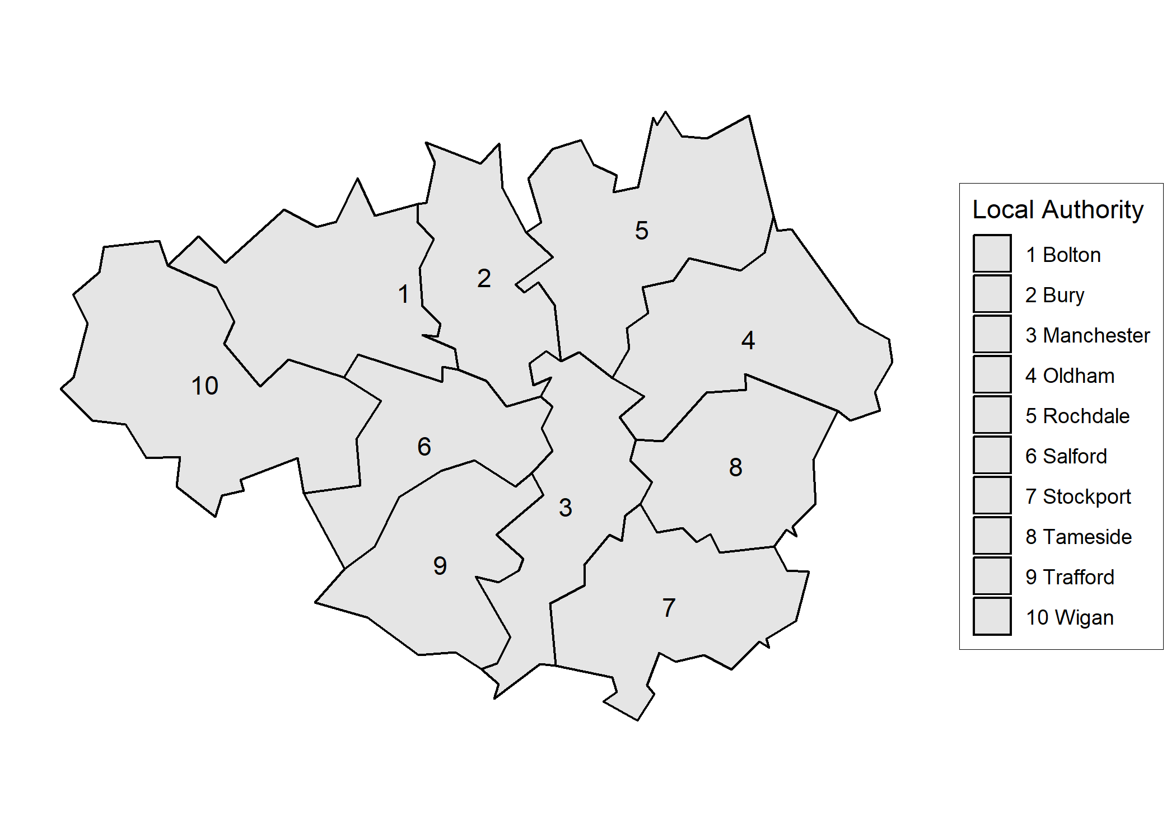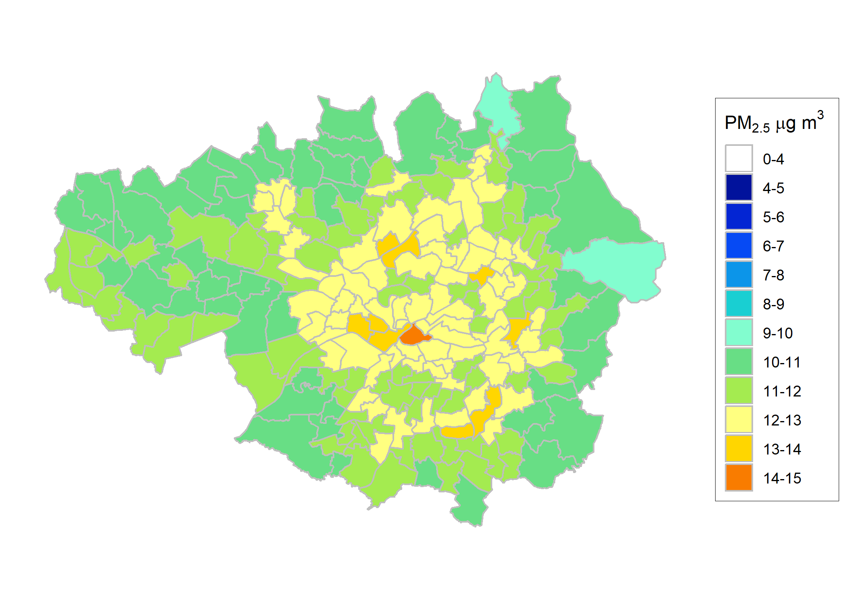
2011
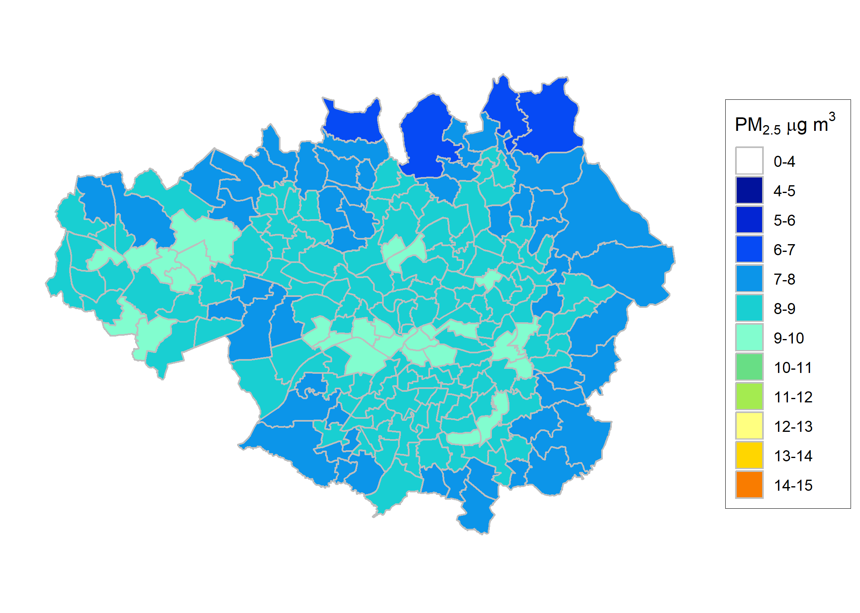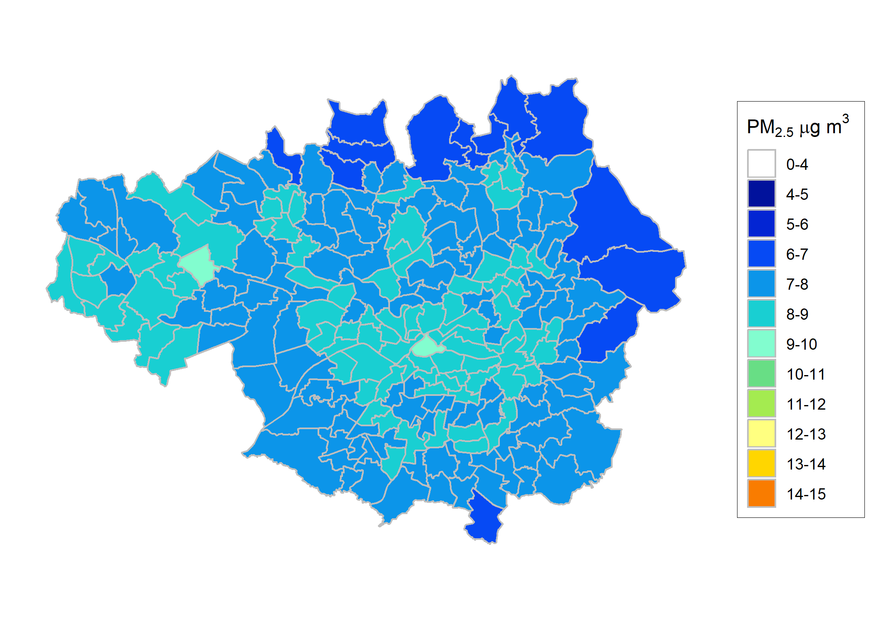
2015
2020
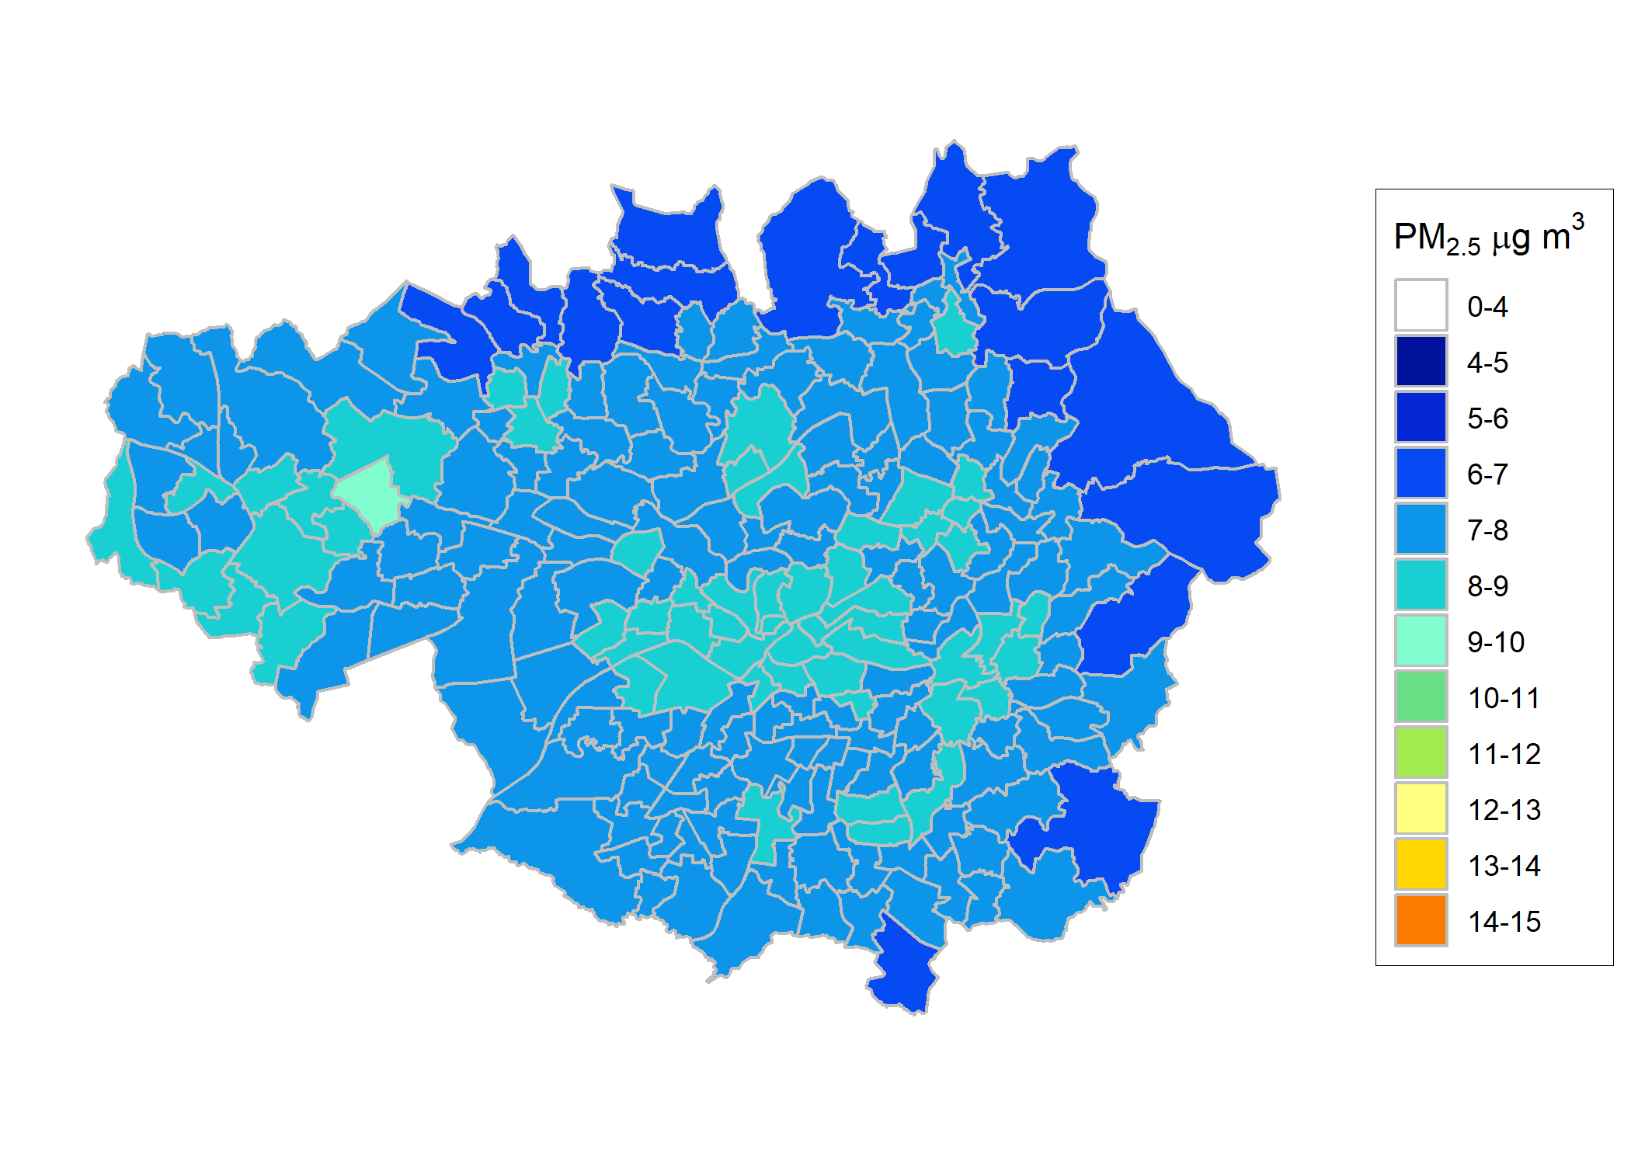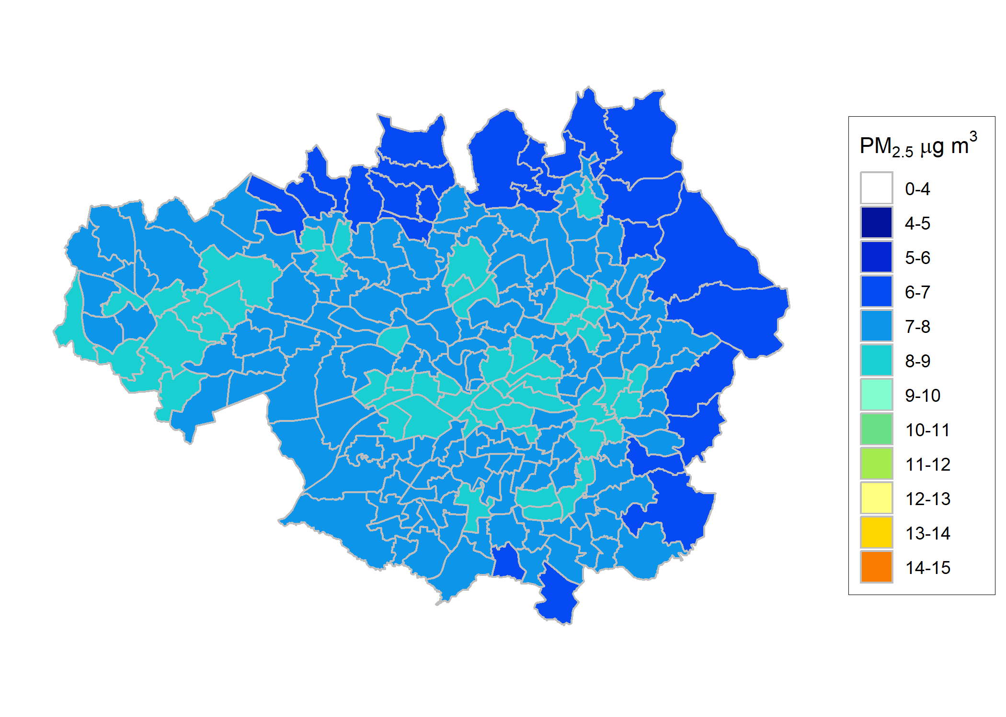
2030
2025
Figure 1 Annual mean PM_{2.5} concentrations (in μg m⁻³) by wards between 2011 and 2030
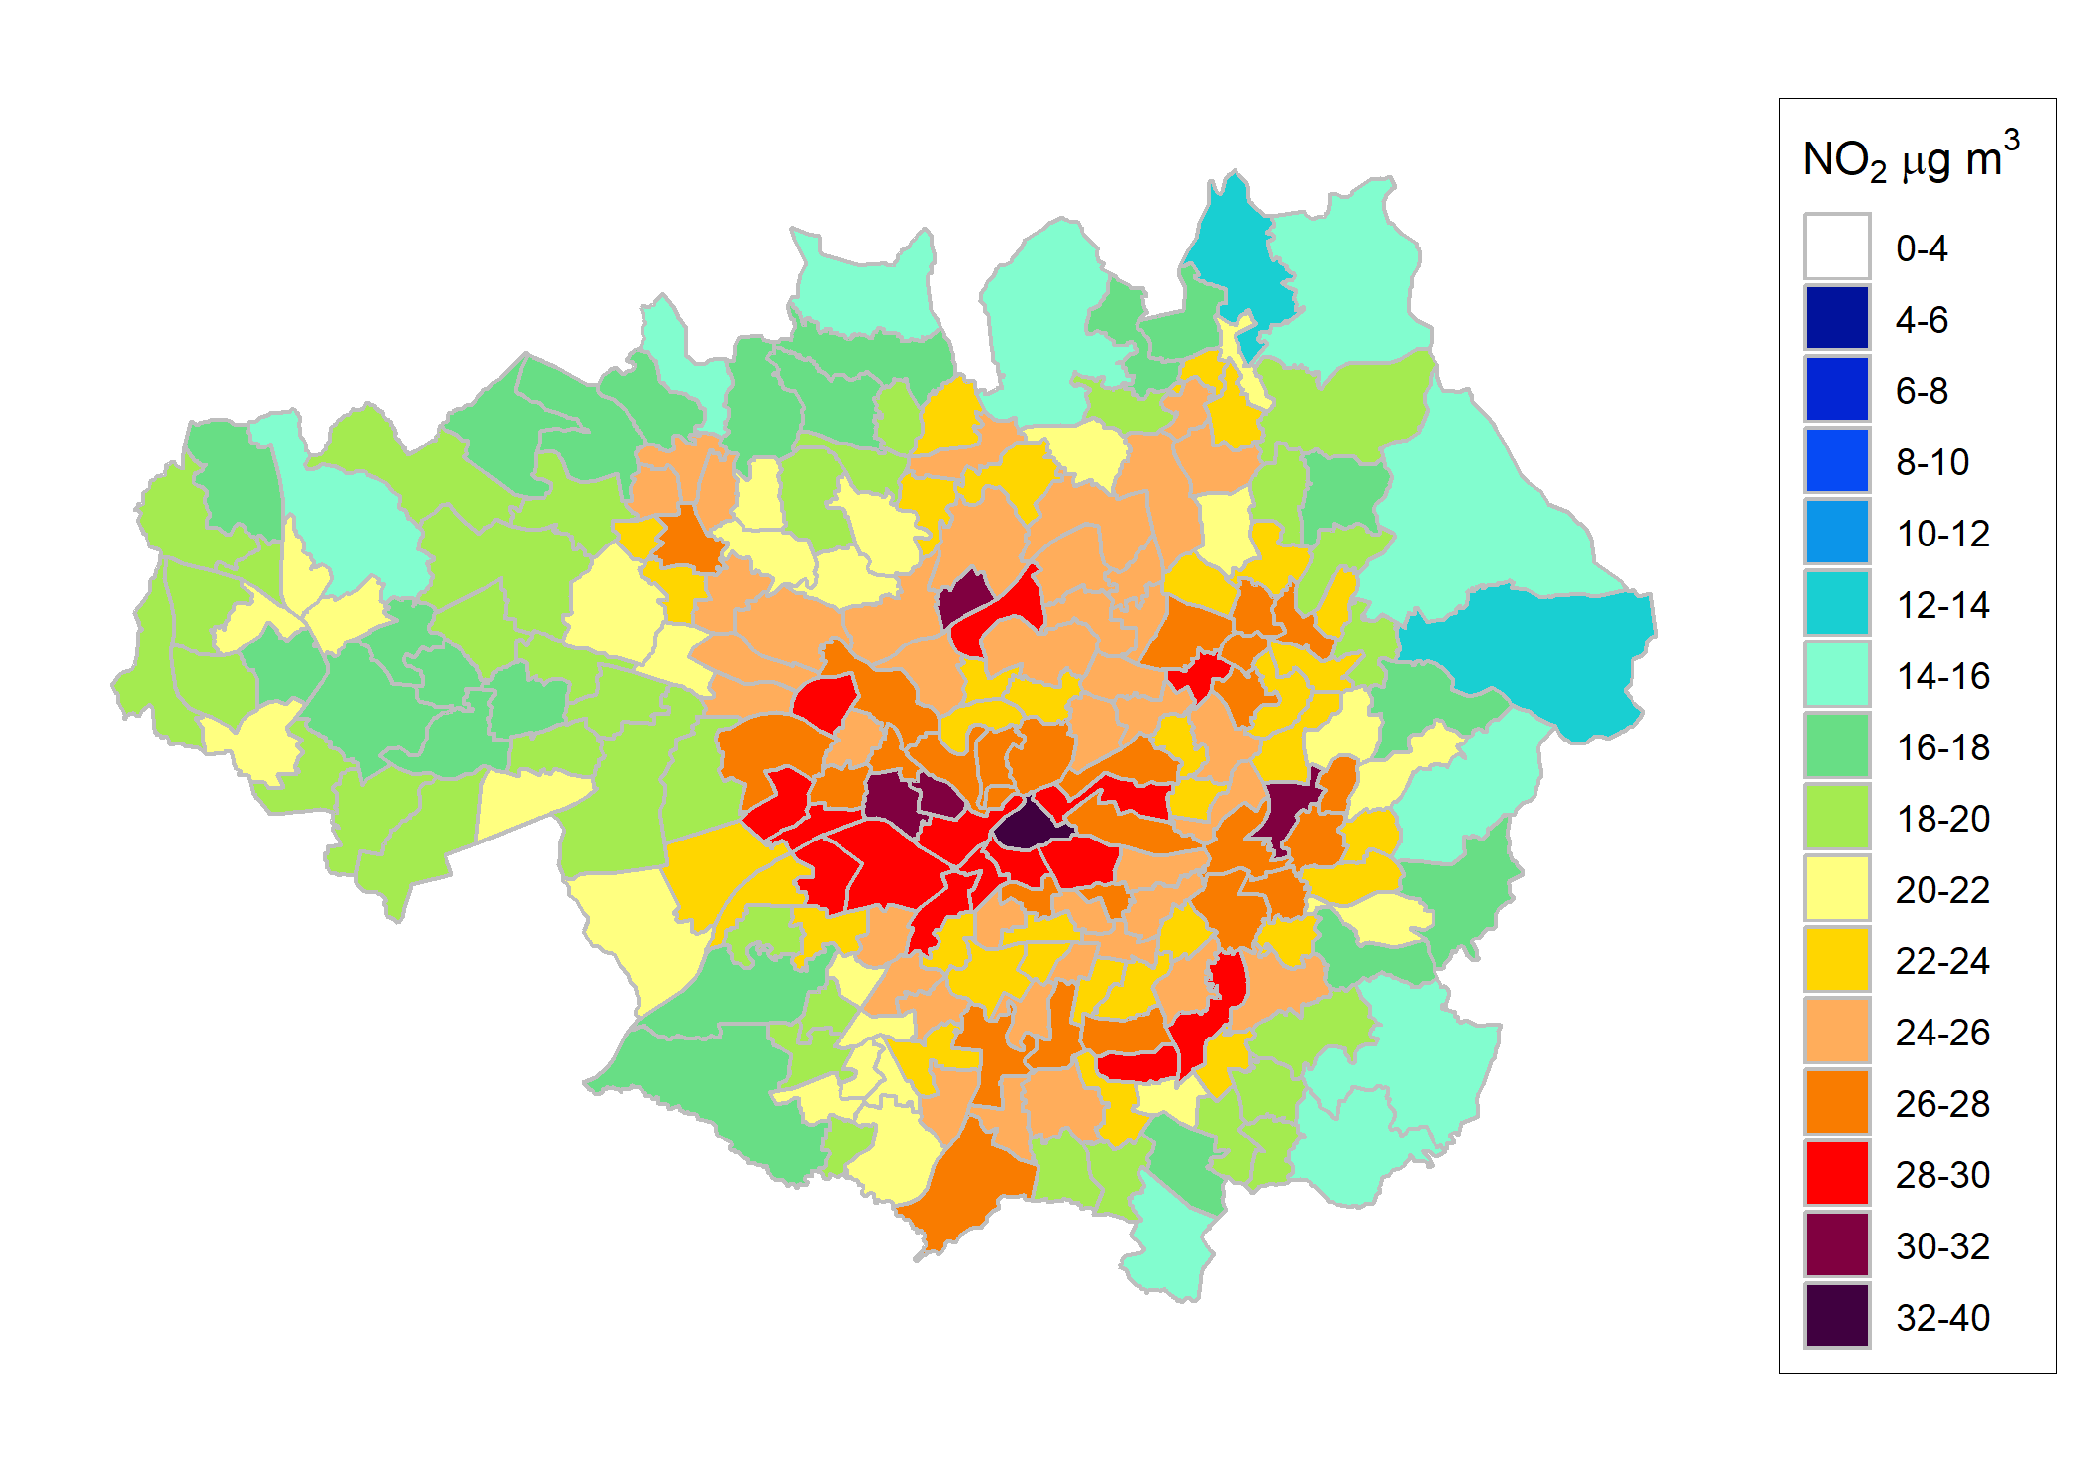
2020
2015
2011
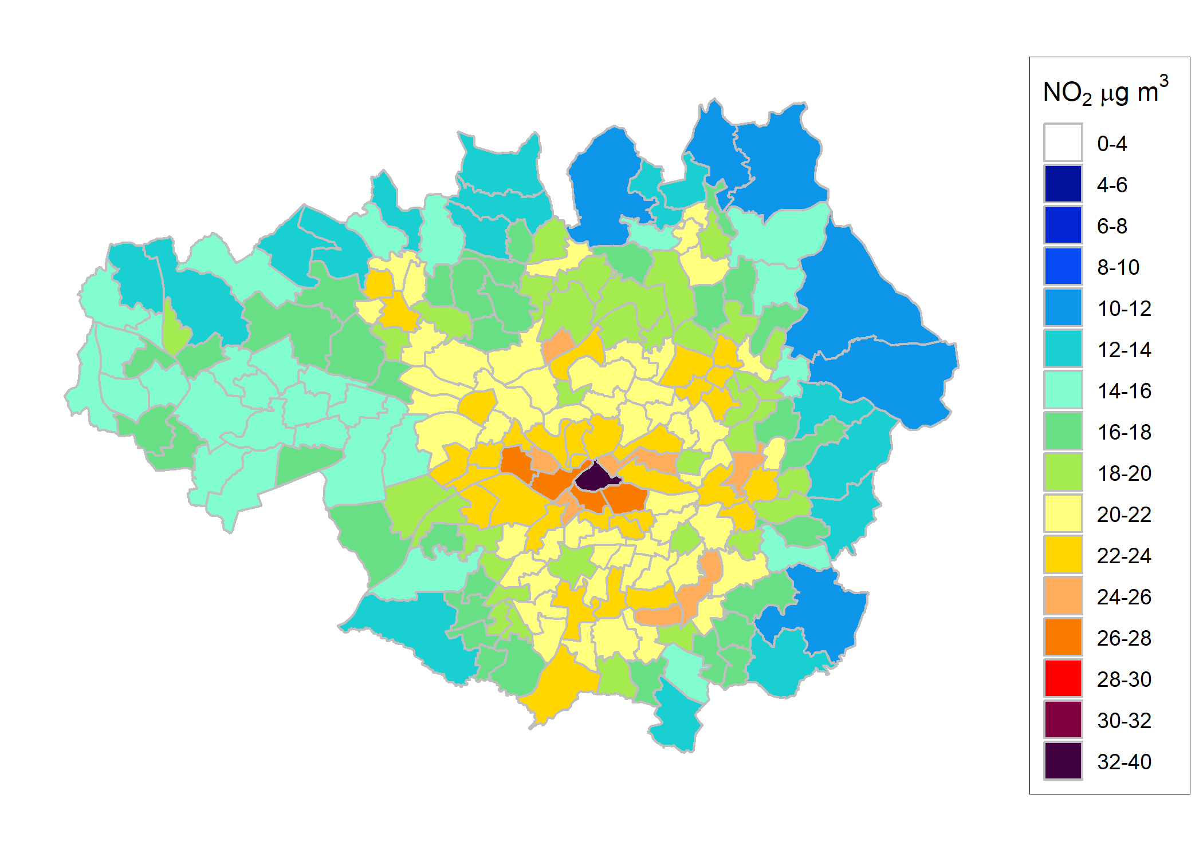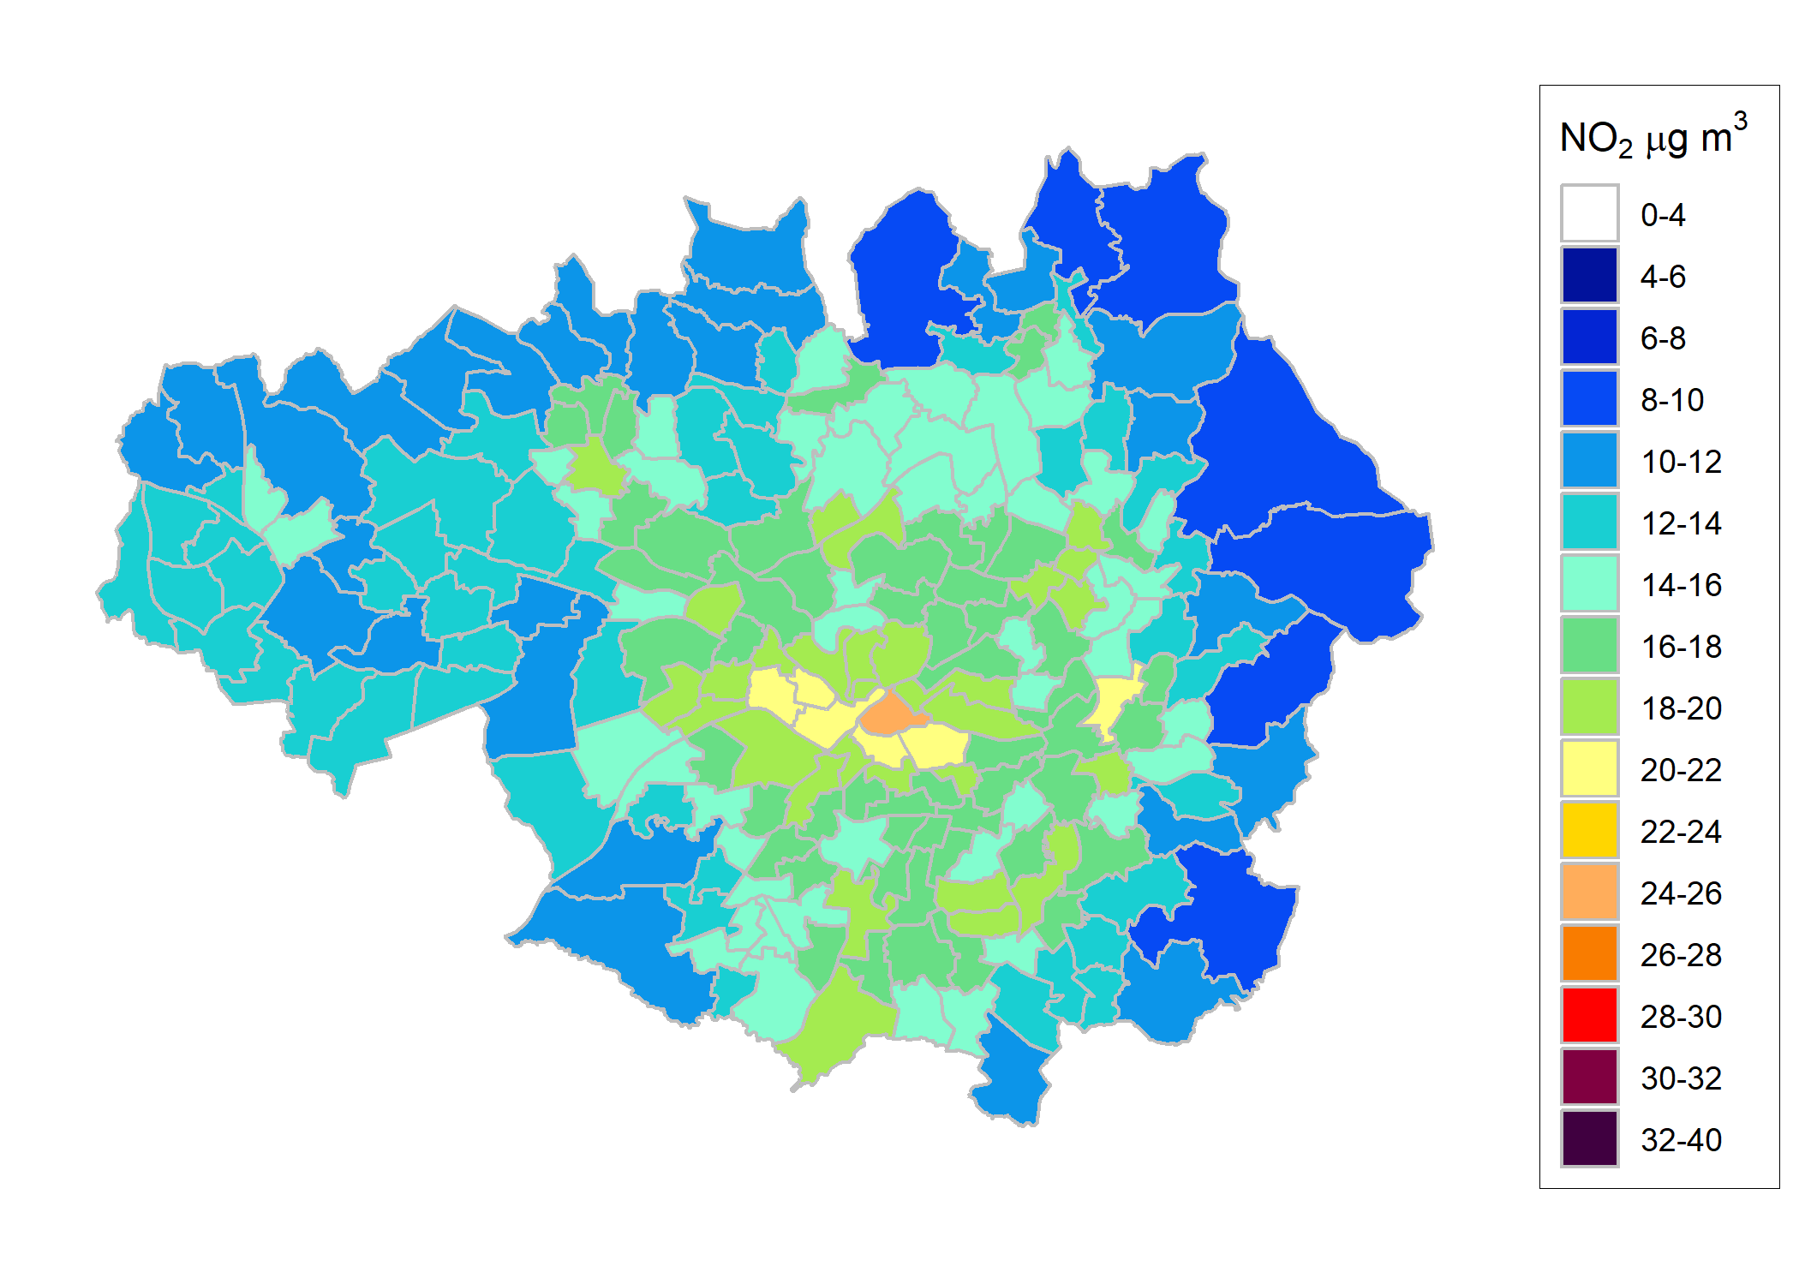
2030
2025
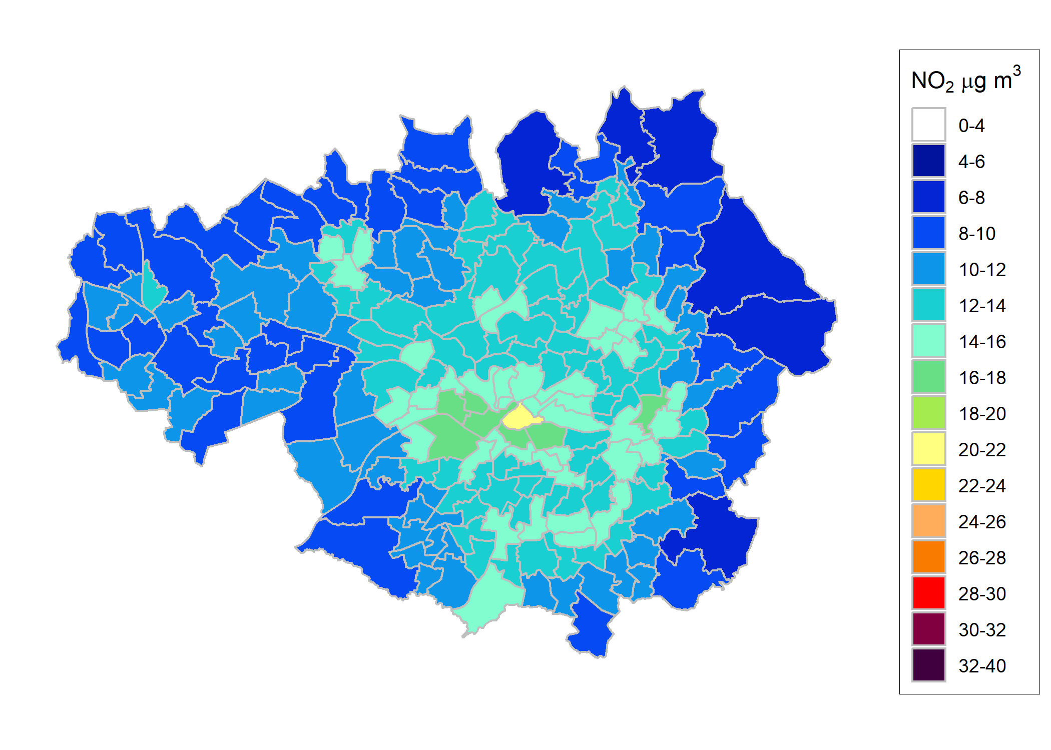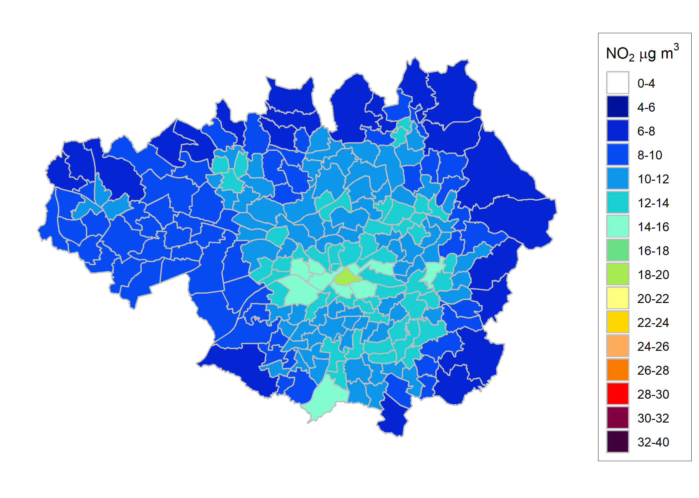
Figure 2 Annual mean NO₂ concentrations (in μg m⁻³) by wards between 2011 and 2030
Health and economic impact results

Estimates of the mortality burden of air pollution
The 2011 mortality burden in GM of 2011 levels of anthropogenic PM_{2.5} was estimated to be equivalent to 1,459 (range 993 to 1,906) attributable deaths at typical ages. Estimates for individual local authorities are provided in Table 3.

Table 3 Estimated burden of effects on annual mortality in 2011 of 2011 levels of anthropogenic PM_{2.5}
Zone | Anthropogenic PM_{2.5}
 | Attributable deaths
 | Central estimate | Lower estimate | Upper estimate
Bolton | 154 | 105 | 201
Bury | 106 | 72 | 139
Manchester | 225 | 153 | 294
Oldham | 129 | 88 | 169
Rochdale | 116 | 79 | 151
Salford | 142 | 97 | 185
Stockport | 159 | 108 | 207
Tameside | 142 | 96 | 185
Trafford | 114 | 78 | 149
Wigan | 172 | 117 | 225
GM | 1,459 | 993 | 1,906
Using COMEAP’s recommended concentration-response coefficient of 1.06 per 10 μg m⁻³ of anthropogenic PM_{2.5} for the central estimate (lower estimate RR of 1.04 and upper estimate RR 1.08)

Burden calculations are a snapshot of the burden in one year, assuming that concentrations had been the same for many years beforehand. They are intended as a simpler calculation than the more detailed assessments that are given below and do not reflect the impact over many years. They are included here as a comparison with similar calculations presented elsewhere (COMEAP, 2010; Walton et al., 2015). The concentration-response functions used for these calculations are evolving over time. These results use recommendations from COMEAP, 2010. Walton et al. (2015) used both COMEAP (2010) recommendations and WHO (2013) recommendations that included recommendations for nitrogen dioxide to provide estimates for London. The results were presented as a range from PM_{2.5} alone to the sum of the PM_{2.5} and NO₂ results, but the uncertainty of the latter was emphasized. Since then it has become clearer that the overlap is likely to be substantial (COMEAP, 2015). Thus, we have not included NO₂ results here but for completeness, the 2011 mortality burden estimates for individual local authorities and GM of 2011 levels of NO₂ can be found the appendix in Table A3. New methods for burden calculations are being developed by COMEAP (COMEAP, 2018 in press) but these were not available at the time of preparation of this report.

[Burden calculations would normally include accompanying estimates of the burden life years lost. This would require inputting average loss of life expectancy by age and gender for calculations in each ward. For this small project, it was not possible to do this.]

Impacts in the next section are all expressed in terms of life years – the most appropriate metric for the health impact of air pollution concentration changes over time. This used a full life-table approach rather than the short-cut method used for burden and the data for these calculations had already been incorporated for previous work (Williams et al., 2018a).

Estimates of the mortality impact of air pollution and its economic valuation
Calculations are first given for PM_{2.5} and NO₂ separately. Because air pollutants are correlated with each other, the air pollutant concentrations in the health studies represent both the pollutants themselves but also other air pollutants closely correlated with them. Health impacts from changes in NO₂ and PM_{2.5} represent the health impacts of changes in the air pollution mixture in slightly different ways that overlap i.e. they should not be added. This is discussed further at the end of this section.

The results from the life table calculations assuming that the concentration does not reduce from 2011 levels and assuming the predicted concentration between 2011 and 2030 (concentrations were modelled at 2011, 2015, 2020, 2025 and 2030 but also interpolated for the intervening years) are shown in Table 4, for anthropogenic PM_{2.5} and NO₂. Results for each local authority can be found in the Appendix in Table A4 (life table calculations for anthropogenic PM_{2.5}), Table A5 (life table calculations for NO₂) and Table A6a and Table A6b (annualised economic impact).

The life years lost gives a large number because the life years (one person living for one year) is summed over the whole population in GM over 124 years. For context, the total life years lived with baseline mortality rates is around 409 million, so these losses of life years involve about 0.5% of total life years lived.
If 2011 concentrations of anthropogenic PM_{2.5} remained unchanged for 124 years, around 1.01 - 2.46 million life years would be lost across GM’s population over that period. This improves to around 0.2 - 1.6 million life years lost with the predicted concentration between 2011 and 2030 changes examined here.

Another way of representing the health impacts if air pollution concentrations remained unchanged (in 2011) compared with the projected future changes (2011 to 2030) is provided by the results for NO₂. If 2011 concentrations of NO₂ remained unchanged for 124 years, around 1.5 - 1.9 million life years would be lost across GM’s population over that period. This improves to around 0.6 - 1 million life years lost with the predicted concentration between 2011 and 2030 changes examined here.

Summarising these results is not easy. The results should not be added as there is considerable overlap. On the other hand, either result is an underestimate to some extent as it is missing the impacts that are better picked up in the calculations using the other pollutant. COMEAP (2017) suggested taking the larger of the two alternatives in the calculation of benefits. We have interpreted this as the larger of the two alternatives in the case of each calculation. Note that this means that the indicator pollutant changes in different circumstances. In this case, for no cut-off, this is the result for PM_{2.5.} However, for the cut-off, this is the result for NO₂. This is one of the first times these recommendations have been applied in practice, so other interpretations e.g. keeping the same indicator pollutant with and without a cut-off, are possible. All the relevant data are in the tables to enable creation of summaries in a different form.
So, the overall summary for the projected future changes in air pollution concentrations from 2011 to 2030 would be around 0.6 to 1.6 million life years lost for the population of Greater Manchester over 124 years.

Table 4 Total life years lost across GM population for anthropogenic PM_{2.5} and NO₂ and associated annualised economic impact (central estimate)
Pollutant | Scenario | Life years lost  Central estimate (without cut-off  with cut-off) | Annualised economic impact (in 2014 prices)  (without cut-off  with cut-off)
Anthropogenic PM_{2.5} (representing the regional air pollution mixture and some of the local mixture) | Concentration does not reduce from 2011 levels | 2,457,123  1,011,212 | £1,419,199,403  £583,416,214
 | Predicted concentration between 2011 and 2030 | 1,638,043  175,471 | £954,495,447  £109,582,547
NO₂ (representing the local mixture and the rural air pollution mixture) | Concentration does not reduce from 2011 levels | 1,910,048  1,492,380 | £1,101,749,453  £860,330,227
 | Predicted concentration between 2011 and 2030 | 981,519  561,169 | £586,562,264  £343,719,554
For anthropogenic PM_{2.5} assuming no net migration, with projected new births, 2011-2134, compared with life years lived with baseline mortality rates (incorporating mortality improvements over time) with a relative risk (RR) of 1.06 per 10 μg m⁻³ of anthropogenic PM_{2.5} without cut-off and with 7 μg m⁻³ cut-off, with lags from the USEPA.
For NO₂ assuming no net migration, with projected new births, 2011-2134, compared with life years lived with baseline mortality rates (incorporating mortality improvements over time) with a relative risk (RR) of 1.023 per 10 μg m⁻³ of NO₂ without cut-off and with 5 μg m⁻³ cut-off, with lags from the USEPA.
(Results with cut-offs do not extrapolate beyond the original data, results with no cut-off represent the possibility that there are effects below the cut-off value (it is unknown whether or not this is the case).)
Figures in bold are the larger of the alternative estimates using PM_{2.5} or NO₂, as summarized in the headline results.

Table 4 also gives the economic impacts (economic costs). Note that these are derived from applying monetary valuation to the health impacts. The monetary values are derived from surveys of what people are willing to pay to avoid the risk of the relevant health impact. They do not represent the costs of the policies or the costs to the NHS.

If 2011 concentrations of anthropogenic PM_{2.5} remained unchanged for 124 years, the annualised economic cost would be around £0.6 – 1.4 billion. This improves to around £0.1 – 1 billion with the projected baseline concentration changes examined here.

If 2011 concentrations of NO₂ remained unchanged for 124 years, the annualized economic cost would be around £0.9 – 1.1 billion. This improves to around £0.3 – 0.6 billion with the predicted concentration between 2011 and 2030 changes examined here.

The overall summary for the projected baseline would be annualised economic costs of around £0.3 to 1 billion.

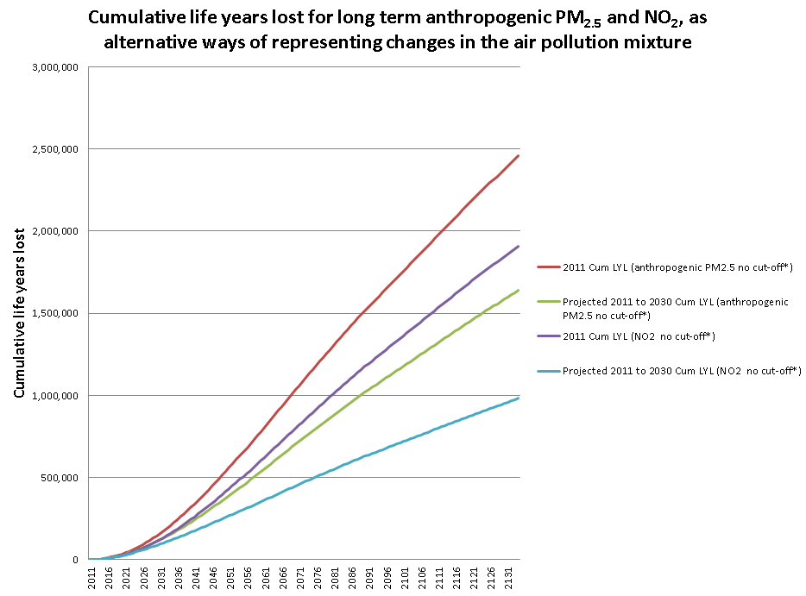
Figure 3 Cumulative life years lost for anthropogenic PM_{2.5} and NO₂ 2011 concentrations remained unchanged and the baseline (current policies 2011-2030) across GM population (no migration), with projected new births, compared with life years lived with baseline mortality rates (incorporating mortality improvements over time) 2011-2134. RR 1.06 per 10 μg m⁻³ for anthropogenic PM_{2.5} and RR 1.023 per 10 μg m⁻³ for NO₂, EPA lag
* Cut-off results not shown

Figure 3 shows that the cumulative life years lost for the predicted concentration between 2011 and 2030 accumulates more slowly than the constant 2011 concentration results for both anthropogenic PM_{2.5} and NO₂ as a result of the reduced concentrations from 2011 to 2030. It is worth remembering that there is a delay before the full benefits of concentration reductions are achieved. This is not just due to a lag between exposure and effect, but also because the greatest gains occur when mortality rates are highest i.e. in the elderly.

Table 5 shows the differences between the predicted concentration between 2011 and 2030 and both particulate levels and NO₂ concentration constant at 2011 levels. Using PM_{2.5} as an indicator of the regional pollution and some of the local pollution mixture gives an estimate of 820,000 to 835,000 life years gained as a result of the predicted concentration between 2011 and 2030. Using NO₂ as an indicator of mostly the local pollution mixture and the rural pollution gives a larger estimate of 930,000 life years gained. This makes sense because the concentration projected (2011 to 2030) suggests more continuous declines in NO₂ concentrations (likely to be mostly due to the improvement in NO_{X} emissions of large parts of the road transport sector) than for PM_{2.5}, reflecting the fact that PM reduction from traffic is not larger due to the increasing contribution from non-exhaust emissions and also that the declines in regional PM_{2.5} are relatively small.

Thus, using NO₂ rather than PM_{2.5,} as the indicator of changes in the traffic pollution mixture seems more appropriate for future changes as presented here. This is a different indicator compared with the overall impact in terms of life years lost. Regional pollution is a greater contributor to absolute total concentrations than to future changes so there is also some sense in PM_{2.5} being the indicator in this case.

The overall summary would be that taking into account predicted air pollution concentration between 2011 and 2030, the population in Greater Manchester would gain around 930,000 life years over a lifetime.

Table 5 Life years saved (and associated monetised benefits) across GM population of the predicted concentration between 2011 and 2030 compared with 2011 anthropogenic PM_{2.5} concentrations and NO₂ remaining unchanged
Pollutant | Scenario | Total life years saved compared with 2011 concentrations maintained  (without cut-off  with cut-off) | Monetised benefits compared with 2011 concentrations maintained  (without cut-off  with cut-off)
Anthropogenic PM_{2.5} (representing the regional air pollution mixture and some of the local mixture) | Predicted concentration between 2011 and 2030 | 819,081  835,741 | £464,703,956  £473,833,667
NO₂ (representing the local mixture and the rural air pollution mixture) | Predicted concentration between 2011 and 2030 | 928,528  931,211 | £515,187,190  £516,610,673
Figures in bold are the larger of the alternative estimates using PM_{2.5} or NO₂, as summarized in the headline results.

Table 5 also provides an estimate of the economic impact as a result of the improvements in pollution from 2011 to 2030 versus 2011 pollution remaining unchanged. The annualised monetary benefit of anthropogenic PM_{2.5} and NO₂ improvements has been estimated to be up to £0.5 billion (at 2014 prices).

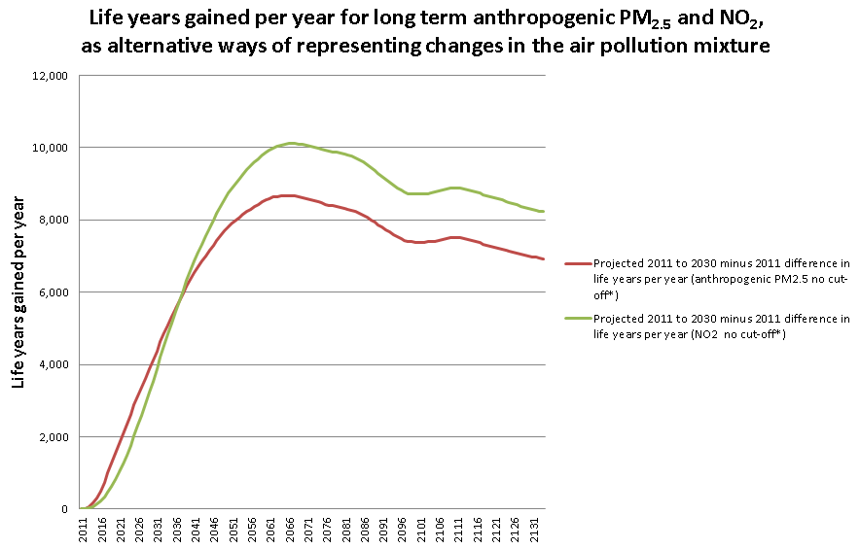
Figure 4 Life years gained per year from long-term exposure to the improvements in pollution from 2011 to 2030 of anthropogenic PM_{2.5} and NO₂ relative to 2011 concentrations remaining unchanged
* Cut-off results not shown

Figure 4 shows the effect of the decrease in PM_{2.5} and NO₂ concentration from 2011 to 2030 (as seen in Tables 1 and 2).

Life-expectancy from birth in 2011
Total life years across the population is the most appropriate metric for cost-benefit analysis of policies as it captures effects in the entire population. However, it is a difficult type of metric to communicate as it is difficult to judge what is a ‘small’ answer or a ‘large’ answer. Life-expectancy from birth is a more familiar concept for the general public, although it only captures effects on those born on a particular date. Results for life expectancy from birth are shown in Table 6. Results for each local authority can be found in the Appendix in Table A7 (Loss of life expectancy for anthropogenic PM_{2.5} and NO₂).

This shows that the average loss of life expectancy from birth in GM would be about 15 – 37 weeks for male and 13 – 32 weeks for female if 2011 PM_{2.5} concentrations were unchanged but improves to 2 – 24 weeks for male and 2 – 21 weeks for female for the predicted concentration between 2011 and 2030 (an improvement by about 11-13 weeks).
Using NO₂, the average loss of life expectancy from birth in GM would be about 22 – 29 weeks for male and 20 – 25 weeks for female if NO₂ concentrations were unchanged from 2011 but improves by about 13-15 weeks to 8 – 14 weeks for male and 7 – 12 weeks for female with projected future changes between 2011 and 2030 included.

The overall summary would be that the projected future changes provide an improvement in average life expectancy from birth in 2011 of around 3.5 months (13 – 15 weeks) but an average loss of life expectancy from birth in 2011 of around 2 to 6 months (7 – 24 weeks) remains even with the reduced concentrations.

Table 6 Loss of life expectancy by gender across GM from birth in 2011 (followed for 105 years) for anthropogenic PM_{2.5} and NO₂
Pollutant | Scenario | Loss of life expectancy from birth compared with baseline mortality rates, 2011 birth cohort (in weeks)  (without cut-off  with cut-off)
 |  | Male | Female
Anthropogenic PM_{2.5} | Concentration does not reduce from 2011 levels | 36.6  15.2 | 32.2  13.3
 | Predicted concentration between 2011 and 2030 | 24.1  2.3 | 21.2  2.0
NO₂ | Concentration does not reduce from 2011 levels | 28.6  22.4 | 25.1  19.6
 | Predicted concentration between 2011 and 2030 | 13.7  7.5 | 12.0  6.5
Figures in bold are the larger of the alternative estimates using PM_{2.5} or NO₂, as summarized in the headline results.

Additional data such as the annualised economic impact and the loss of life expectancy lower and upper estimate and the full range of confidence intervals with and without counterfactual for both PM_{2.5} and NO₂ are available upon request to the authors.

Appendix

Additional tables

Table A1 Concentration-response functions (CRFs) for long-term exposures and mortality
Pollutant | Averaging time | Hazard ratio per 10 μg m⁻³ | Confidence interval | Counterfactual | Comment/Source
PM_{2.5} | Annual average | 1.06 | 1.04-1.08 | Zero  Or 7 μg m⁻³ | Age 30+, Anthropogenic PM_{2.5} (Hazard ratio COMEAP (2010) and COMEAP (2017))  Age 30+, total PM_{2.5} (cut-off reference COMEAP (2010))
NO₂ | Annual average | 1.023 | 1.008 – 1.037 | Zero  or 5 μg m⁻³ | Age 30+ (Hazard ratio COMEAP (2017), cutoff COMEAP (2016)

Table A2 Geographic scales of health impact calculations
Concentrations | Concentration output for health impacts | Population by gender and age group | Population-weighting | Mortality data | Impact calculations
1km | Ward | Ward | Ward to LA | Local authority | Sum of LA results

Additional data such as the annualised economic impact and the loss of life expectancy lower and upper estimate and the full range of confidence interval with and without counterfactual for both PM_{2.5} and NO₂ are available upon request to the authors.

Table A3 Estimated burden of effects on annual mortality in 2011 of 2011 levels of NO₂
Zone | NO₂
 | Attributable deaths
 | Central estimate | Lower estimate | Upper estimate
Bolton | 116 | 41 | 182
Bury | 82 | 29 | 129
Manchester | 190 | 68 | 298
Oldham | 99 | 35 | 156
Rochdale | 86 | 31 | 136
Salford | 122 | 44 | 191
Stockport | 119 | 42 | 187
Tameside | 110 | 39 | 172
Trafford | 89 | 32 | 140
Wigan | 120 | 42 | 189
GM | 1,132 | 404 | 1,781
Using COMEAP’s recommended concentration-response coefficient of 1.023 per 10 μg m⁻³ of anthropogenic PM_{2.5} for the central estimate (lower estimate RR of 1.008 and upper estimate RR 1.037)

Table A4 Life years lost by gender across the local authorities and GM population for anthropogenic PM_{2.5} (without cut-off)
Zone | Gender | Concentration does not reduce from 2011 levels |  |  | Predicted concentration between 2011 and 2030
 |  | Central estimate | Lower estimate | Upper estimate | Central estimate | Lower estimate | Upper estimate
Bolton | Female | 110,214 | 74,363 | 145,221 | 76,013 | 51,247 | 100,235
Bolton | Male | 125,992 | 85,008 | 166,012 | 86,925 | 58,604 | 114,625
Bury | Female | 73,641 | 49,681 | 97,042 | 47,819 | 32,233 | 63,068
Bury | Male | 82,653 | 55,763 | 108,915 | 53,687 | 36,190 | 70,805
Manchester | Female | 257,517 | 173,998 | 338,835 | 169,058 | 114,072 | 222,748
Manchester | Male | 304,577 | 205,573 | 401,181 | 199,758 | 134,693 | 263,378
Oldham | Female | 98,252 | 66,323 | 129,398 | 63,973 | 43,139 | 84,342
Oldham | Male | 110,444 | 74,527 | 145,505 | 71,828 | 48,424 | 94,719
Rochdale | Female | 88,840 | 59,979 | 116,987 | 57,671 | 38,892 | 76,027
Rochdale | Male | 99,675 | 67,253 | 131,335 | 64,683 | 43,605 | 85,303
Salford | Female | 114,637 | 77,425 | 150,899 | 75,454 | 50,899 | 99,443
Salford | Male | 128,822 | 86,953 | 169,672 | 84,632 | 57,068 | 111,581
Stockport | Female | 107,348 | 72,482 | 141,342 | 70,860 | 47,791 | 93,405
Stockport | Male | 117,500 | 79,301 | 154,780 | 77,430 | 52,207 | 102,094
Tameside | Female | 93,826 | 63,293 | 123,650 | 61,567 | 41,499 | 81,202
Tameside | Male | 104,690 | 70,610 | 137,992 | 68,725 | 46,320 | 90,652
Trafford | Female | 88,146 | 59,523 | 116,046 | 58,666 | 39,571 | 77,325
Trafford | Male | 94,163 | 63,563 | 124,014 | 62,555 | 42,184 | 82,469
Wigan | Female | 122,876 | 82,902 | 161,912 | 89,596 | 60,408 | 118,140
Wigan | Male | 133,310 | 89,911 | 175,719 | 97,147 | 65,484 | 128,127
GM | Female | 1,155,296 | 779,970 | 1,521,332 | 770,674 | 519,751 | 1,015,935
GM | Male | 1,301,827 | 878,461 | 1,715,125 | 867,368 | 584,780 | 1,143,753
GM | Total | 2,457,123 | 1,658,431 | 3,236,458 | 1,638,043 | 1,104,530 | 2,159,688

Table A5 Life years lost by gender across the local authorities and GM population for NO₂ (without cut-off)
Zone | Gender | Concentration does not reduce from 2011 levels |  |  | Predicted concentration between 2011 and 2030
 |  | Central estimate | Lower estimate | Upper estimate | Central estimate | Lower estimate | Upper estimate
Bolton | Female | 80,973 | 28,471 | 128,957 | 42,114 | 14,784 | 67,172
Bolton | Male | 92,872 | 32,655 | 147,907 | 48,374 | 16,983 | 77,154
Bury | Female | 56,366 | 19,818 | 89,768 | 28,266 | 9,922 | 45,088
Bury | Male | 63,231 | 22,234 | 100,698 | 31,771 | 11,154 | 50,673
Manchester | Female | 216,659 | 76,400 | 344,118 | 111,078 | 39,049 | 176,942
Manchester | Male | 257,412 | 90,608 | 409,513 | 131,990 | 46,361 | 210,416
Oldham | Female | 74,402 | 26,182 | 118,400 | 38,391 | 13,482 | 61,213
Oldham | Male | 83,753 | 29,457 | 133,345 | 43,100 | 15,132 | 68,737
Rochdale | Female | 65,525 | 23,060 | 104,266 | 32,885 | 11,549 | 52,434
Rochdale | Male | 73,520 | 25,851 | 117,085 | 36,926 | 12,963 | 58,898
Salford | Female | 97,595 | 34,393 | 155,098 | 48,538 | 17,056 | 77,348
Salford | Male | 109,931 | 38,701 | 174,865 | 54,656 | 19,199 | 87,127
Stockport | Female | 80,097 | 28,195 | 127,428 | 43,268 | 15,198 | 68,975
Stockport | Male | 87,949 | 30,938 | 140,005 | 47,305 | 16,612 | 75,429
Tameside | Female | 71,599 | 25,171 | 114,042 | 37,263 | 13,080 | 59,438
Tameside | Male | 79,998 | 28,117 | 127,451 | 41,727 | 14,647 | 66,563
Trafford | Female | 68,679 | 24,185 | 109,222 | 35,334 | 12,413 | 56,323
Trafford | Male | 73,453 | 25,851 | 116,875 | 37,598 | 13,205 | 59,945
Wigan | Female | 84,429 | 29,678 | 134,498 | 43,648 | 15,320 | 69,631
Wigan | Male | 91,603 | 32,185 | 145,988 | 47,287 | 16,595 | 75,448
GM | Female | 896,325 | 315,553 | 1,425,796 | 460,784 | 161,855 | 734,562
GM | Male | 1,013,722 | 356,597 | 1,613,732 | 520,735 | 182,851 | 830,390
GM | Total | 1,910,048 | 672,150 | 3,039,529 | 981,519 | 344,706 | 1,564,952

Table A6a Central Annualised economic impact estimate (in 2014 prices) across the local authorities and GM population for anthropogenic PM_{2.5} and NO₂ (without cut-off)
Zone | Anthropogenic PM_{2.5} |  | NO₂
 | Concentration does not reduce from 2011 levels | Predicted concentration between 2011 and 2030 | Concentration does not reduce from 2011 levels | Predicted concentration between 2011 and 2030
 | Central estimate | Central estimate | Central estimate | Central estimate
Bolton | £137,066,674 | £95,325,026 | £100,870,878 | £54,451,019
Bury | £91,373,983 | £59,909,105 | £69,914,314 | £36,492,600
Manchester | £313,723,487 | £207,335,151 | £264,592,054 | £139,793,276
Oldham | £120,160,112 | £78,896,199 | £91,051,381 | £48,556,980
Rochdale | £109,672,208 | £71,848,995 | £80,886,238 | £42,149,668
Salford | £138,907,493 | £92,155,823 | £118,398,649 | £61,160,573
Stockport | £133,470,626 | £88,885,069 | £99,737,108 | £55,785,561
Tameside | £116,193,614 | £76,996,218 | £88,727,173 | £47,897,175
Trafford | £106,813,195 | £71,654,496 | £83,263,524 | £44,368,472
Wigan | £151,818,011 | £111,489,366 | £104,308,133 | £55,906,940
GM | £1,419,199,403 | £954,495,447 | £1,101,749,453 | £586,562,264

Table A6b Lower and upper Annualised economic impact estimate (in 2014 prices) across the local authorities and GM population for anthropogenic PM_{2.5} and NO₂ (without cut-off)
Zone | Anthropogenic PM_{2.5} |  | NO₂
 | Predicted concentration between 2011 and 2030 |  | Predicted concentration between 2011 and 2030
 | Lower estimate | Upper estimate | Lower estimate | Upper estimate
Bolton | £71,629,372 | £119,293,195 | £40,915,722 | £68,141,979
Bury | £45,017,051 | £74,972,427 | £27,421,362 | £45,668,163
Manchester | £155,796,302 | £259,466,727 | £105,043,816 | £174,942,375
Oldham | £59,284,381 | £98,733,565 | £36,486,809 | £60,765,966
Rochdale | £53,988,953 | £89,914,438 | £31,672,210 | £52,747,624
Salford | £69,247,961 | £115,327,139 | £45,957,433 | £76,538,560
Stockport | £66,790,243 | £111,233,999 | £41,918,527 | £69,812,074
Tameside | £57,856,692 | £96,355,859 | £35,991,016 | £59,940,262
Trafford | £53,842,802 | £89,671,035 | £33,339,469 | £55,524,315
Wigan | £83,775,621 | £139,521,836 | £42,009,734 | £69,963,972
GM | £717,229,378 | £1,194,490,220 | £440,756,097 | £734,045,290

Table A7 Loss of life expectancy by gender across the local authorities and GM from birth in 2011 for anthropogenic PM_{2.5} and NO₂
Zone | Gender | Loss of life expectancy from birth compared with baseline mortality rates, 2011 birth cohort followed for 105 years (weeks)
 |  | Anthropogenic PM_{2.5} (without cut-off) |  | NO₂ (without cut-off)
 |  | Concentration does not reduce from 2011 levels | Predicted concentration between 2011 and 2030 | Concentration does not reduce from 2011 levels | Predicted concentration between 2011 and 2030
Bolton | Female | 30.4 | 20.7 | 22.4 | 10.8
Bolton | Male | 34.9 | 23.8 | 25.8 | 12.5
Bury | Female | 30.4 | 19.5 | 23.3 | 10.8
Bury | Male | 34.9 | 22.3 | 26.7 | 12.4
Manchester | Female | 35.6 | 23.1 | 30.0 | 14.5
Manchester | Male | 41.5 | 26.9 | 35.1 | 17.0
Oldham | Female | 32.3 | 20.8 | 24.5 | 11.8
Oldham | Male | 36.8 | 23.6 | 28.0 | 13.5
Rochdale | Female | 31.4 | 20.1 | 23.2 | 10.8
Rochdale | Male | 36.4 | 23.3 | 26.9 | 12.5
Salford | Female | 35.3 | 22.9 | 30.0 | 13.9
Salford | Male | 39.3 | 25.5 | 33.6 | 15.5
Stockport | Female | 28.6 | 18.6 | 21.4 | 10.7
Stockport | Male | 32.5 | 21.1 | 24.3 | 12.1
Tameside | Female | 33.1 | 21.4 | 25.3 | 12.3
Tameside | Male | 37.5 | 24.2 | 28.7 | 13.9
Trafford | Female | 28.9 | 19.0 | 22.6 | 10.7
Trafford | Male | 31.6 | 20.7 | 24.7 | 11.7
Wigan | Female | 30.7 | 22.1 | 21.1 | 10.1
Wigan | Male | 33.4 | 24.1 | 23.0 | 11.0
GM | Female | 32.2 | 21.2 | 25.1 | 12.0
GM | Male | 36.6 | 24.1 | 28.6 | 13.7

Table A8 Life years lost by gender across the local authorities and GM for PM_{2.5} (with 7 μg m⁻³ cut-off)
Zone | Gender | Concentration does not reduce from 2011 levels |  |  | Predicted concentration between 2011 and 2030
 |  | Central estimate | Lower estimate | Upper estimate | Central estimate | Lower estimate | Upper estimate
Bolton | Female | 42,635 | 28,723 | 56,263 | 7,889 | 5,311 | 10,417
Bolton | Male | 48,888 | 32,936 | 64,514 | 9,187 | 6,185 | 12,132
Bury | Female | 29,759 | 20,049 | 39,272 | 3,838 | 2,584 | 5,068
Bury | Male | 33,402 | 22,503 | 44,078 | 4,317 | 2,907 | 5,700
Manchester | Female | 112,098 | 75,575 | 147,822 | 20,903 | 14,075 | 27,599
Manchester | Male | 132,922 | 89,573 | 175,362 | 25,285 | 17,024 | 33,387
Oldham | Female | 40,902 | 27,563 | 53,962 | 6,232 | 4,196 | 8,229
Oldham | Male | 46,029 | 31,014 | 60,734 | 7,020 | 4,726 | 9,270
Rochdale | Female | 35,511 | 23,931 | 46,849 | 4,532 | 3,051 | 5,984
Rochdale | Male | 39,831 | 26,835 | 52,560 | 5,119 | 3,447 | 6,760
Salford | Female | 50,437 | 33,998 | 66,521 | 10,084 | 6,790 | 13,314
Salford | Male | 56,807 | 38,282 | 74,941 | 11,402 | 7,677 | 15,055
Stockport | Female | 43,505 | 29,319 | 57,391 | 6,166 | 4,151 | 8,142
Stockport | Male | 47,745 | 32,171 | 62,997 | 6,802 | 4,580 | 8,982
Tameside | Female | 39,592 | 26,673 | 52,246 | 6,763 | 4,553 | 8,930
Tameside | Male | 44,247 | 29,807 | 58,394 | 7,666 | 5,161 | 10,122
Trafford | Female | 35,326 | 23,808 | 46,600 | 4,875 | 3,283 | 6,438
Trafford | Male | 37,772 | 25,453 | 49,834 | 5,170 | 3,481 | 6,827
Wigan | Female | 45,005 | 30,318 | 59,394 | 10,676 | 7,188 | 14,097
Wigan | Male | 48,798 | 32,869 | 64,407 | 11,546 | 7,773 | 15,246
GM | Female | 474,770 | 319,957 | 626,318 | 81,957 | 55,181 | 108,218
GM | Male | 536,442 | 361,443 | 707,820 | 93,514 | 62,961 | 123,481
GM | Total | 1,011,212 | 681,399 | 1,334,139 | 175,471 | 118,142 | 231,698

Table A9 Life years lost by gender across the local authorities and GM population for NO₂ (with 5 μg m⁻³ cut-off)
Zone | Gender | Concentration does not reduce from 2011 levels |  |  | Predicted concentration between 2011 and 2030
 |  | Central estimate | Lower estimate | Upper estimate | Central estimate | Lower estimate | Upper estimate
Bolton | Female | 61,487 | 21,601 | 98,002 | 22,526 | 7,902 | 35,953
Bolton | Male | 70,639 | 24,817 | 112,591 | 26,027 | 9,131 | 41,539
Bury | Female | 43,691 | 15,350 | 69,635 | 15,523 | 5,446 | 24,777
Bury | Male | 49,006 | 17,218 | 78,103 | 17,469 | 6,129 | 27,879
Manchester | Female | 174,621 | 61,498 | 277,683 | 68,627 | 24,098 | 109,437
Manchester | Male | 207,776 | 73,070 | 330,840 | 82,009 | 28,783 | 130,835
Oldham | Female | 57,872 | 20,346 | 92,182 | 21,754 | 7,633 | 34,713
Oldham | Male | 65,189 | 22,908 | 103,875 | 24,430 | 8,571 | 38,989
Rochdale | Female | 50,139 | 17,627 | 79,863 | 17,393 | 6,103 | 27,756
Rochdale | Male | 56,259 | 19,765 | 89,667 | 19,572 | 6,866 | 31,238
Salford | Female | 79,032 | 27,821 | 125,733 | 29,805 | 10,463 | 47,539
Salford | Male | 89,105 | 31,341 | 141,863 | 33,675 | 11,820 | 53,720
Stockport | Female | 61,637 | 21,673 | 98,160 | 24,683 | 8,662 | 39,383
Stockport | Male | 67,782 | 23,822 | 107,997 | 27,023 | 9,482 | 43,122
Tameside | Female | 55,967 | 19,661 | 89,207 | 21,553 | 7,561 | 34,400
Tameside | Male | 62,577 | 21,979 | 99,761 | 24,228 | 8,500 | 38,668
Trafford | Female | 53,363 | 18,770 | 84,958 | 19,901 | 6,984 | 31,751
Trafford | Male | 57,103 | 20,077 | 90,948 | 21,138 | 7,417 | 33,728
Wigan | Female | 61,938 | 21,753 | 98,750 | 21,049 | 7,383 | 33,601
Wigan | Male | 67,198 | 23,593 | 107,169 | 22,784 | 7,991 | 36,373
GM | Female | 699,747 | 246,100 | 1,114,173 | 262,813 | 92,235 | 419,311
GM | Male | 792,634 | 278,590 | 1,262,814 | 298,355 | 104,690 | 476,092
GM | Total | 1,492,380 | 524,691 | 2,376,987 | 561,169 | 196,925 | 895,403

Table A10 Annualised economic impact (in 2014 prices) across the local authorities and GM population for PM_{2.5} and NO₂ (with 7 μg m⁻³ and 5 μg m⁻³ cut-off for PM_{2.5} and NO₂, respectively)
Zone | Anthropogenic PM_{2.5} |  | NO₂
 | Concentration does not reduce from 2011 levels | Predicted concentration between 2011 and 2030 | Concentration does not reduce from 2011 levels | Predicted concentration between 2011 and 2030
 | Central estimate | Central estimate | Central estimate | Central estimate
Bolton | £53,099,013 | £10,706,018 | £76,659,153 | £30,126,413
Bury | £36,918,988 | £5,337,130 | £54,185,931 | £20,688,424
Manchester | £136,750,687 | £27,353,615 | £213,424,541 | £88,219,427
Oldham | £50,041,347 | £8,352,029 | £70,843,363 | £28,236,656
Rochdale | £43,824,533 | £6,265,755 | £61,891,647 | £23,048,854
Salford | £61,176,254 | £13,131,904 | £95,920,609 | £38,511,962
Stockport | £54,147,647 | £8,602,703 | £76,803,787 | £32,726,014
Tameside | £49,066,044 | £9,209,554 | £69,378,730 | £28,466,207
Trafford | £42,813,772 | £6,569,698 | £64,707,300 | £25,691,218
Wigan | £55,577,927 | £14,054,143 | £76,515,165 | £28,004,378
GM | £583,416,214 | £109,582,547 | £860,330,227 | £343,719,554

Table A11 Loss of life expectancy by gender across the local authorities and GM from birth in 2011 for anthropogenic PM_{2.5} and NO₂
Zone | Gender | Loss of life expectancy from birth compared with baseline mortality rates, 2011 birth cohort followed for 105 years (weeks)
 |  | Anthropogenic PM_{2.5} (with 7 μg m⁻³ cut-off) |  | NO₂ (with 5 μg m⁻³ cut-off)
 |  | Concentration does not reduce from 2011 levels | Predicted concentration between 2011 and 2030 | Concentration does not reduce from 2011 levels | Predicted concentration between 2011 and 2030
Bolton | Female | 11.8 | 1.9 | 17.0 | 5.4
Bolton | Male | 13.6 | 2.2 | 19.6 | 6.3
Bury | Female | 12.3 | 1.3 | 18.1 | 5.5
Bury | Male | 14.1 | 1.4 | 20.7 | 6.4
Manchester | Female | 15.5 | 2.6 | 24.2 | 8.6
Manchester | Male | 18.1 | 3.1 | 28.3 | 10.2
Oldham | Female | 13.5 | 1.7 | 19.1 | 6.3
Oldham | Male | 15.4 | 2.0 | 21.8 | 7.3
Rochdale | Female | 12.6 | 1.3 | 17.8 | 5.3
Rochdale | Male | 14.6 | 1.5 | 20.6 | 6.2
Salford | Female | 15.5 | 2.7 | 24.3 | 8.1
Salford | Male | 17.4 | 3.1 | 27.2 | 9.1
Stockport | Female | 11.6 | 1.3 | 16.5 | 5.7
Stockport | Male | 13.2 | 1.5 | 18.8 | 6.5
Tameside | Female | 14.0 | 2.0 | 19.8 | 6.7
Tameside | Male | 15.9 | 2.3 | 22.4 | 7.6
Trafford | Female | 11.6 | 1.3 | 17.5 | 5.7
Trafford | Male | 12.7 | 1.4 | 19.2 | 6.2
Wigan | Female | 11.3 | 2.3 | 15.5 | 4.4
Wigan | Male | 12.3 | 2.5 | 16.9 | 4.8
GM | Female | 13.3 | 2.0 | 19.6 | 6.5
GM | Male | 15.2 | 2.3 | 22.4 | 7.5

Additional Health and economic assessment method

Anthropogenic PM_{2.5}: Non-anthropogenic PM_{2.5} was derived by subtracting the modelled contribution from natural sources – here sea-salt - from the total PM_{2.5} modelled as above to give anthropogenic PM_{2.5}.

Population data in GM: 2011 census data by ward by 5 year age group and gender (ONS, 2012) was split into 1 year age groups using the age ratios from single year of age and gender population data, by LSOA, for mid-2012 (ONS, 2016a).

Deaths data in GM: Deaths data by gender and 5 year age group by ward for 2011 was obtained on request from ONS (ONS, 2016b). It was scaled to 1 year age groups using age group ratios from data by LSOA by single year of age and gender for mid-2014 (ONS, 2016c). Ward data was then aggregated up to local authority level.

Mortality Burden
The calculations followed COMEAP (2010) and Gowers et al (2014). The relative risk (RR) per 10 μg m⁻³ was scaled to a new relative risk for anthropogenic PM_{2.5} concentration. The equation used was:
RR(x) = 1.06x/10 where x is the average concentration of interest.
The new RR(x) was then converted to the attributable fraction (AF) using the following formula:
AF = (RR-1)/RR multiplied by 100 to give a percentage.
The attributable fraction was then multiplied by the number of deaths in the relevant gender and 5 year age group aged 30+ to give the number of attributable deaths.
The attributable deaths were then summed across the 5 year age groups above aged 30, for both males and females, to give a total for each ward.
The calculations above were done at ward level and the results for deaths summed to give a total for each local authority. This allows different death rates in different wards and LA to influence the results.
The process was repeated for the lower and upper confidence intervals around the relative risks.

Mortality Impact
Projections for the baseline life tables before applying concentration changes
Natural change – current population size, age distributions and mortality rates will generate future changes in population and age structure in any case. We did not add this separately as it is already taken into account in our life table modelling.
Changes in births over time – actual data on numbers of births in each local authority was used from 2011-2015 (ONS, 2016d), birth projections by local authority were used from 2016 to 2033 (ONS, 2016e) and the ratio of birth projections to 2039 births for England obtained from national populations projections (ONS, 2015a) was used to scale 2039 births in local authorities to local authority births for 2040 to 2114. No projections were available after 2114 so births were left constant for 2115 to 2134.
Mortality rate improvements were applied to the 2011 all cause hazard rates according to the projected % improvements per year provided by ONS. Percentage improvements for different example ages are provided in Office for National Statistics (ONS, 2015b); we requested the full set of percentage improvements from ONS.
Migration – predicting migration at the current time post the European referendum is particularly uncertain with both increases and decreases forecast. We did not therefore include this in our first analyses as presented in this report. Over the country as a whole this contribution to overall health impacts is likely to be small. This can be explored further in future work.
Lags: The approach allowed for a delay between exposure and effect using the recommended distribution of lags from COMEAP (COMEAP, 2010) i.e. 30% of the effect in the first year, 12.5% in each of years 2-5 and 20% spread over years 5-20. An analogous approach was used for the effects of long-term exposure to NO₂. HRAPIE (WHO, 2013) recommended that, in the absence of information on likely lags between long-term exposure to NO₂ and mortality, calculations should follow whatever lags are chosen for PM_{2.5}.

Calculations
The relative risk (RR) per 10 μg m⁻³ was scaled to a new relative risk for the appropriate population-weighted mean for each gender in each local authority for each scenario and year. The equation used (for the example coefficient of 1.06) was: RR(x) = 1.06x/10 where x is the concentration of interest (with a negative sign for a reduction). Concentrations were assumed to reduce linearly between the years in which modelled concentrations were available (2011, 2015, 2020, 2025, 2030). The scaled RR was then used to adjust the all cause hazard rates in the life table calculations.
For the 5 μg m⁻³ cut-off for NO₂, ward concentrations were interpolated between 2011, 2015, 2020, 2025 and 2030and 5 μg m⁻³ was then subtracted from the ward concentrations in each year. Any resulting negative concentrations were then set to zero before all the ward concentrations were population-weighted to local authority level as normal.
Life table calculations were programmed in SQL based on the methods used in the standard IOMLIFET spreadsheets ¹³² with the following amendments:
- Extension to 2134 (105 years after 2030)
- Adjustment of the baseline hazard rates over time according to projected mortality rate improvements
- Inclusion of changes in numbers of births over time
- IOMLIFET excludes neonatal deaths. We included neonatal deaths and followed the South East Public Health Observatory life-expectancy calculator (IOM, 2013) and Gowers et al. (2014) in taking into account the uneven distribution of deaths over the course of the first year when calculating the survival probability. (The survival probability (the ratio of the number alive at the end of the year to the number alive at the beginning) is derived by the equivalent of adding half the deaths back onto the mid-year population to give the starting population and subtracting half the deaths from the mid-year population to give the end population, assuming deaths are distributed evenly across the year. This is not the case in the first year where a weighting factor based on 90% of the deaths occurring in the first half of the year and 10% in the second half is used instead. After rearrangement the actual formula is (1- 0.1 x hazard rate)/(1+ 0.9 x hazard rate) rather than the (1- 0.5 x hazard rate)/(1+ 0.5 x hazard rate) used in other years.)
Results for total and annual life years lost by local authority were then summed to GM. We also used the life tables to calculate changes in life expectancy.

Economic valuation
The approach taken here is based on the discipline of environmental economics (ExternE, 2005). Environmental economics was developed partly in response to recognition of the externalities, or external costs, posed by various human activities. ‘Externalities’ are unforeseen effects that arise from action that benefits one party generally to the detriment of others, when those effects are external, or not considered, in the decision making process. Notable examples include the loss of utility from effects of air pollution arising from power generation or transport. The question faced by the economist in this situation is not how to allocate a defined amount of resource (the health service budget), but how much should be spent to mitigate externalities. This requires that health impacts are monetised in order that the benefits of action can be compared directly with the costs in a benefit-cost analysis.

Several approaches have been taken to value mortality impacts (the impacts that dominate the assessment made in this report), though all seek to quantify public preference, demonstrating consistency in objective with the health economics work in deriving QALYs for various conditions. The methods used for valuing a death fall into three categories:
Wage-risk studies, which consider the additional wage demanded of people working in risky occupations, providing an estimate of willingness to accept (WTA) risk.
Consumer market studies, that consider the willingness of individuals to pay (WTP) for equipment that will reduce their risk of death. Several studies were carried out on car safety equipment (air bags, etc.) before they were made mandatory.
Contingent valuation (CV) surveys, where individuals are asked for their WTP for treatments that will reduce the risk of a health impact of some kind, or of dying within X years.
Early work in this field was affected by various biases. Considerable effort has been taken over the last three decades to identify these biases and refine CV approaches to reduce them, with some success.
In the context of health valuation, the underlying calculations are similar whichever of the three methods just mentioned is used. In the case of the wage risk studies, for example, it may be observed that construction workers operating at height will accept an additional risk of death annually of 1 in 1,000 (0.001), for an additional wage of £1000. The value of statistical life (VSL) calculated from these figures would be £1000/0.001 - £1,000,000. A review by OECD gives an averaged VSL for EU Member States of €3million. UK Government, via the Department for Transport, adopts a value that is lower by about 40% of £1.56 million (DfT, 2017).

Opinion is divided as to whether valuation of mortality should concern ‘deaths’ or ‘life years lost’. The OECD is firmly committed to use of the VSL (OECD, 2012). UK government, through the Interdepartmental Group on Costs and Benefits, however, values mortality in terms of the loss of life expectancy expressed as the ‘Value of a Life Year’ (VOLY), taking a value of £36,379 in 2014 prices. The basic approach to quantification, however, is the same, with values elicited against a change in the risk of a health outcome, in this case, the loss of a life year. The large difference between the unit values for VSL and VOLY is partly mitigated in subsequent analysis by the number of life years lost being about 10 times higher than the number of deaths. However, the UK government position generates estimates of air pollution damage that are significantly lower than estimates made using the OECD position. Given that the UK government position is followed here, results should be considered to be at the conservative end of plausible ranges.
Similar calculations can be made to assess the WTP to avoid ill health more generally, such as development of respiratory or cardiovascular disease. The total impact for morbidity has a number of elements:
WTP to avoid lost utility (being well, and enjoying the opportunities that good health offers)
The costs of health care
Costs to the marketed economy through lost productivity
Costs have been defined for a variety of endpoints of relevance to air pollution in analysis for UK government and also for other bodies, such as the European Commission (Holland, 2014a and 2014b).

Adopted values, discounting and uplift
The values of most relevance concern acute and chronic mortality, as these have been shown by numerous studies to dominate the CBA. The value of a lost year of life to chronic exposure as applied in the current analysis is £36,379, assuming that it reflects the loss of a year of life in ‘normal health’ taken from the guidance issued by Defra (2013).
It is important to factor the time at which impacts occur into the analysis for two reasons. The first is that values should be uplifted for future years to capture the likely effect of (anticipated) growth in incomes on WTP for health protection. The second, opposing effect, concerns the need to discount future values on the basis that money or goods are more valuable now than at some point in the future. There are several reasons for this. One is that resource available now can be used to increase the availability of resource in the future. An obvious example concerns investment in infrastructure projects that facilitate economic development. Along similar lines, investment in health research may lead to the development of cures or treatments for illnesses in the future. Further information can be found in Guidance from Her Majesty’s Treasury in the ‘Green Book’ (HMT, 2011).
The Green Book recommends the use of declining discount rates for effects quantified over prolonged periods. However, the impact of using declining discount rates in line with the HMT recommendation, rather than constant discount rates, will be minimal as they apply only after 30 years have passed, by which time values are reduced by two thirds. The impact of the declining rates will clearly increase over time, though the rate of decline (see Table A12) is so slight this will still make little difference.

Table A12 Schedule of declining long term discount rates from HMT, 2011
Period of years | Discount rate
0 – 30 | 3.5%
31 – 75 | 3.0%
76 – 125 | 2.5%
126 – 200 | 2.0%
201 – 300 | 1.5%
301+ | 1.0%

The government guidance (HMT, 2013) recommends that future values should be uplifted at 2% per annum given that “It is expected that as people’s incomes rise, so too does their willingness to pay to reduce health risks such as those associated with air pollution.” However, it is unclear whether the uplift of 2% is still appropriate. It is notable that it was first developed before the economic crash of 2008, and so does not account for any change in growth since that time. However, the present analysis is based on a long time-frame, so short-term perturbations to growth seem likely to be factored out in the longer term.
Inequality is not factored explicitly into the economic analysis, beyond the acceptance of a national average estimate for mortality valuation (in other words, the values of disadvantaged groups are not down rated to reflect a likely lower WTP linked to reduced ability to pay).

References

COMEAP (Committee on the Medical Effects of Air Pollutants), 2010, The mortality effects of long-term exposure to particulate matter air pollution in the UK, London, UK. Available at http://comeap.org.uk/documents/reports/128-the-mortality-effects-of-long-term-exposure-to-particulate-air-pollution-in-the-uk.html. (Accessed 4 May 2018).
COMEAP (2015) Interim Statement on Quantifying the Association of Long-Term Average Concentrations of Nitrogen Dioxide and Mortality. https://www.gov.uk/government/publications/nitrogen-dioxide-interim-view-on-long-term-average-concentrations-and-mortality . Accessed: 4 May 2018.
COMEAP (2016) Minutes of the meeting held on Wednesday 24th February 2016 COMEAP/2016/MIN/1 ‘Choice of cut-off’ under Item 5. Available from https://www.gov.uk/government/groups/committee-on-the-medical-effects-of-air-pollutants-comeap#minutes Accessed: 4 May 2018
COMEAP (2017) Annex A in Technical Report to Department for Environment Food & Rural Affairs (DEFRA). Air quality plan for nitrogen dioxide (NO2) in the UK, 2017, ‘UK Plan for tackling roadside nitrogen dioxide concentrations – technical report’. https://assets.publishing.service.gov.uk/government/uploads/system/uploads/attachment_data/file/632916/air-quality-plan-technical-report.pdf . Accessed: 4 May 2018.
COMEAP (2018) In press. Associations of long-term average concentrations of nitrogen dioxide with mortality. Will be available at www.comeap.org.uk.
Defra (2013) Impact Pathway Guidance for Valuing Changes in Air Quality. https://www.gov.uk/government/uploads/system/uploads/attachment_data/file/197900/pb13913-impact-pathway-guidance.pdf (Accessed 9 May 2018).
DfT (Department for Transport) (2017) Transport Analysis Guidance (TAG), March 2017. https://www.gov.uk/government/uploads/system/uploads/attachment_data/file/603277/webtag-databook-march-2017-release-v1-7.xls (Accessed 9 May 2018).
ExternE (2005) ExternE – Externalities of Energy, Methodology 2005 update. http://www.externe.info/externe_d7/sites/default/files/methup05a.pdf (Accessed 9 May 2018).
Gowers A, Miller BG, Stedman JR, Estimating the mortality burdens associated with particulate air pollution, Public Health England, Report number PHE-CRCE-010, 2014.
https://www.gov.uk/government/uploads/system/uploads/attachment_data/file/332854/PHE_CRCE_010.pdf
http://www.hpa.org.uk/Publications/Environment/PHECRCEReportSeries/PHECRCE010/. (Accessed 4 May 2018).
HMT (2011). The Green Book: appraisal and evaluation in central government. Published by HMT. https://www.gov.uk/government/uploads/system/uploads/attachment_data/file/220541/green_book_complete.pdf. (Accessed 9 May 2018).
HMT (2013) Valuing impacts on air quality: May 2013 Supplementary Green Book guidance. HM Treasury. https://www.gov.uk/government/uploads/system/uploads/attachment_data/file/197893/pu1500-air-quality-greenbook-supp2013.pdf. (Accessed 9 May 2018).
Holland, M. (2014a) Implementation of the HRAPIE Recommendations for European Air Pollution CBA work. Report to European Commission DG Environment. January 2014.
Holland, M. (2014b) Cost-benefit analysis of final policy scenarios for the EU Clean Air Package. Corresponding to IIASA TSAP report no.11. Report to European Commission DG Environment. March 2014. http://ec.europa.eu/environment/air/pdf/TSAP%20CBA.pdf (Accessed 9 May 2018).
IOM (2013) IOMLIFET: A Spreadsheet System For Life table Calculations For Health Impact Assessment Available at: http://www.iom-world.org/research/iom-research-disciplines/statistical-services/iomlifet/. (Accessed 4 May 2018).
OECD (2012) Mortality Risk Valuation in Environment, Health and Transport Policies. OECD, Paris.
ONS (Office for National Statistics) (2012) Dataset(s):2011 Census: Population and Household Estimates for Wards and Output Areas in England and Wales https://www.ons.gov.uk/peoplepopulationandcommunity/populationandmigration/populationestimates/datasets/2011censuspopulationandhouseholdestimatesforwardsandoutputareasinenglandandwales. (Accessed 4 May 2018).
ONS - Office for National Statistics (2015a) All data related to national population projections 2014-based statistical bulletin https://www.ons.gov.uk/peoplepopulationandcommunity/populationandmigration/populationprojections/bulletins/nationalpopulationprojections/2015-10-29/relateddata. (Accessed 4 May 2018).
ONS - Office for National Statistics (2015b) Compendium: Mortality assumptions (2014-based national population projections) http://www.ons.gov.uk/peoplepopulationandcommunity/populationandmigration/populationprojections/compendium/nationalpopulationprojections/2015-10-29/mortalityassumptions. (Accessed 4 May 2018).
ONS - Office for National Statistics (2016a) Dataset: Lower Super Output Area Mid-Year Population Estimates (supporting information) https://www.ons.gov.uk/peoplepopulationandcommunity/populationandmigration/populationestimates/datasets/lowersuperoutputareamidyearpopulationestimates. (Accessed 4 May 2018).
110 Office for National Statistics (2016b) VS4: Births and Mortality data by ward; 2011 Email to H Walton 5/8/2016.
ONS - Office for National Statistics (2016c) User requested data: Deaths by LSOA, single year of age and sex, England and Wales, 2014 registrations https://www.ons.gov.uk/peoplepopulationandcommunity/birthsdeathsandmarriages/deaths/adhocs/005453deathsbylsoasingleyearofageandsexenglandandwales2014registrations. (Accessed 4 May 2018).
ONS - Office for National Statistics (2016d) Dataset: Births by mothers’ usual area of residence in the UK. https://www.ons.gov.uk/peoplepopulationandcommunity/birthsdeathsandmarriages/livebirths/datasets/birthsbyareaofusualresidenceofmotheruk. (Accessed 4 May 2018).
ONS - Office for National Statistics (2016e) Sub-national population projections, local authorities in England SNPP Z1 – 2014 based https://www.ons.gov.uk/peoplepopulationandcommunity/populationandmigration/populationprojections/datasets/localauthoritiesinenglandz1. (Accessed 4 May 2018).
Walton H, Dajnak D, Beevers SD, Williams ML, Watkiss P, Hunt A, Understanding the Health Impacts of Air Pollution in London, King’s College London 2015 available at: https://www.london.gov.uk/sites/default/files/hiainlondon_kingsreport_14072015_final.pdf. (Accessed 4 May 2018).
Williams ML, Lott MC, Kitwiroon N, Dajnak D, Walton H, Holland M, Pye S, Fecht D, Toledano MB, Beevers SD (2018a) The Lancet Countdown on health benefits from the UK Climate Change Act: a modelling study for Great Britain. Lancet Planetary Health 2 (5): e202-e213
Williams ML, Lott MC, Kitwiroon N, Dajnak D, Walton H, Holland M, Pye S, Fecht D, Toledano MB, Beevers SD (2018b) Public health air pollution impacts of different pathways to meet the UK Climate Change Act commitment to 80% reduction on CO2 and other greenhouse gas emissions by 2050. Full report in press, summary at https://www.journalslibrary.nihr.ac.uk/programmes/phr/11300513/#/. (Accessed 10 May 2018).
World Health Organisation (2013), Health risks of air pollution in Europe-HRAPIE project, WHO Regional office for Europe,. Available at:http://www.euro.who.int/en/health-topics/environment-and-health/air-quality/publications/2013/health-risks-of-air-pollution-in-europe-hrapie-project.-recommendations-for-concentrationresponse-functions-for-costbenefit-analysis-of-particulate-matter,-ozone-and-nitrogen-dioxide. (Accessed 4 May 2018).

Defra (2013) Impact pathway guidance for valuing changes in air quality
HM Treasury (2011) The Green Book
Burden life years lost represent a snapshot of the burden in one year and are not to be confused with the full calculation of the life years lost for the health impact of air pollution concentration changes over time as presented in the next section.
It is possible that this cut-off will be defined at a value lower than 7 μg m⁻³ in the future as this is based on a 2002 study. The concentration-response function and its confidence intervals have been updated using a 2013 meta-analysis (the central estimate happened to remain the same). The cut-off has not so far been updated to reflect the range of the data in the meta-analysis.
This was not the case for the cut-off, where NO₂ rather than PM_{2.5}gives the larger result. But this may be mostly to do with the value of the cut-off.
Much of this section is sourced from text written by Mike Holland in Williams et al (2018b) in press.

