Bristol City Health and Economic Impact Assessment study

For: UK:100
By: David Dajnak, Heather Walton and Sean Beevers

Address: Environmental Research Group, School of Analytical, Environmental and Forensic Sciences , King’s College London, Franklin-Wilkins Building, 150 Stamford Street, London, SE1 9NH, United Kingdom.
Tel: +44 207 848 4009, email: heather.walton@kcl.ac.uk
Web: https://www.kcl.ac.uk/lsm/research/divisions/aes/research/ERG/index.aspx
London monitoring: http://www.londonair.org.uk/LondonAir/Default.aspx

Table of Contents
1.0 Executive Summary and Key results 3
2.0 Introduction 6
3.0 Method 6
3.1 Air Quality data 6
3.2 Health assessment 6
3.3 Economic assessment 7
4.0 Air Quality modelling 9
5.0 Health Estimates of the mortality impact of air pollution and its economic valuation 12
5.1 Mortality impact 12
5.2 Life-expectancy from birth in 2011 17
6.0 Health Estimates of the mortality burden of air pollution 19
6.1 Burden background 19
6.2 Combined estimate for PM_{2.5} and NO₂ using multi pollutant model results 19
6.3 Single pollutant model estimates 20
6.4 Summary of burden results 22
7.0 Discussion 23
7.1 Impact of Air Pollution on inequalities, ethnic groups, population change, migration and students within Bristol 23
7.2 Comparison with results for Greater Manchester (GM), Birmingham City, Liverpool City Region (LCR) and London 6
7.3 Ozone 9
8.0 Appendix 10
8.1 Additional tables- method 10
8.2 Additional tables - impact 12
8.3 Additional tables – burden 21
8.4 Additional Health and economic assessment methods 25
9.0 References 29

Executive Summary and Key results

UK100 commissioned the Environment Research Group (ERG) at Kings’ College London (King’s) to produce a health and economic impact assessment associated with current and future pollution concentrations in Bristol City. ERG has previously carried out similar health impact calculations for London, Greater Manchester, Birmingham City and Liverpool City Region, but to our knowledge this is the first time that the new health impact recommendations (COMEAP, 2018a) have been applied in practice to the largest city in the South West of England – Bristol – using the NAEI 2017 PM_{2.5} and NO₂ concentrations projected to 2030.

Mortality impact (long –term exposure)
The population in Bristol would gain around 150,000 life years over a lifetime to 2134 if air pollution concentrations improved as projected from 2011 to 2030, compared with remaining at 2011 concentrations. The average life expectancy of a child born in Bristol in 2011 would improve by around 2 to 3 months for the same comparison.

Taking into account the UK Government’s projected future changes in air pollution concentrations from 2011 to 2030, the population would still be losing between 90,000 to 300,000 life years in Bristol (a life year is one person living for one year). Put another way, children born in 2011 are still estimated to die 1.5-6 months early on average, if exposed over their lifetimes to the projected future air pollution concentrations in Bristol. Males are more affected than females, and this is due to the fact that men have higher death rates and die earlier than women.

The report provides figures for both PM_{2.5} and NO₂ separately but then uses one or the other as the best indicator pollutant rather than adding results together to avoid large overestimation of the mortality impact of air pollution (details in the report below). The ‘best indicator’ approach may result in a small underestimate.

Economic costs
The monetised benefits over a lifetime of improvements to future anthropogenic PM_{2.5} and NO₂ concentrations, compared with 2011 concentrations remaining unchanged, has been estimated to be up to £80 million on average/year (at 2014 prices).

Despite the projected future improvements in air pollution concentrations from 2011 to 2030, the economic health impact costs in Bristol over a lifetime are still between £50 - £170 million on average per year.

These are what is called ‘annualised’ figures - a term for an average per year when the result is not the same every year. Economists assign monetary values to the health benefits of reducing air pollution in cost-benefit analysis in order to compare with the costs of implementing a package of policies. The monetary value for each individual health outcome is then added up across time, people and the total health effects. They are not actual costs but a measure of the amount of money society believes it would be reasonable to spend on policies to reduce air pollution (to avoid the adverse health effects of the remaining pollution) or was reasonable to have spent on policies that have already reduced air pollution.

Mortality burden (long –term exposure)
Mortality burden calculations are a simplified calculation at one point in time. They are not suitable for analysing several years in succession because they do not have a mechanism for allowing the number of deaths the year before to influence the age and population size the following year (lifetables do this, see impact calculations above). Nonetheless, they provide a useful feel for the size of the air pollution problem.

In 2011 in Bristol the equivalent of between 200 to 260 deaths are estimated to be attributable to anthropogenic PM_{2.5} and NO₂. These deaths occur mostly at older ages, as is typical for deaths in the general population.

The results varied by constituency with the highest in Bristol North West and the lowest in Bristol West. The ranking by constituency did not follow the ranking in pollutant concentrations. This is because the results are also influenced by variations in death rates by constituency, which in turn are driven in part by the proportion of elderly in the population and the level of deprivation.

Impact of Air Pollution on inequalities, ethnic groups, population change, migration and students
Although Bristol is considered to be one of the relatively less deprived English core cities, Bristol deprivation ‘hot spots’ are amongst some of the most deprived in the country. Overall, Bristol does not particularly show environmental inequality (in which socioeconomically disadvantaged populations are among the most exposed), except for the area of Lawrence Hill identified as having both some of the highest levels of deprivation and air pollution in Bristol as well as by far the highest Black and Minority Ethnic population in Bristol.

The highest concentrations of PM_{2.5} and NO₂ air pollution in Bristol have been found to coincide with areas of exceptional population growth (70% population change between 2007 and 2017 in Central, 55% in Hotwells & Harbourside and 39% in Lawrence Hill wards), areas where most recent migrants tend to live (in inner city areas of Bristol in particular in Central and Lawrence Hill wards and some part of Hotwells & Harboursidse) and areas where most students live during term time (including Central, Cotham, Clifton Down, Hotwells and Harbourside and Clifton wards).

This study shows that adverse health impacts remain and that further pollution improvements beyond those already made are still needed. All Bristol citizens would benefit greatly from a reduction in air pollution concentrations.

Comparison with results for Liverpool City Region (LCR), Greater Manchester (GM) and Birmingham City
The results for life years lost (after pollution improvements) and attributable deaths (from 2011) in Bristol were smaller than the results in Liverpool City Region, Birmingham city and Greater Manchester. Bristol has a lower death rate (1.28%) than LCR (1.49%), Birmingham (1.33%) and GM (1.36%) but these results can be explained primarily by the population in Bristol (around 0.5 million) being much smaller than LCR (1.5 million), Birmingham (1 million) and GM (2.7 million). In addition, Bristol has lower NO₂ concentrations than Birmingham and GM and lower PM_{2.5} concentrations than Birmingham, further explaining the lower results in comparison with these cities. Bristol does have higher NO₂ concentrations than LCR and higher PM_{2.5} concentrations than LCR and GM but not to a sufficient extent to counteract the influence of its lower population and death rate i.e. the results are still lower overall despite the higher pollution concentrations in some cases.

The loss of life expectancy (which is independent of population) is close between the four cities/region of interest and somewhat follows the ranking order of the PM_{2.5} and NO₂ concentrations. Gains in life years are smaller in Bristol than in the other three cities/region of interest, again mainly due to differences in population size and the ranking across the cities in the size of the reduction in pollution concentrations over time.

Limitations
The main report presents a wider range of uncertainty around the results for the mortality burden, mortality impacts and economic costs than the figures shown here.

The study was focused on air pollution changes within Bristol. Reductions in emissions will also have benefits for air pollution concentrations in the wider region (South West England and beyond). For example, reductions in NO_{x} emissions will reduce nitrate concentrations and thus PM_{2.5} concentrations in the wider region. The health benefits of this are not reflected here, although they are likely to be smaller than those in Bristol itself.

There will be further impacts from ozone concentrations. The long-term ozone exposure (representative of summer smog ozone concentrations metric) is projected to decrease over time compared with 2011 but less than other pollutants such as NO₂ and PM_{2.5}.

This study addressed the effect of air pollution on deaths and loss of life-expectancy. This included all causes of death grouped together so covers, for example, respiratory, lung cancer and cardiovascular deaths for which there is good evidence for an effect of air pollution. It does not, however, cover the effect of air pollution on health where this does not result in death. So well established effects (such as respiratory and cardiovascular hospital admissions, effects on asthma, low birth weight etc) and other outcomes more recently potentially linked with air pollution (such as dementia) are not included. Their inclusion would increase the benefit of policies to further reduce air pollution.

Introduction
UK100 commissioned the Environment Research Group (ERG) at King’s College London (King’s) to help produce a health impact and economic assessment associated with air pollution levels of Bristol City, the largest city in the South West of England, formed of four parliamentary constituencies (Bristol East, Bristol North West, Bristol South and Bristol West). In order to do that, ERG first downloaded the air pollution data in Bristol City, which then, combined with relationships between concentrations and health outcomes, were used to calculate the impacts on health from the air pollution emitted in each constituency.

Method

Air Quality data

From 1kmx1km grid data to ward concentration
Maps of particulate matter with diameter <2.5 μm (PM_{2.5}) and nitrogen dioxide (NO₂) annual average concentration were produced for Bristol City. To do this, ERG downloaded PM_{2.5} and NO₂ air pollution data for the regions of 'Southern England' from the DEFRA Local Air Quality Management webpages (https://uk-air.defra.gov.uk/data/laqm-background-maps). The 2011 data were downloaded from the 2011 model predictions, and the 2017 to 2030 data were downloaded from the newly released 2017 model predictions. Using these data of regular 1km by 1km pollutant points we then created a raster layer (for every year and pollutant) using the R statistical analysis package. Mean spatially-weighted concentrations for each Ward were then calculated, using the Ward boundaries from the Governments Open Data portal (http://geoportal.statistics.gov.uk/datasets/wards-december-2016-generalised-clipped-boundaries-in-the-uk).

From ward to population-weighted constituency concentration
Population-weighting average concentration (PWAC): Population-weighting was done at ward level. The ward concentrations were multiplied by the population aged 30 plus for each gender and the resulting population-concentration product summed across all wards in each constituency and then divided by the constituency population. The constituency population-weighted means were then used directly in the health impact calculations across all four constituencies (This process allows one health calculation per constituency rather than calculations in each separate ward). A map of Bristol parliamentary constituencies and wards boundaries can be found in Figure 1.

Health assessment
It is now well established that adverse health effects, including mortality, are statistically associated with outdoor ambient concentrations of air pollutants. Moreover, toxicological studies of potential mechanisms of damage have added to the evidence such that many organisations (e.g. US Environmental Protection Agency; World Health Organisation, COMEAP) consider the evidence strong enough to infer a causal relationship between the adverse health effects and the air pollution concentrations.

The concentration-response functions used and the spatial scales of the input data is given in Table 13, Table 14 and Table 15 in the Appendix. The concentration-response functions are based on the latest advice from the Committee on the Medical Effects of Air Pollutants in 2018 (COMEAP, 2018a). Previously, burden calculations were based only on concentrations of PM_{2.5} (COMEAP, 2010). The new COMEAP report considers whether there is an additional burden or impact from nitrogen dioxide or other pollutants with which it is closely correlated.

Results are given with and without a cut-off of 7 µg m⁻³ for PM_{2.5} and 5 µg m⁻³ for NO₂.

This study uses this epidemiological evidence to estimate the health impacts of the changes in air pollutant concentrations discussed in the air quality modelling section below.

Economic assessment
Economists assign monetary values to the health benefits in order to compare the benefits with the real costs of implementing a package of policies. The largest proportion of the monetary value comes from a survey asking 170 members of the public how much they would be willing to pay to reduce their risk of experiencing a loss of one month of life (in good health) due to air pollution (Chilton et al, 2004). Added up across time, people and the total health effects, this is then used to represent the amount society thinks should be spent to reduce these risks. NHS costs and loss of productivity are not included.

In undertaking a valuation in monetary terms of the mortality impacts described in the previous section, we have used the methods set out in an earlier report from ERG on the health impacts of air pollution in London (Walton et al., 2015) and in an ERG project funded by NIHR and reported in their journal library (Williams et al., 2018b). This built on previous work by the study team for Defra and the Inter-departmental Group on Costs and Benefits (IGCB) within the UK government. The methods are therefore consistent with those used in government in the UK.
Life years lost were valued using values recommended in Defra guidance, updated to 2014 prices. Consistent with this guidance, values for future life years lost were increased at 2% per annum, then discounted using the declining discount rate scheme in the HMT Green Book. The economic impact was then annualised back to 2014, i.e. divided by the total number of years but front-loaded to take into account that benefits accrued sooner are valued more than those accrued later.

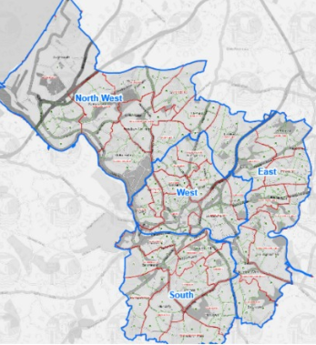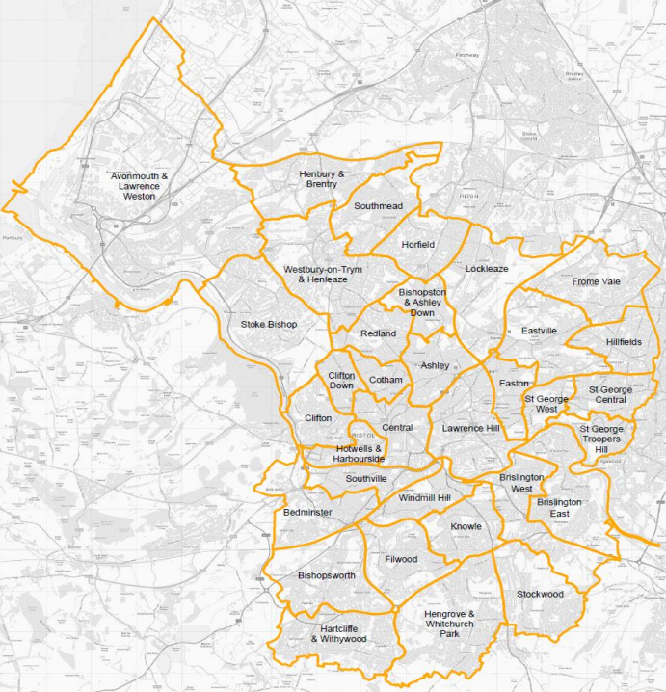
Figure 1 Map of Bristol’s parliamentary constituencies (Bristol East, Bristol North West, Bristol South and Bristol West) and Wards boundaries

Air Quality modelling
Bristol city air quality annual status and air quality plan reports show that some parts of Bristol have been in breach of both the national air quality objective for NO₂ and the World Health Organization (WHO) guideline for PM_{2.5}. Epidemiological evidence shows that heath impacts are still seen at concentration below the limit values and WHO guidelines. Tackling pollutant emission sources is therefore essential to improve air quality to meet both the UK limit values and the WHO guidelines, and ultimately to achieve the lowest possible levels of pollution.

2011 and 2017 concentrations representing current reference years and any future years in 2020, 2025 and up to 2030 have been estimated from the 2017 baseline. A summary of the population-weighted average concentration (PWAC) between 2011 and 2030 in each constituency is shown in Table 1 and Table 2 for anthropogenic PM_{2.5} and NO₂, respectively. Maps of Bristol city total PM_{2.5} and NO₂ annual mean concentration by wards are shown in Figure 2 and Figure 3, respectively. The reader should refer to the Background Maps User guide (https://laqm.defra.gov.uk/review-and-assessment/tools/background-maps.html#about) for information on an estimated breakdown of the relative sources of pollution and on how pollutant concentrations change over time.

Table 1 Anthropogenic PM_{2.5} PWAC (in μg m⁻³) (annual) by constituency
Constituency | 2011 | 2017 | 2020 | 2025 | 2030
Bristol East | 11.76 | 9.59 | 9.17 | 8.74 | 8.71
Bristol North West | 11.53 | 8.76 | 8.35 | 7.92 | 7.88
Bristol South | 11.14 | 8.92 | 8.51 | 8.08 | 8.05
Bristol West | 12.79 | 9.46 | 9.03 | 8.59 | 8.56

Table 2 NO₂ PWAC (in μg m⁻³) (annual) by constituency
Constituency | 2011 | 2017 | 2020 | 2025 | 2030
Bristol East | 20.48 | 16.30 | 14.45 | 11.98 | 10.55
Bristol North West | 21.18 | 14.95 | 13.20 | 10.95 | 9.66
Bristol South | 18.06 | 13.67 | 12.08 | 10.04 | 8.89
Bristol West | 27.21 | 19.69 | 17.43 | 14.43 | 12.74

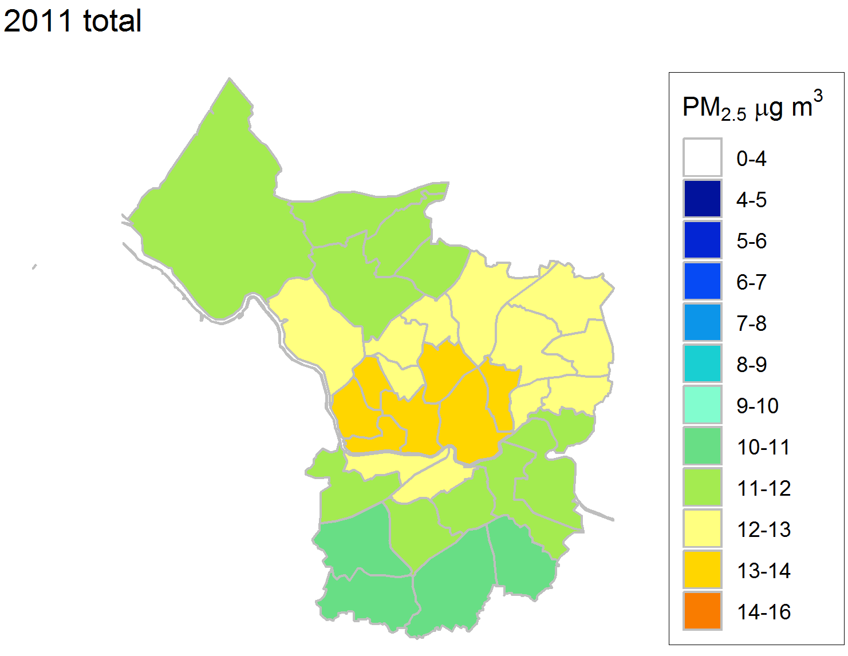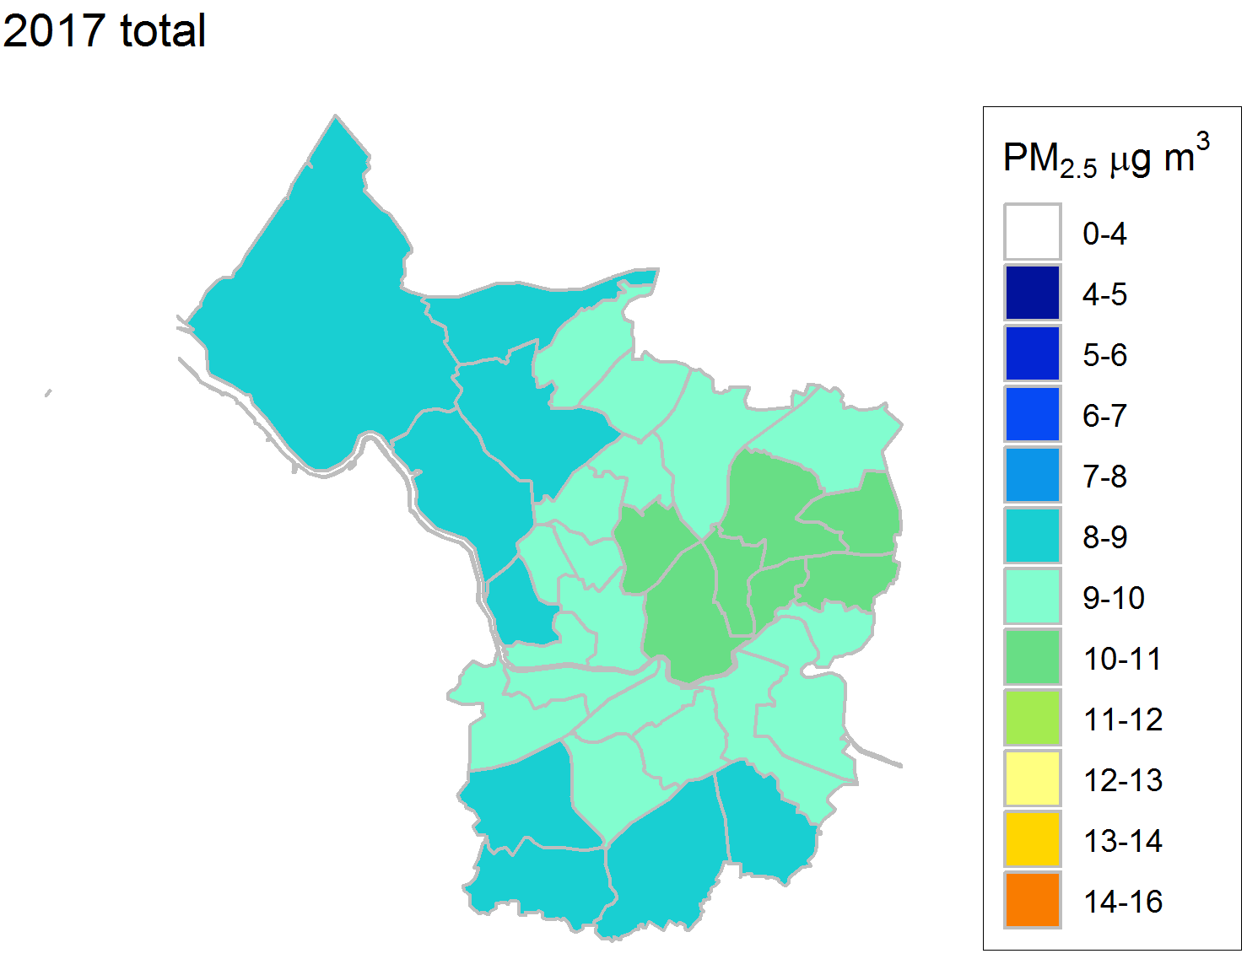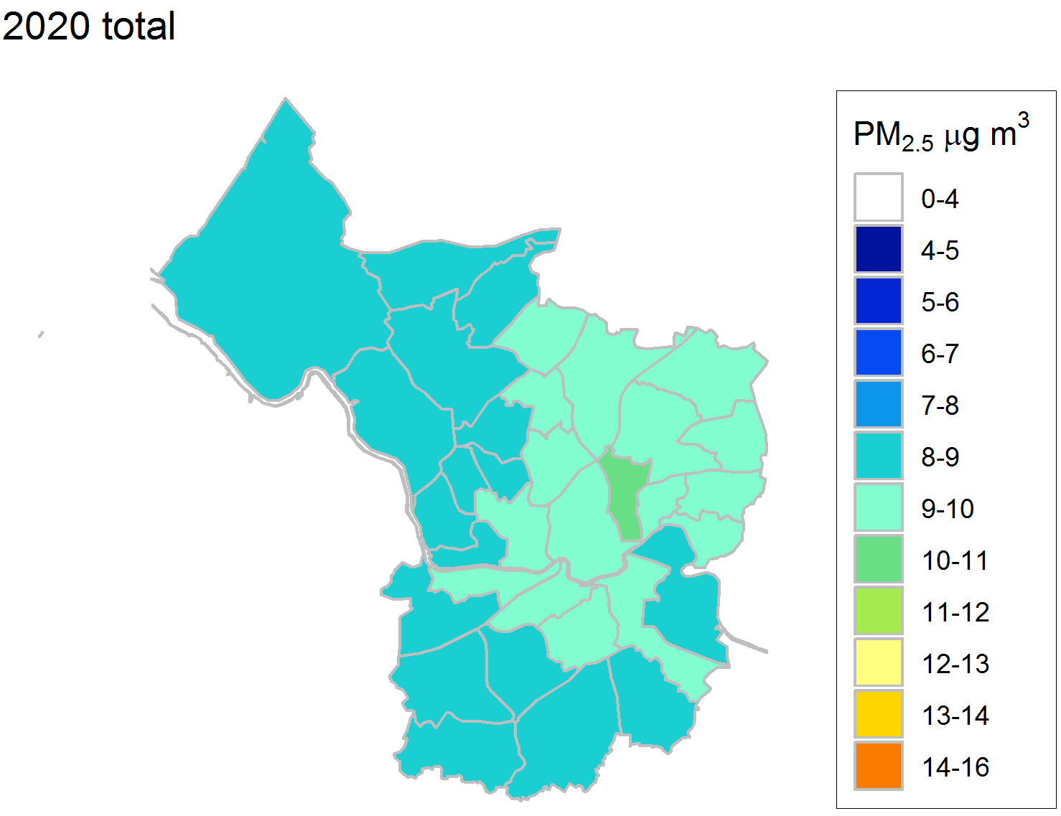
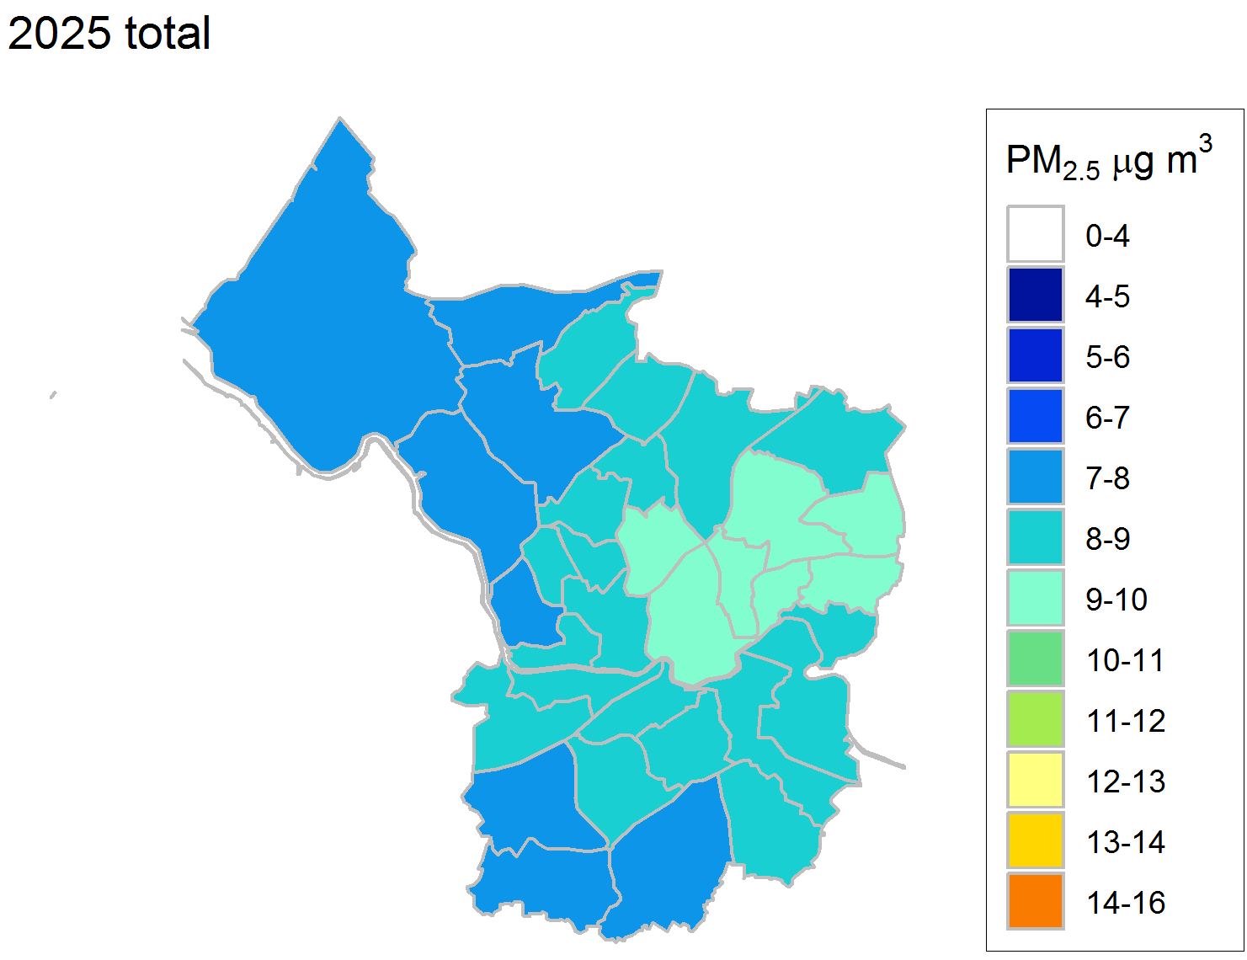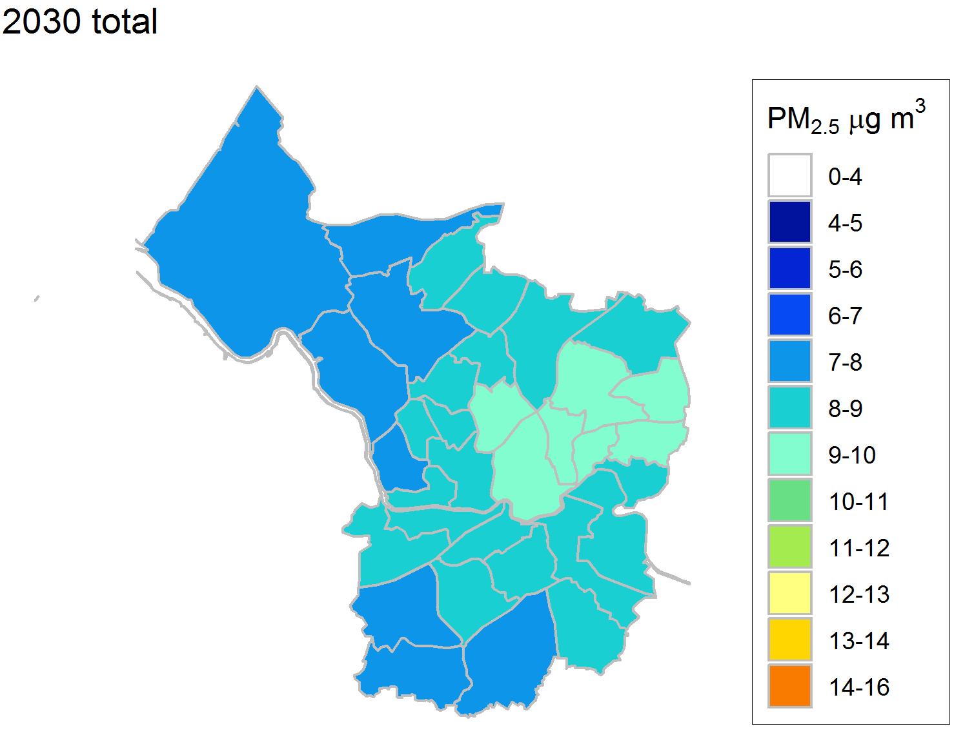
Figure 2 Annual mean PM_{2.5} concentrations (in μg m⁻³) by wards between 2011 and 2030

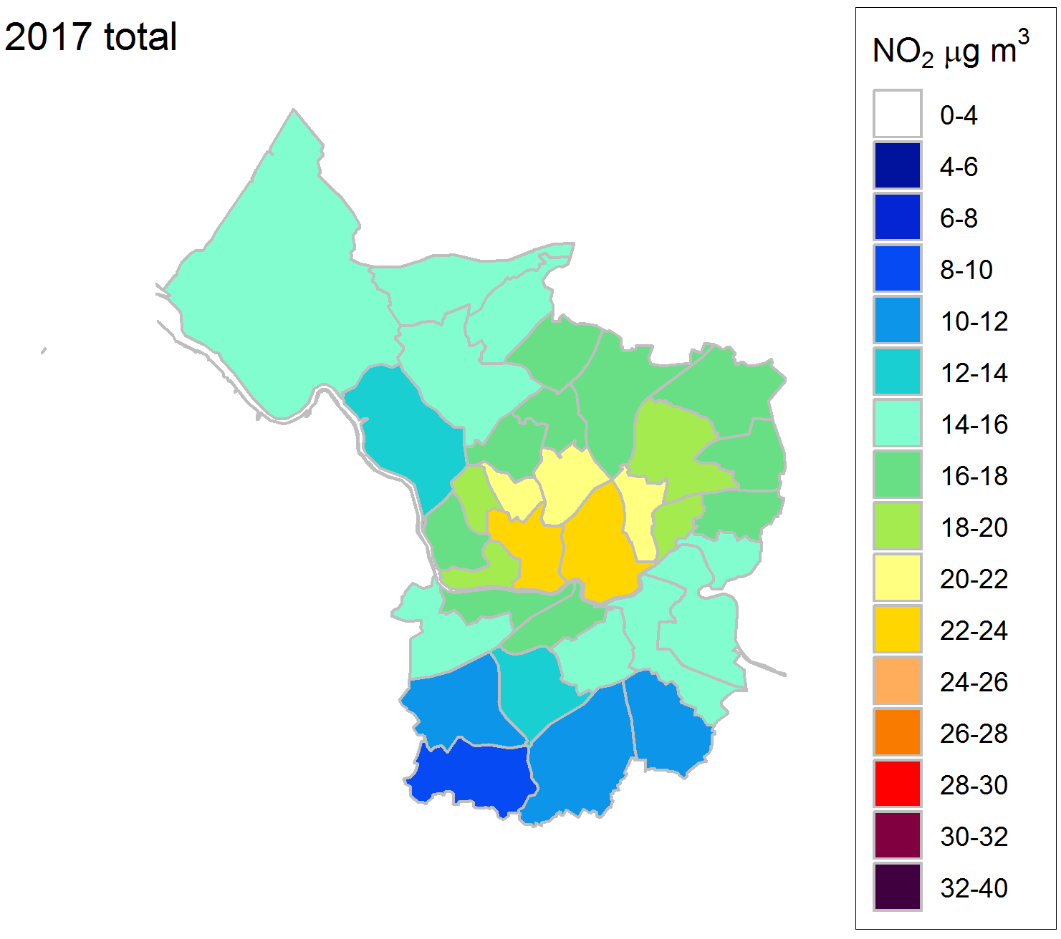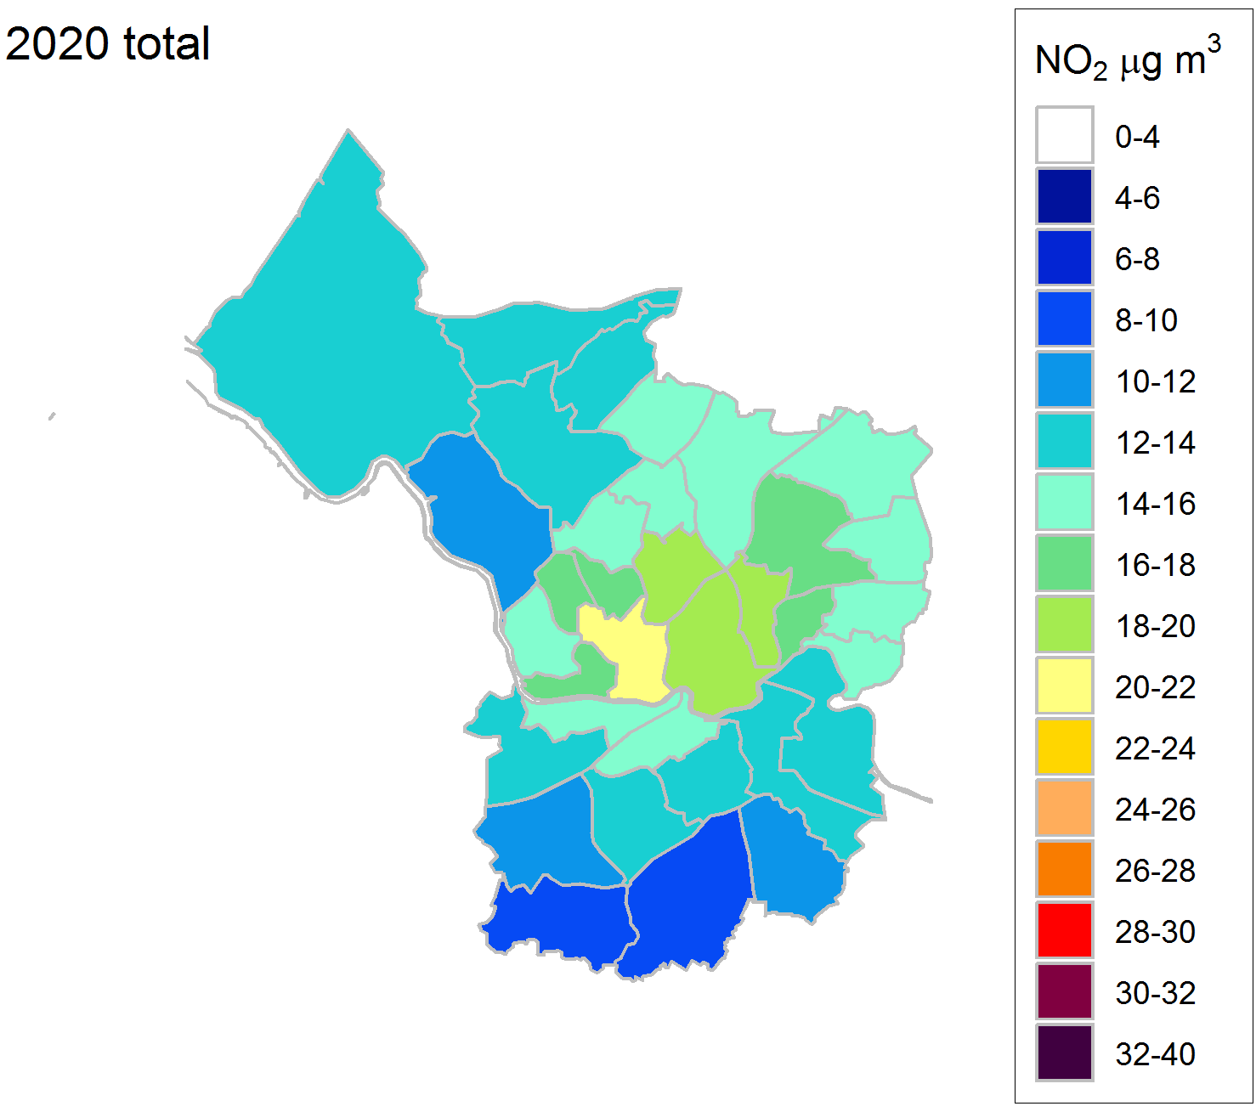
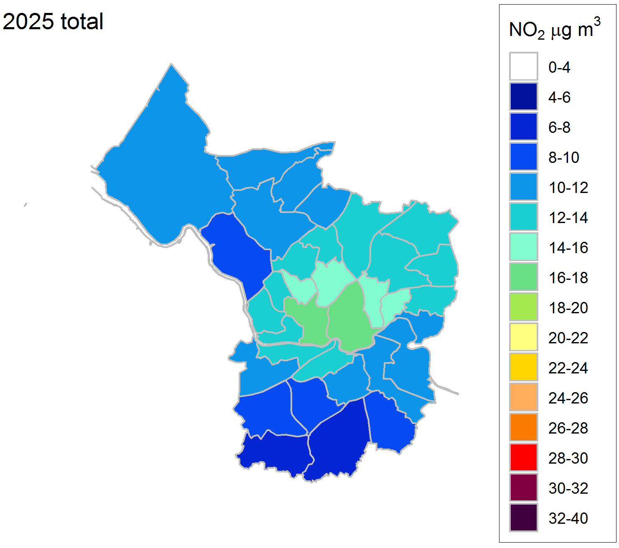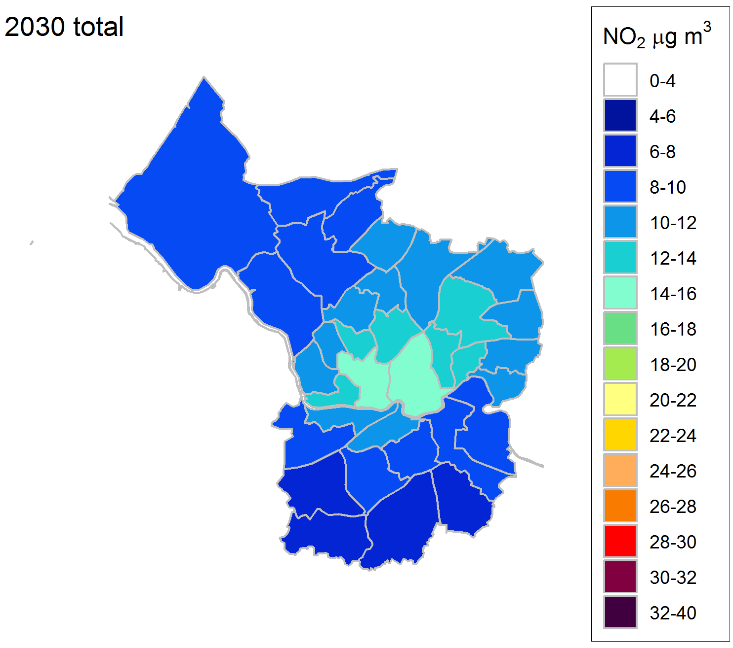
Figure 3 Annual mean NO₂ concentrations (in μg m⁻³) by wards between 2011 and 2030

Health Estimates of the mortality impact of air pollution and its economic valuation

Mortality impact

Impacts in the next section are all expressed in terms of life years – the most appropriate metric for the health impact of air pollution concentration changes over time. This used a full life-table approach rather than the short-cut method used for burden and the data for these calculations had already been incorporated for previous work (Williams et al., 2018a).

Calculations are first given for PM_{2.5} and NO₂ separately. Because air pollutants are correlated with each other, the air pollutant concentrations in the health studies represent both the pollutants themselves but also other air pollutants closely correlated with them. Health impacts from changes in PM_{2.5} and NO₂ represent the health impacts of changes in the air pollution mixture in slightly different ways that overlap i.e. they should not be added. This is discussed further at the end of this section.

The results from the life table calculations assuming that the concentration does not reduce from 2011 levels and assuming the predicted concentration between 2011 and 2030 (concentrations were modelled at 2011, 2017, 2020, 2025 and 2030 but also interpolated for the intervening years) are shown in Table 3, for anthropogenic PM_{2.5} and NO₂. Results for each constituency can be found in the Appendix in Table 16 and Table 20 (life table calculations for anthropogenic PM_{2.5} with and for PM_{2.5} without a cut-off), in Table 17 and Table 21 (life table calculations for NO₂ with and without a cut-off) and Table 18 and Table 19 (central and lower/upper CI estimates of annualised economic impact for anthropogenic PM_{2.5} and NO₂ without a cut-off) and Table 22 (central estimates of annualised economic impact for PM_{2.5} and NO₂ with a cut-off).

The life years lost gives a large number because the life years (one person living for one year) is summed over the whole population in Bristol over 124 years. For context, the total life years lived with baseline mortality rates is around 80 million, so these losses of life years involve about 0.5% of total life years lived.

If 2011 concentrations of anthropogenic PM_{2.5} remained unchanged for 124 years, around 180,000 – 420,000 life years would be lost across Bristol’s population over that period. This improves to around 60,000 – 300,000 life years lost with the predicted concentration changes between 2011 and 2030 examined here.

Another way of representing the health impacts if air pollution concentrations remained unchanged (in 2011) compared with the projected future changes (2011 to 2030) is provided by the results for NO₂. If 2011 concentrations of NO₂ remained unchanged for 124 years, around 230,000 – 300,000 life years would be lost across Bristol’s population over that period. This improves to around 90,000 – 150,000 life years lost with the predicted concentration changes between 2011 and 2030 examined here.

Summarising these results is not easy. The results should not be added as there is considerable overlap. On the other hand, either result is an underestimate to some extent as it is missing the impacts that are better picked up in the calculations using the other pollutant. COMEAP (2017, 2018a) suggested taking the larger of the two alternatives in the calculation of benefits. We have interpreted this as the larger of the two alternatives in the case of each calculation. Note that this means that the indicator pollutant changes in different circumstances. In the case above, for no cut-off, this is the result for PM_{2.5} (300,000 vs 150,000 life years lost for NO₂). However, for the cut-off, this is the result for NO₂ (90,000 vs 60,000 life years lost for PM_{2.5}). Other interpretations e.g. keeping the same indicator pollutant with and without a cut-off, are possible. All the relevant data are in the tables to enable creation of summaries in a different form.
So, the overall summary for the projected future changes in air pollution concentrations from 2011 to 2030 would be around 90,000 to 300,000 life years lost for the population of Bristol over 124 years.

Table 3 Total life years lost across Bristol City population for anthropogenic PM_{2.5} and NO₂ and the associated annualised economic impact (central estimate)
Pollutant | Scenario | Life years lost  Central estimate (without cut-off  with cut-off) | Annualised economic impact (in 2014 prices)  (without cut-off  with cut-off)
Anthropogenic PM_{2.5} (representing the regional air pollution mixture and some of the local mixture) | Concentration does not reduce from 2011 levels | 415,747  180,004 | £234,138,912  £101,281,417
 | Predicted concentration between 2011 and 2030 | 297,060  57,453 | £168,836,821  £33,905,354
NO₂ (representing the local mixture and the rural air pollution mixture) | Concentration does not reduce from 2011 levels | 301,524  233,226 | £169,619,895  £131,132,464
 | Predicted concentration between 2011 and 2030 | 154,011  85,184 | £89,318,091  £50,552,040
For anthropogenic PM_{2.5} assuming no net migration, with projected new births, 2011-2134, compared with life years lived with baseline mortality rates (incorporating mortality improvements over time) with a relative risk (RR) of 1.06 per 10 μg m⁻³ of anthropogenic PM_{2.5} without cut-off and with 7 μg m⁻³ cut-off, with lags from the USEPA.
For NO₂ assuming no net migration, with projected new births, 2011-2134, compared with life years lived with baseline mortality rates (incorporating mortality improvements over time) with a relative risk (RR) of 1.023 per 10 μg m⁻³ of NO₂ without cut-off and with 5 μg m⁻³ cut-off, with lags from the USEPA.
(Results with cut-offs do not extrapolate beyond the original data, results with no cut-off represent the possibility that there are effects below the cut-off value (it is unknown whether or not this is the case).)
Figures in bold are the larger of the alternative estimates using PM_{2.5} or NO₂, as summarised in the headline results. Note that the comparison for which is largest for the predicted concentration changes is across the results either without a cut-off (first row in each cell; 297,060 vs 154,011) or with a cut-off (second row in each cell; 85,184 vs 57,453) using Life year lost of predicted concentration between 2011 and 2030 results as an example.

Table 3 also gives the economic impacts (economic costs). Note that these are derived from applying monetary valuation to the health impacts. The monetary values are derived from surveys of what people are willing to pay to avoid the risk of the relevant health impact. They do not represent the costs of the policies or the costs to the NHS.

If 2011 concentrations of anthropogenic PM_{2.5} remained unchanged for 124 years, the annualised economic cost would be around £100 – 230 million. This improves to around £30 – 170 million with the projected baseline concentration changes examined here.

If 2011 concentrations of NO₂ remained unchanged for 124 years, the annualised economic cost would be around £130 – 170 million. This improves to around £50 – 90 million with the predicted concentration between 2011 and 2030 changes examined here.

The overall summary for the projected baseline would be annualised economic costs of around £50 to 170 million.

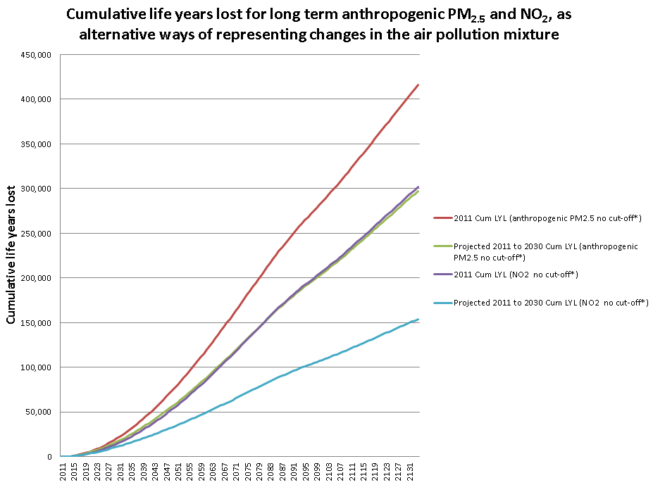
Figure 4 Cumulative life years lost for anthropogenic PM_{2.5} and NO₂ if 2011 concentrations remained unchanged and the baseline (current policies 2011-2030) across Bristol population (no migration), with projected new births, compared with life years lived with baseline mortality rates (incorporating mortality improvements over time) 2011-2134. RR 1.06 per 10 μg m⁻³ for anthropogenic PM_{2.5} and RR 1.023 per 10 μg m⁻³ for NO₂, EPA lag
* Cut-off results not shown

Figure 4 shows that the cumulative life years lost for the predicted concentration between 2011 and 2030 accumulates more slowly than the constant 2011 concentration results for both anthropogenic PM_{2.5} and NO₂ as a result of the reduced concentrations from 2011 to 2030. It is worth remembering that there is a delay before the full benefits of concentration reductions are achieved. This is not just due to a lag between exposure and effect, but also because the greatest gains occur when mortality rates are highest i.e. in the elderly.

Table 4 shows the differences between the predicted concentrations between 2011 and 2030 and both particulate levels and NO₂ concentration constant at 2011 levels. Using PM_{2.5} as an indicator of the regional pollution and some of the local pollution mixture gives an estimate of 120,000 life years gained as a result of the predicted concentration between 2011 and 2030. Using NO₂ as an indicator of mostly the local pollution mixture and the rural pollution gives a larger estimate of 150,000 life years gained, although the PM_{2.5} concentration response function (see Table 13) is much stronger than for NO₂ (RR 1.06 per 10 μg m⁻³ for anthropogenic PM_{2.5} and RR 1.023 per 10 μg m⁻³ for NO₂). This makes sense because the concentration projected (2011 to 2030) suggests more continuous declines in NO₂ concentrations (likely to be mostly due to the improvement in NO_{X} emissions of large parts of the road transport sector) than for PM_{2.5}, reflecting the fact that PM reduction from traffic is not larger due to the increasing contribution from non-exhaust emissions and also that the declines in regional PM_{2.5} are relatively small.

Thus, using NO₂ rather than PM_{2.5,} as the indicator of changes in the traffic pollution mixture seems more appropriate for future changes as presented here. This is a different indicator compared with the overall impact in terms of life years lost. Regional pollution is a greater contributor to absolute total concentrations than to future changes so there is also some sense in PM_{2.5} being the indicator in this case.

The overall summary would be that taking into account predicted air pollution concentration changes between 2011 and 2030, the population in Bristol would gain around 150,000 life years over a lifetime.

Table 4 Life years saved (and associated monetised benefits) across Bristol City population of the predicted concentration between 2011 and 2030 compared with 2011 anthropogenic PM_{2.5} concentrations and NO₂ remaining unchanged
Pollutant | Scenario | Total life years saved compared with 2011 concentrations maintained  (without cut-off  with cut-off) | Monetised benefits compared with 2011 concentrations maintained  (without cut-off  with cut-off)
Anthropogenic PM_{2.5} (representing the regional air pollution mixture and some of the local mixture) | Predicted concentration between 2011 and 2030 | 118,687  122,551 | £65,302,091  £67,376,063
NO₂ (representing the local mixture and the rural air pollution mixture) | Predicted concentration between 2011 and 2030 | 147,513  148,042 | £80,301,804  £80,580,424
Figures in bold are the larger of the alternative estimates using PM_{2.5} or NO₂, as summarised in the headline results. Note that the comparison for which is largest for the predicted concentration changes is across the results either without a cut-off (first row in each cell; 147,513 vs 118,687) or with a cut-off (second row in each cell; 148,042 vs 122,551) using total life years saved compared with 2011 concentrations maintained results as an example.

Table 4 also provides an estimate of the economic impact as a result of the improvements in pollution from 2011 to 2030 versus 2011 pollution remaining unchanged. The annualised monetary benefit of anthropogenic PM_{2.5} and NO₂ improvements has been estimated to be up to £80 million (at 2014 prices).

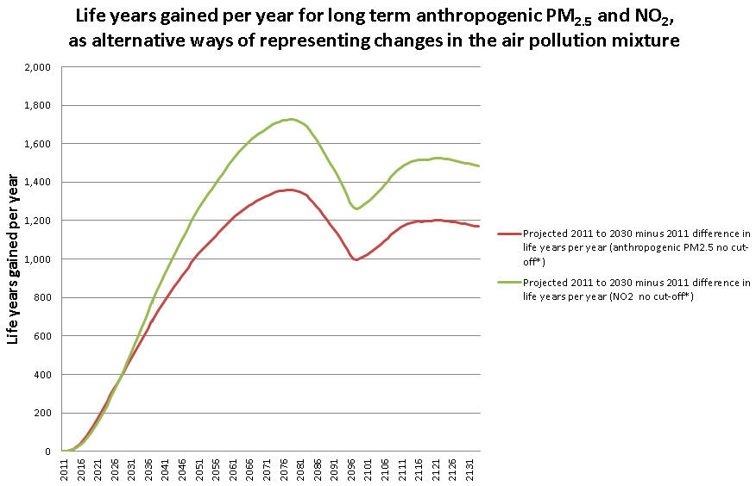
Figure 5 Life years gained per year from long-term exposure to the improvements in pollution from 2011 to 2030 of anthropogenic PM_{2.5} and NO₂ relative to 2011 concentrations remaining unchanged
* Cut-off results not shown

Figure 5 shows the effect of the decrease in PM_{2.5} and NO₂ concentration from 2011 to 2030 (as seen in Table 1 and Table 2).

Life-expectancy from birth in 2011

Total life years across the population is the most appropriate metric for cost-benefit analysis of policies as it captures effects in the entire population. However, it is a difficult type of metric to communicate as it is difficult to judge what is a ‘small’ answer or a ‘large’ answer. Life-expectancy from birth is a more familiar concept for the general public, although it only captures effects on those born on a particular date. Results for life expectancy from birth are shown in Table 5. Results for each constituency can be found in the Appendix in Table 23 and Table 24 (Loss of life expectancy for anthropogenic PM_{2.5} and NO₂ with and without a cut-off).

This shows that the average loss of life expectancy from birth in Bristol would be about 16 – 36 weeks for males and 13 – 31 weeks for females if 2011 PM_{2.5} concentrations were unchanged but improves to 5 – 25 weeks for males and 4 – 22 weeks for females for the predicted concentration changes between 2011 and 2030 (an improvement by about 9-11 weeks).
Using NO₂, the average loss of life expectancy from birth in birth would be about 20 – 26 weeks for males and 17 – 22 weeks for females if NO₂ concentrations were unchanged from 2011 but improves by about 11-14 weeks to 7 – 13 weeks for males and 6 – 11 weeks for females with projected future changes between 2011 and 2030 included.

The overall summary would be that the projected future changes provide an improvement in average life expectancy from birth in 2011 of around 2 – 3 months (9 – 14 weeks) but an average loss of life expectancy from birth in 2011 of around 1.5 to 6 months (6 – 25 weeks) remains even with the reduced concentrations. Males are more affected than females – this is mainly due to the higher mortality rates in men compared with women rather than differences in air pollution exposure. The concentration-response function is implemented as a percentage change in baseline mortality rates. If the baseline mortality rates are higher then the absolute impact is higher even though the percentage change is the same.

Table 5 Loss of life expectancy by gender across Bristol City from birth in 2011 (followed for 105 years) for anthropogenic PM_{2.5} and NO₂
Pollutant | Scenario | Loss of life expectancy from birth compared with baseline mortality rates, 2011 birth cohort (in weeks)  (without cut-off  with cut-off)
 |  | Male | Female
Anthropogenic PM_{2.5} | Concentration does not reduce from 2011 levels | 36.0  15.6 | 30.9  13.4
 | Predicted concentration between 2011 and 2030 | 25.4  4.6 | 21.9  3.9
NO₂ | Concentration does not reduce from 2011 levels | 26.1  20.2 | 22.3  17.2
 | Predicted concentration between 2011 and 2030 | 12.6  6.6 | 10.8  5.6
Figures in bold are the larger of the alternative estimates using PM_{2.5} or NO₂, as summarised in the headline results. Note that the comparison for which is largest for the predicted concentration changes is across the results either without a cut-off (first row in each cell; 25.4 vs 12.6) or with a cut-off (second row in each cell; 6.6 vs 4.6) using Male results as an example.

Additional data such as the loss of life expectancy lower and upper estimate and the full range of confidence intervals with and without the counterfactual for both PM_{2.5} and NO₂ are available upon request to the authors.

Health Estimates of the mortality burden of air pollution

Burden background
Burden calculations are a snapshot of the burden in one year, assuming that concentrations had been the same for many years beforehand. They are intended as a simpler calculation than the more detailed assessments that are given above (in the mortality impact section). They are not suitable for calculation is several successive years as they do not have a mechanism for allowing the number of deaths the year before to influence the age and population size the following year as the lifetables used in impact calculations do. They are included here as a comparison with similar calculations presented elsewhere (COMEAP, 2010; Walton et al., 2015; Dajnak et al., 2018; Dajnak et al., 2019). The concentration-response functions used for these calculations are evolving over time. Previous recommendations favoured methods similar to the single pollutant model approach presented below. The latest COMEAP (2018a) report shows that a majority of the committee supported a new approach using information from multi pollutant model results but COMEAP (2018a) also recommended using a range to reflect the uncertainty. Single pollutant models relate health effects to just one pollutant at a time, although because pollutants tend to vary together, they may in fact represent the effects of more than one pollutant. Single pollutant models for different pollutants cannot therefore be added together as there may be substantial overlap. Multi-pollutant models aim to disentangle the effects of separate pollutants but this is difficult to do. Despite the best attempts, it may still be the case that some of the effect of one pollutant ‘attaches’ to the effects ascribed to another pollutant, leading to an underestimation of the effects of one pollutant and an overestimation of the effects of another. In this situation, the combined effect across the two pollutants should give a more reliable answer than the answers for the individual pollutants that may be over- or under-estimated. This was the basis for the approach described below, including adding results derived from information within each of 4 separate studies first, before combining them as a range. The intention is not to present the individual pollutant results separately as final results, although the calculations for individual pollutants are done as intermediate stages towards the overall results.

[Burden calculations would normally include accompanying estimates of the burden of life years lost. This would require inputting average loss of life expectancy by age and gender for calculations in each ward. For this small project, it was not possible to do this.]

The calculations are based on deaths from all causes including respiratory, lung cancer and cardiovascular deaths, the outcomes for which there is strongest evidence for an effect of air pollution.

Combined estimate for PM_{2.5} and NO₂ using multi pollutant model results
Using the exploratory new combined method (COMEAP, 2018a) gives an estimate for the 2011 mortality burden in Bristol of 2011 levels of air pollution (represented by anthropogenic PM_{2.5} and NO₂) to be equivalent to 200 to 260 attributable deaths at typical ages, or a result equivalent to 130 to 140 deaths when cut-offs for each pollutant were implemented. Estimates for individual constituencies are provided in Table 6. The results varied by constituency with the highest in Bristol North West and the lowest in Bristol West. The ranking by constituency in Table 6 did not follow the ranking in pollutant concentrations (see Table 1 and Table 2). This is because the results are also influenced by variations in death rates by constituency (highest in Bristol North West, lowest in Bristol West), which in turn are driven in part by the proportion of elderly in the population (highest in Bristol North West, lowest in Bristol West) and the level of deprivation (highest in Bristol South, lowest in Bristol North West and Bristol West). Details are given in Table 26 in the Appendix. Note that the level of deprivation by constituency does not represent the complexity and spatial variability within a constituency as can be seen in section 7.1 (Figure 6).

These results use recommendations from COMEAP, 2018a. For each of the four individual cohort studies that included multi-pollutant model results, the burden results were estimated separately using mutually adjusted summary coefficients for PM_{2.5} and NO₂ and then the adjusted PM_{2.5} and NO₂ results were summed to give an estimated burden of the air pollution mixture. Example of the calculations for each study for individual constituency and Bristol of 2011 levels of NO₂ and PM_{2.5} can be found in the appendix in Table 27 and Table 28. The uncertainty of each separate study was not quantified (COMEAP, 2018a) but it is worth noting that each of the individual results also has uncertainty associated with it.

Table 6 Estimated burden (from the estimates derived by using information from multi-pollutant model results from 4 different cohort studies) of effects on annual mortality in 2011 of 2011 levels of anthropogenic PM_{2.5} and NO₂ (with and without cut-off)
Zone | Anthropogenic PM_{2.5} and NO2  (without cut-off) | Anthropogenic PM_{2.5} and NO2  (with cut-off)
 | Attributable deaths (using coefficients derived from information in 4 studies below*) | Attributable deaths (using coefficients derived from information in 4 studies below*)
Bristol East | 47 - 61 | 30 - 32
Bristol North West | 64 - 82 | 41 - 45
Bristol South | 51 - 70 | 31 - 34
Bristol West | 38 - 47 | 27 - 29
Bristol City | 200 - 261 | 129 - 140
*Using COMEAP’s recommended concentration-response coefficient of 1.029, 1.033, 1.053 and 1.019 per 10 μg m⁻³ of anthropogenic PM_{2.5} derived by applying to a single pollutant model summary estimate the % reduction in the coefficient on adjustment for nitrogen dioxide from the Jerrett et al (2013), Fischer et al (2015), Beelen et al (2014) and Crouse et al (2015) studies , respectively
*Using COMEAP’s recommended concentration-response coefficient of 1.019, 1.016, 1.011 and 1.020 per 10 μg m⁻³ of NO₂ derived by applying to a single pollutant model summary estimate the % reduction in the coefficient on adjustment for PM_{2.5} from the Jerrett et al (2013), Fischer et al (2015), Beelen et al (2014) and Crouse et al (2015) studies , respectively

Single pollutant model estimates
The previous mortality burden method using single pollutant model estimates would have estimated that Bristol’s 2011 levels of anthropogenic PM_{2.5} would lead to effects equivalent to 210 (range 140 to 280) attributable deaths at typical ages, or results equivalent to 90 (range 60 to 120) deaths when the cut-off was implemented. Estimates for individual constituencies are provided in Table 7. This represents the regional pollution mixture and partially represents the contribution from traffic pollution.

These results use recommendations from COMEAP, 2010. Walton et al. (2015) used both COMEAP (2010) recommendations and WHO (2013) recommendations that included recommendations for nitrogen dioxide to provide estimates for London. The results were presented as a range from PM_{2.5} alone to the sum of the PM_{2.5} and NO₂ results, but the uncertainty of the latter was emphasized. Since then it has become clearer that the overlap is likely to be substantial (COMEAP, 2015). COMEAP (2018a) concluded that the combined adjusted coefficients were similar to, or slightly larger than, the single-pollutant association reported with either pollutant alone.

The lower and upper estimates in Table 7 are based on the 95% confidence intervals (1.04 – 1.08) around the pooled summary estimate (1.06) for the increase in risk from Hoek et al (2013). COMEAP recently agreed to use this range (COMEAP, 2018b) rather than the wider ones of 1.01 – 1.12 in the original COMEAP (2010) report. Nonetheless, the wider ones remain reflective of the fact that the uncertainties are wider than just the statistical uncertainty represented by the confidence intervals. We have included results for this wider range of uncertainty in Table 25 of the Appendix but as a rough guide the range goes from around a sixth to around double the central estimate in Table 7.

Table 7 Estimated burden (from single-pollutant model summary estimate) of effects on annual mortality in 2011 of 2011 levels of anthropogenic PM_{2.5} (with and without cut-off)
Zone | Anthropogenic PM_{2.5}  (without cut-off) |  |  | Anthropogenic PM_{2.5}  (with cut-off)
 | Attributable deaths |  |  | Attributable deaths
 | Central estimate | Lower estimate | Upper estimate | Central estimate | Lower estimate | Upper estimate
Bristol East | 50 | 34 | 65 | 22 | 15 | 28
Bristol North West | 66 | 45 | 87 | 28 | 19 | 37
Bristol South | 59 | 40 | 77 | 23 | 16 | 31
Bristol West | 36 | 25 | 47 | 17 | 12 | 23
Bristol City | 211 | 144 | 276 | 90 | 61 | 119
Using COMEAP’s recommended concentration-response coefficient of 1.06 per 10 μg m⁻³ of anthropogenic PM_{2.5} for the central estimate (lower estimate RR of 1.04 and upper estimate RR 1.08)

In addition to the combined multi-pollutant model derived estimates in the section above, the COMEAP (2018a) report suggests also calculating the burden using the single pollutant model result for NO₂ (this may represent the burden of traffic pollution more clearly than that of PM_{2.5}). The results give estimates that Bristol’s 2011 levels of NO₂ lead to effects equivalent to 150 (range 50 to 240) attributable deaths at typical ages, or results equivalent to 110 (range 40 to 180) deaths when the cut-off was implemented. Estimates for individual constituencies are provided in Table 8.

Table 8 Estimated burden (from single pollutant model summary estimate) of effects on annual mortality in 2011 of 2011 levels of NO₂ (with and without cut-off)
Zone | NO₂ (without cut-off) |  |  | NO₂ (with cut-off)
 | Attributable deaths |  |  | Attributable deaths
 | Central estimate | Lower estimate | Upper estimate | Central estimate | Lower estimate | Upper estimate
Bristol East | 34 | 12 | 54 | 26 | 9 | 41
Bristol North West | 48 | 17 | 76 | 37 | 13 | 58
Bristol South | 37 | 13 | 58 | 27 | 9 | 42
Bristol West | 30 | 11 | 47 | 25 | 9 | 39
Bristol City | 149 | 53 | 235 | 114 | 40 | 180
Using COMEAP’s recommended concentration-response coefficient of 1.023 per 10 μg m⁻³ of NO₂ for the central estimate (lower estimate RR of 1.008 and upper estimate RR 1.037)

Summary of burden results
Results without the cut-off give a range of 200-260 attributable deaths using the approach derived from multi-pollutant model results. This compares with around 210 attributable deaths using the single-pollutant model estimate for PM_{2.5} (the previous method) and around 150 attributable deaths using the single-pollutant model estimate for NO₂ (a good indicator of traffic pollution). As expected, the estimate combining effects of NO₂ and PM_{2.5} is slightly larger than for either pollutant alone but not by much, reflecting the substantial overlap between the single pollutant model estimates for PM_{2.5} and NO₂. Nonetheless, there are substantial ranges of uncertainty around these estimates so it is not clear cut that there is an additional effect over and above estimates using the previous method.

The message from the results with a cut-off is similar with a range of 130-140 attributable deaths using the approach derived from multi-pollutant model results compared with 90 (PM_{2.5} single-pollutant model) and 110 (NO₂ single-pollutant model). In this case, the result for NO₂ is larger than that for PM_{2.5} - probably a reflection of the different cut-offs for NO₂ and PM_{2.5}.

In developing policy in the face of uncertainty, it is useful to have guidance on the result using the most conservative assumptions and that using approaches using recent trends in evidence and methods that may also be more uncertain. In this case, the ‘conservative assumptions’ result would be 90 attributable deaths (long-established method for PM_{2.5}, avoids the complexities of interpreting multi-pollutant model results) and the ‘exploratory, more up to date, extrapolate beyond the data’ results would be 200-260 attributable deaths (combined NO₂ and PM_{2.5}; no cut-off). For messages incorporating most of the uncertainties, the message would be ‘somewhere between about 50 and 260 attributable deaths’.

Discussion
This study addressed the effect of air pollution on deaths and loss of life-expectancy. This included all causes of death grouped together so covers, for example, respiratory, lung cancer and cardiovascular deaths for which there is good evidence for an effect of air pollution. It does not, however, cover the effect of air pollution on health where this does not result in death. So well established effects (such as respiratory and cardiovascular hospital admissions, effects on asthma, low birth weight etc) and other outcomes more recently potentially linked with air pollution (such as dementia) are not included. Their inclusion would increase the benefit of policies to further reduce air pollution.

Impact of Air Pollution on inequalities, ethnic groups, population change, migration and students within Bristol
The HIA results’ variation and ranking by constituency did not follow the ranking in pollutant concentrations. As already discussed in section 6.2, this is because the results are also influenced by variations in death rates, the proportion of elderly in the population and the level of deprivation by constituency as seen in Table 26 in the Appendix.
Individuals of lower social classes may experience increased susceptibility to the negative air pollution-related health effects particularly in urban areas, where they are possibly more affected than individuals of higher social class (discussed in Williams et al., 2018b). As a result, higher levels of pollution exposure and socioeconomic deprivation may lead to impaired health.

Some indicators in Table 9 such as income and employment show that Bristol have more income- and employment-deprived people than some English core cities like Newcastle and Nottingham. But overall, Bristol continues to be one of the relatively less deprived English cities according to most measures in Table 9 such as indices of multiple deprivation (IMD) or proportion of LSOAs (Lower Layer Super Output Area) in the most deprived 10% nationally. Nonetheless, Bristol has deprivation ‘hot spots’ that are amongst some of the most deprived in the country as identified in Figure 6.

On the whole, the Bristol map of multiple deprivation (Figure 6) alongside PM_{2.5} and NO₂ air pollution maps (Figure 2 and Figure 3) does not particularly show environmental inequality (in which socioeconomically disadvantaged populations are among the most exposed). An exception is the area of Lawrence Hill (see wards boundaries in Figure 1) identified as having both some of the highest levels of deprivation and air pollution in Bristol. Furthermore, areas (LSOAs) around and within Lawrence Hill have the highest Black and Minority Ethnic (BME) population in strong contrast with the rest of in Bristol (Figure 7).

Bristol’s maps of (i) population change between 2007 and 2017 (Figure 8), (ii) new migrants arriving in UK since 2001 (Figure 9) and (iii) full time students living in Bristol during term time (Figure 10) show that the areas of (i) exceptional population growth (70% population change in Central, 55% in Hotwells & Harbourside and 39% in Lawrence Hill wards), (ii) the areas where most recent migrants tend to live (in inner city areas of Bristol in particular in Central and Lawrence Hill wards and some part of Hotwells & Harboursidse) and (iii) the areas where most students live during term time (including Central, Cotham, Clifton Down, Hotwells and Harbourside and Clifton wards) are concentrated in zones of the city linked to the highest concentrations of PM_{2.5} and NO₂ air pollution as can be seen in Figure 2 and Figure 3 maps.

In recognition of the World Health Organization’s advocacy that there is no safe limit for exposure to air pollution, all Bristol citizens would benefit greatly from a reduction in air pollution concentrations, ultimately to achieve the lowest possible levels of pollution.

Table 9 English Core City Local Authority level Summaries including Indices of Multiple Deprivation (IMD) 2015: Local Authority Rankings
(1 = most deprived and 326 is least deprived of the English local authority areas)
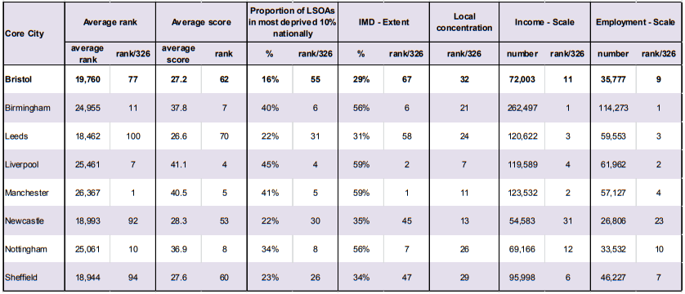

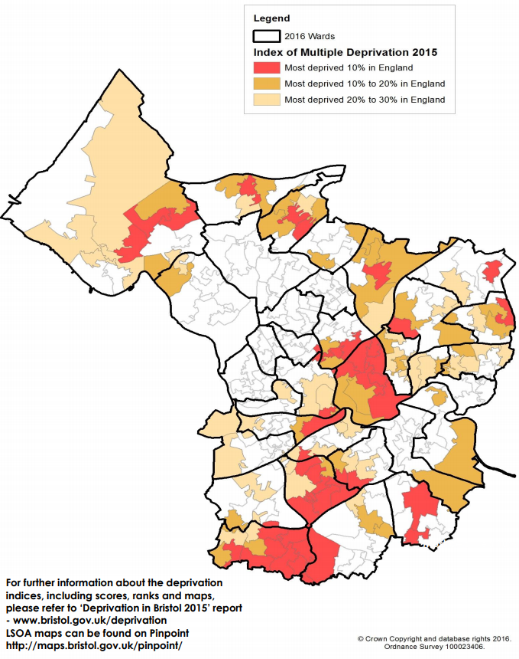
Figure 6 Map of Index of Multiple Deprivation 2015 in Bristol
Source: DCLG English Indices of Deprivation 2015
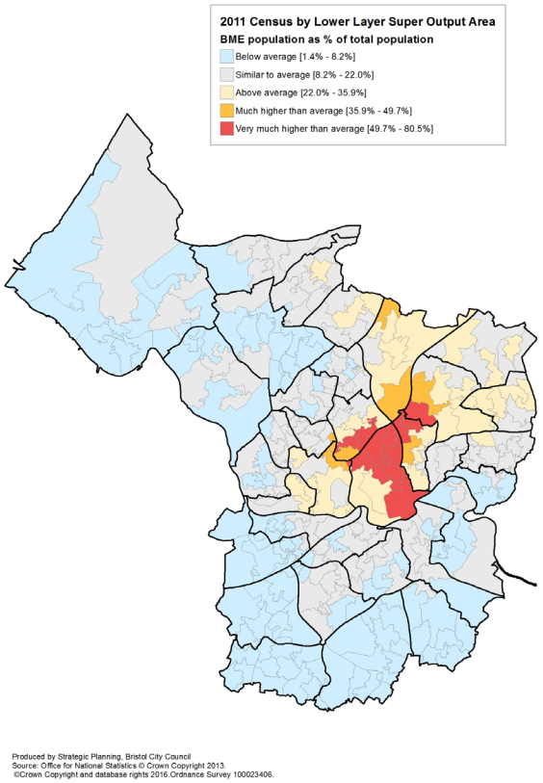
Figure 7 Map of 2011 Black and Minority Ethnic (BME) population as % of total population by LSOA (Lower Layer Super Output Area) in Bristol
Source: 2011 Census Office for National Statistics © Crown Copyright 2013 [from Nomis]

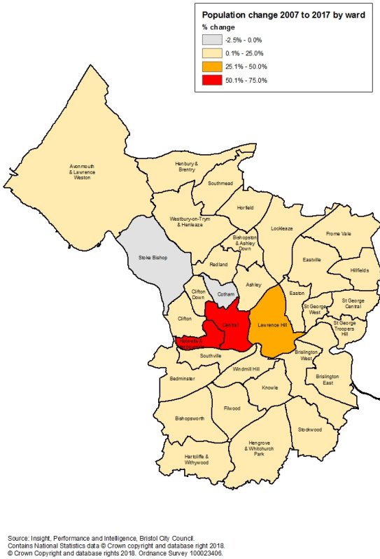
Figure 8 Map of population change between 2007 and 2017 by wards in Bristol
Source: Annual Small Area Population Estimates, Office for National Statistics © Crown Copyright 2018
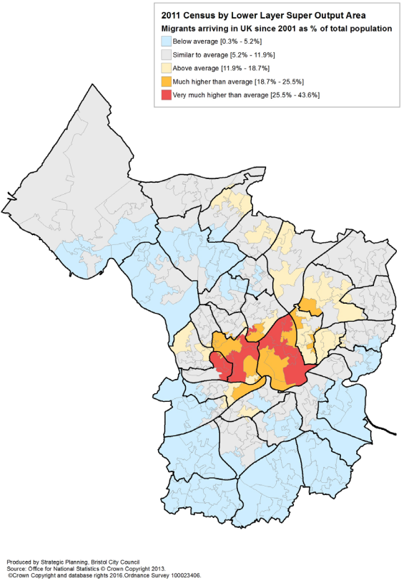
Figure 9 Map of new migrants arriving in UK since 2001 as % of total population (2011 census by LSOA)
Source: 2011 Census Office for National Statistics © Crown Copyright 2013 [from Nomis]
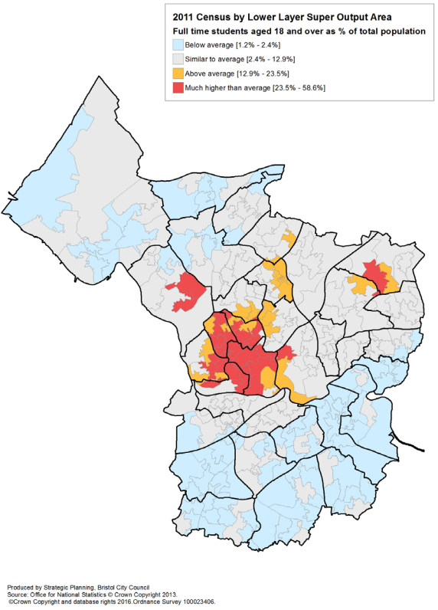
Figure 10 Map of full time students aged 18 and over living in Bristol during term time as % of total population (2011 census by LSOA)
Source: 2011 Census Office for National Statistics © Crown Copyright 2013 [from Nomis]

Comparison with results for Greater Manchester (GM), Birmingham City, Liverpool City Region (LCR) and London
The current authors performed a similar analysis for Greater Manchester (Dajnak et al., 2018), for Birmingham (Dajnak et al., 2019) and more recently for Liverpool City Region (in press). This analysis was similar to the one for Greater Manchester, Birmingham City and Liverpool City Region for the impact calculations although the Greater Manchester report predated the multi-pollutant model aspects of the new burden methodology published in COMEAP (2018). Even with the same methodology, comparisons for the impact calculations are complex because the results are driven by multiple factors changing over time (not only the pollutant concentrations but also the mortality rates, new births and the changes in population age distribution and size as a result of the pollutant changes). Nonetheless, some approximate comparisons can be made.

Life years lost still remaining after pollution improvements: The largest result in Bristol, Greater Manchester, Liverpool City Region and Birmingham City was for PM_{2.5} with no cut-off. The result was lowest for Bristol (0.3 million life years lost) when compared with Greater Manchester (1.6 million life years lost) and, Liverpool City Region and Birmingham city (both 0.8 million life years lost). The primary driver of this difference is probably the difference in population – Bristol is the largest city in the South West of England but is a smaller area (Table 12) and has the smallest population (<0.5 million) when compared with the population for Greater Manchester (2.7 million), Liverpool City Region (1.5 million) and Birmingham city at 1 million. Furthermore, the Bristol death rate (Table 12) is also the lowest between the four cities/region of interest (in these studies) which will result in lower life years lost relative to Greater Manchester, LVR and Birmingham city.
The equivalent result for NO₂ with no cut-off is 150,000 life years lost in Bristol, again the lowest of the four cities/region of interest with the explanations being similar, 1 million life years lost in Greater Manchester and 0.5 million life years lost in both Liverpool City Region and Birmingham city.
In addition, Bristol has lower NO₂ concentrations than GM and Birmingham and lower PM_{2.5} concentrations than Birmingham (Table 11), further explaining the lower results in comparison with these cities. On the other hand, Bristol does have higher NO₂ concentrations than LCR and higher PM_{2.5} concentrations than LCR and GM but not to a sufficient extent to counteract the influence of its lower population and death rate i.e. the results are still lower overall despite the higher pollution concentrations in some cases.

The comparison of the results with a cut-off give different messages for NO₂ and PM_{2.5}. The comparison for NO₂ with a cut-off is similar to the no cut-off results (the result for Bristol is the lowest with 85,000 life years lost while Liverpool City Region and Birmingham, circa 300,000 life years lost, and Manchester, 560,000 life years lost). For PM_{2.5}, however, while the result for Bristol (60,000 life years lost) was substantially smaller than for Birmingham City (210,000 life years lost) (as expected from the smaller population) this was not as obvious for the comparisons against the other cities. The result for Bristol is similar to that for the Liverpool City Region (both around 60,000 life years lost), and smaller than Greater Manchester (175,000 life years lost) but by a smaller margin than expected for the difference in population. This is because the PM_{2.5} concentrations in the LCR and GM are much lower in some areas than the 7 μg m⁻³ cut-off. It is therefore assumed that the particulate pollution has no effect on life-years lost in those areas, reducing the total overall. (Strictly, the definition of a cut-off means it is unknown whether or not there are effects. In addition, this cut-off is based on Pope et al (2002) which in turn used particulate concentrations from many years earlier. As concentrations reduce and newer studies are completed, it is often found that the health effects at lower concentrations become clearer as there are more data points available for analysis at these lower concentrations.)

Table 10 Total life years lost across Bristol, the Liverpool City Region, Birmingham City and Greater Manchester population for anthropogenic PM_{2.5} and NO₂ and the associated annualised economic impact (central estimate)
Pollutant | Scenario | Location | Life years lost  Central estimate (without cut-off  with cut-off) | Annualised economic impact (in 2014 prices)  (without cut-off  with cut-off)
Anthropogenic PM_{2.5} | Predicted concentration between 2011 and 2030 | Bristol | 297,060  57,453 | £168,836,821  £33,905,354
 |  | Liverpool City Region | 798,521  61,107 | £477,603,949  £40,773,443
 |  | Birmingham City | 831,708  213,344 | £467,766,599  £121,993,163
 |  | Greater Manchester | 1,638,043  175,471 | £954,495,447  £109,582,547
NO₂ | Predicted concentration between 2011 and 2030 | Bristol | 154,011  85,184 | £89,318,091  £50,552,040
 |  | Liverpool City Region | 493,408  272,258 | £300,081,973  £169,191,136
 |  | Birmingham City | 505,434  328,491 | £289,339,663  £190,370,755
 |  | Greater Manchester | 981,519  561,169 | £586,562,264  £343,719,554

Table 11 Anthropogenic PM_{2.5} PWAC (in μg m⁻³) (annual) and NO₂ PWAC (in μg m⁻³) (annual) for Bristol, Liverpool City Region (LCR), Birmingham City and Greater Manchester (GM)
Pollutant | Location | 2011 | 2015 for Birmingham/GM  2017 for Bristol/LCR | 2020 | 2025 | 2030
Anthropogenic PM_{2.5} PWAC* | Bristol | 11.81 | 9.18 | 8.77 | 8.33 | 8.30
 | Liverpool City Region | 10.39 | 7.52 | 7.21 | 6.93 | 6.89
 | Birmingham City | 12.82 | 9.81 | 9.21 | 9.02 | 8.99
 | Greater Manchester | 11.39 | 8.09 | 7.62 | 7.47 | 7.44
NO₂ PWAC* | Bristol | 21.73 | 16.15 | 14.29 | 11.85 | 10.46
 | Liverpool City Region | 18.97 | 15.11 | 13.38 | 11.31 | 10.22
 | Birmingham City | 26.12 | 21.33 | 17.68 | 14.75 | 13.14
 | Greater Manchester | 22.39 | 18.78 | 14.94 | 12.08 | 10.65
*For Bristol: average of the PWAC by constituency from Table 1 and Table 2, above (see Dajnak et al., 2019 for Birmingham City). For Greater Manchester (Dajnak et al., 2018) and Liverpool City Region (in press), average of the PWAC by local authority from Table 1 and Table 2.

Table 12 Total population in 2011 and mortality rate (total death age 30 plus divided by total population age 30 plus) in Bristol, Liverpool City Region, Birmingham City and Greater Manchester
Location | Total population | Mortality rate  (age group 30 plus)
Bristol | 428,254 | 1.28%
Liverpool City Region | 1,507,032 | 1.49%
Birmingham City | 1,073,188 | 1.33%
Greater Manchester | 2,682,727 | 1.36%

Loss of life expectancy still remaining after pollution improvements: The influence of the difference in pollution concentrations and death rate between Bristol, Liverpool City Region, Birmingham City and Greater Manchester can be seen more clearly in the results for loss of life expectancy from birth. This is because it comes from the total life years lost in those exposed for a lifetime divided by the size of that population. So, the difference in population has already been taken into account. The loss of life expectancy using PM_{2.5} as an indicator without a cut-off was 22/25 weeks (Female/Male) in Bristol, 19/22 weeks (Female/Male) in Liverpool City Region, 21/24 weeks (Female/Male) in Greater Manchester and 25/29 weeks (F/M) in Birmingham City, similar to but not exactly following the PM_{2.5} concentrations ranking order (Table 11). The comparison was similarly close for life expectancy using NO₂ without a cut-off as an indicator (11 – 13 weeks (Bristol) compared with 12 – 13 weeks (LCR), 12 – 14 weeks (GM) and 15-17 weeks in Birmingham). As with the previous discussions of total life years lost, the difference between Bristol, Liverpool City Region, Greater Manchester and Birmingham City is more marked for PM_{2.5} with a cut-off than for NO₂ with a cut-off because the cut-off of 7 µg m⁻³ is closer to the general PM_{2.5} concentrations.

Gains in life years from pollution improvements: Similar factors influence the comparative results for life years gained between the four cities, driven mainly by the population size, the pollution levels and by the NO₂ and PM_{2.5} reductions in all four cities (Table 11), which also influence the answer. For example, the gains from PM_{2.5} and NO₂ reductions in Bristol are a bit less than half and a third those in LCR, respectively.

Mortality burden: The mortality burden in Bristol (200-260 and 210 attributable deaths from multi-pollutant and single-pollutant model results, respectively) is smaller than for the Liverpool City Region (800-1,040 and 840 attributable deaths from multi-pollutant and single-pollutant models, respectively), Birmingham City (570-709 and 554 attributable deaths from multi-pollutant and single-pollutant models, respectively) and Greater Manchester (1,459 attributable deaths from the single-pollutant model ) and can be explained by the population, death rate (Table 12) and pollution level differences as above.

In all the cases discussed above, other factors may also be having an influence (see discussion of differences across constituencies in section 6.2).

Comparisons are more difficult with an earlier report in London (Walton et al 2015) as the methodology has changed to a greater extent and the time periods of the pollution changes are also different. The mortality burden result for the single pollutant model for PM_{2.5} was 3,537 deaths at typical ages for 2010 compared with 210 attributable deaths for Bristol for 2011. Again, this difference is primarily driven by the larger population in London (8 million vs 0.5 million, London vs Bristol respectively).

In summary, this report shows the gains in life years from the projected pollution improvements but also that adverse health impacts will still remain. There is still justification for further pollution improvements beyond those already made, ultimately to achieve the lowest possible levels of pollution which would benefit all Bristol citizens greatly.

Ozone
This report does not consider ozone but some general comments can be made. The study from Williams et al. (2018a and 2018b) shows that ozone concentrations in 2035 and 2050 are projected to increase in winter because the removal of ozone by reaction with NO occurs to a lesser extent due to reductions in NOx emissions. So-called summer smog ozone concentrations are projected to decrease because of the reductions in emissions of ozone precursors. The Williams (2018a and 2018b) study found that the long-term ozone exposure metric recommended by WHO (2013) is projected to decrease over time compared with 2011. This outcome is a relatively small change compared with that for the other pollutants, due to the WHO threshold of 35 parts per billion and the effect being on respiratory mortality, not all cause mortality. Williams et al. (2018a and 2018b) also warned that the increased proportion of ozone in the mixture of oxidant gases, including NO₂, is potentially of some concern because ozone has a higher redox potential than does NO₂, and so could possibly increase the hazard from oxidative stress, although it is too early to be confident about this theory.

Appendix

Additional tables- method

Additional data such as the annualised economic impact and the loss of life expectancy lower and upper estimate and the full range of confidence interval with and without counterfactual for both PM_{2.5} and NO₂ are available upon request to the authors.

Table 13 Concentration-response functions (CRFs) for long-term exposures and mortality (for impact calculations of general changes in pollutant concentrations (rather than policies targeting one pollutant alone) and for the single-pollutant model aspect of burden calculations).
Pollutant | Averaging time | Hazard ratio per 10 μg m⁻³ | Confidence interval | Counterfactual | Comment/Source
PM_{2.5} | Annual average | 1.06 | 1.04-1.08  1.01-1.12* | Zero  Or 7 μg m⁻³ | Age 30+, Anthropogenic PM_{2.5} (Hazard ratio COMEAP (2010) and COMEAP (2018))  Age 30+, total PM_{2.5} (cut-off reference COMEAP (2010))
NO₂ | Annual average | 1.023 | 1.008 – 1.037 | Zero  or 5 μg m⁻³ | Age 30+ (Hazard ratio COMEAP (2017), cutoff COMEAP (2018)
*This wider uncertainty is only used as an addition for the single-pollutant model aspect of burden calculations

Table 14 Concentration-response functions (CRFs) for long-term exposures and mortality burden from the four multi-pollutant model cohort studies including multi-pollutant model estimates
Pollutant | Averaging time | Hazard ratio  per 10 μg m⁻³ | Counterfactual | Comment/Source
PM_{2.5} | Annual average | 1.029 (Jerrett)  1.033 (Fischer)  1.053 (Beelen)  1.019 (Crouse) | Zero  Or 7 μg m⁻³ | Age 30+, Anthropogenic PM_{2.5} (Hazard ratio COMEAP (2010) and COMEAP (2018))  Age 30+, total PM_{2.5} (cut-off reference COMEAP (2010))
NO₂ | Annual average | 1.019 (Jerrett)  1.016 (Fischer)  1.011 (Beelen)  1.020 (Crouse) | Zero  or 5 μg m⁻³ | Age 30+ (Hazard ratio COMEAP (2017), cutoff COMEAP (2018)
*Derived from applying the % reduction on adjustment for the other pollutants in each individual study to the pooled single pollutant summary estimate as in COMEAP (2018a)

Table 15 Geographic scales of health impact calculations
Concentrations | Concentration output for health impacts | Population by gender and age group | Population-weighting | Mortality data | Impact calculations
1km | Ward | Ward | Ward to parliamentary constituency | Constituency | Sum of constituency results

Additional tables - impact

Table 16 Life years lost by gender across the parliamentary constituencies and Bristol City population for anthropogenic PM_{2.5} (without cut-off)
Zone | Gender | Concentration does not reduce from 2011 levels |  |  | Predicted concentration between 2011 and 2030
 |  | Central estimate | Lower estimate | Upper estimate | Central estimate | Lower estimate | Upper estimate
Bristol East | Female | 42,826 | 28,941 | 56,342 | 32,303 | 21,807 | 42,542
Bristol East | Male | 48,951 | 33,072 | 64,415 | 36,908 | 24,911 | 48,614
Bristol North West | Female | 45,734 | 30,892 | 60,193 | 32,016 | 21,602 | 42,186
Bristol North West | Male | 46,961 | 31,688 | 61,871 | 32,766 | 22,093 | 43,204
Bristol South | Female | 47,915 | 32,359 | 63,075 | 35,270 | 23,798 | 46,474
Bristol South | Male | 54,538 | 36,807 | 71,843 | 40,083 | 27,032 | 52,842
Bristol West | Female | 55,774 | 37,740 | 73,280 | 38,080 | 25,722 | 50,119
Bristol West | Male | 73,048 | 49,330 | 96,166 | 49,634 | 33,482 | 65,412
Bristol City | Female | 192,248 | 129,933 | 252,889 | 137,669 | 92,929 | 181,321
Bristol City | Male | 223,498 | 150,897 | 294,296 | 159,391 | 107,518 | 210,071
Bristol City | Total | 415,747 | 280,829 | 547,185 | 297,060 | 200,446 | 391,392

Table 17 Life years lost by gender across the parliamentary constituencies and Bristol City population for NO₂ (without cut-off)
Zone | Gender | Concentration does not reduce from 2011 levels |  |  | Predicted concentration between 2011 and 2030
 |  | Central estimate | Lower estimate | Upper estimate | Central estimate | Lower estimate | Upper estimate
Bristol East | Female | 29,186 | 10,281 | 46,403 | 16,038 | 5,636 | 25,557
Bristol East | Male | 33,450 | 11,780 | 53,196 | 18,360 | 6,451 | 29,261
Bristol North West | Female | 32,882 | 11,579 | 52,293 | 16,200 | 5,690 | 25,826
Bristol North West | Male | 33,729 | 11,860 | 53,714 | 16,485 | 5,787 | 26,295
Bristol South | Female | 30,297 | 10,660 | 48,220 | 15,897 | 5,582 | 25,350
Bristol South | Male | 34,761 | 12,220 | 55,368 | 18,173 | 6,379 | 28,990
Bristol West | Female | 46,378 | 16,392 | 73,504 | 22,833 | 8,035 | 36,339
Bristol West | Male | 60,841 | 21,433 | 96,719 | 30,025 | 10,550 | 47,849
Bristol City | Female | 138,743 | 48,913 | 220,420 | 70,968 | 24,943 | 113,072
Bristol City | Male | 162,781 | 57,293 | 258,998 | 83,043 | 29,167 | 132,394
Bristol City | Total | 301,524 | 106,206 | 479,418 | 154,011 | 54,110 | 245,466

Table 18 Central annualised economic impact estimate (in 2014 prices) across the parliamentary constituencies and Bristol City population for anthropogenic PM_{2.5} and NO₂ (without cut-off)
Zone | Anthropogenic PM_{2.5} |  | NO₂
 | Concentration does not reduce from 2011 levels | Predicted concentration between 2011 and 2030 | Concentration does not reduce from 2011 levels | Predicted concentration between 2011 and 2030
 | Central estimate | Central estimate | Central estimate | Central estimate
Bristol East | £52,096,726 | £39,611,768 | £35,547,621 | £20,135,937
Bristol North West | £52,842,864 | £37,352,199 | £37,967,972 | £19,339,922
Bristol South | £57,887,757 | £42,963,077 | £36,750,351 | £19,873,955
Bristol West | £71,311,565 | £48,909,777 | £59,353,952 | £29,968,278
Bristol City | £234,138,912 | £168,836,821 | £169,619,895 | £89,318,091

Table 19 Lower and upper annualised economic impact estimate (in 2014 prices) across the parliamentary constituencies and Bristol City population for anthropogenic PM_{2.5} and NO₂ (without cut-off)
Zone | Anthropogenic PM_{2.5} |  | NO₂
 | Predicted concentration between 2011 and 2030 |  | Predicted concentration between 2011 and 2030
 | Lower estimate | Upper estimate | Lower estimate | Upper estimate
Bristol East | £26,735,354 | £52,177,851 | £7,075,466 | £32,089,348
Bristol North West | £25,191,346 | £49,238,176 | £6,791,203 | £30,840,015
Bristol South | £28,977,535 | £56,630,290 | £6,977,313 | £31,697,496
Bristol West | £33,014,412 | £64,418,931 | £10,538,756 | £47,723,402
Bristol City | £113,918,647 | £222,465,248 | £31,382,739 | £142,350,261

Table 20 Life years lost by gender across the parliamentary constituencies and Bristol City for PM_{2.5} (with 7 μg m⁻³ cut-off)
Zone | Gender | Concentration does not reduce from 2011 levels |  |  | Predicted concentration between 2011 and 2030
 |  | Central estimate | Lower estimate | Upper estimate | Central estimate | Lower estimate | Upper estimate
Bristol East | Female | 18,378 | 12,391 | 24,233 | 7,442 | 5,012 | 9,823
Bristol East | Male | 21,035 | 14,181 | 27,740 | 8,531 | 5,746 | 11,261
Bristol North West | Female | 19,027 | 12,825 | 25,095 | 4,913 | 3,308 | 6,486
Bristol North West | Male | 19,513 | 13,148 | 25,748 | 4,965 | 3,343 | 6,556
Bristol South | Female | 19,020 | 12,819 | 25,090 | 5,898 | 3,972 | 7,787
Bristol South | Male | 21,731 | 14,642 | 28,674 | 6,772 | 4,560 | 8,941
Bristol West | Female | 26,543 | 17,910 | 34,973 | 8,235 | 5,547 | 10,868
Bristol West | Male | 34,756 | 23,430 | 45,837 | 10,697 | 7,204 | 14,121
Bristol City | Female | 82,968 | 55,945 | 109,392 | 26,487 | 17,839 | 34,963
Bristol City | Male | 97,036 | 65,400 | 127,999 | 30,966 | 20,853 | 40,880
Bristol City | Total | 180,004 | 121,345 | 237,391 | 57,453 | 38,692 | 75,843

Table 21 Life years lost by gender across the parliamentary constituencies and Bristol City population for NO₂ (with 5 μg m⁻³ cut-off)
Zone | Gender | Concentration does not reduce from 2011 levels |  |  | Predicted concentration between 2011 and 2030
 |  | Central estimate | Lower estimate | Upper estimate | Central estimate | Lower estimate | Upper estimate
Bristol East | Female | 22,091 | 7,772 | 35,165 | 8,888 | 3,120 | 14,180
Bristol East | Male | 25,350 | 8,916 | 40,361 | 10,202 | 3,581 | 16,276
Bristol North West | Female | 25,165 | 8,851 | 40,066 | 8,420 | 2,955 | 13,437
Bristol North West | Male | 25,802 | 9,065 | 41,122 | 8,513 | 2,986 | 13,588
Bristol South | Female | 21,897 | 7,695 | 34,889 | 7,444 | 2,611 | 11,882
Bristol South | Male | 25,230 | 8,862 | 40,223 | 8,596 | 3,015 | 13,722
Bristol West | Female | 37,926 | 13,383 | 60,201 | 14,263 | 5,012 | 22,732
Bristol West | Male | 49,766 | 17,514 | 79,190 | 18,857 | 6,620 | 30,077
Bristol City | Female | 107,079 | 37,702 | 170,321 | 39,016 | 13,697 | 62,232
Bristol City | Male | 126,147 | 44,357 | 200,896 | 46,168 | 16,202 | 73,663
Bristol City | Total | 233,226 | 82,059 | 371,217 | 85,184 | 29,899 | 135,895

Table 22 Annualised economic impact (in 2014 prices) across the parliamentary constituencies and Bristol City population for PM_{2.5} and NO₂ (with 7 μg m⁻³ and 5 μg m⁻³ cut-off for PM_{2.5} and NO₂, respectively)
Zone | PM_{2.5} |  | NO₂
 | Concentration does not reduce from 2011 levels | Predicted concentration between 2011 and 2030 | Concentration does not reduce from 2011 levels | Predicted concentration between 2011 and 2030
 | Central estimate | Central estimate | Central estimate | Central estimate
Bristol East | £22,364,341 | £9,411,950 | £26,920,583 | £11,450,991
Bristol North West | £21,964,406 | £6,072,744 | £29,048,057 | £10,364,808
Bristol South | £23,017,788 | £7,569,118 | £26,618,639 | £9,691,117
Bristol West | £33,934,882 | £10,851,542 | £48,545,185 | £19,045,125
Bristol City | £101,281,417 | £33,905,354 | £131,132,464 | £50,552,040

Table 23 Loss of life expectancy by gender across the parliamentary constituencies and Bristol City from birth in 2011 for anthropogenic PM_{2.5} (without cut-off) and NO₂ (without cut-off)
Zone | Gender | Loss of life expectancy from birth compared with baseline mortality rates, 2011 birth cohort followed for 105 years (weeks)
 |  | Anthropogenic PM_{2.5} (without cut-off) |  | NO₂ (without cut-off)
 |  | Concentration does not reduce from 2011 levels | Predicted concentration between 2011 and 2030 | Concentration does not reduce from 2011 levels | Predicted concentration between 2011 and 2030
Bristol East | Female | 30.6 | 22.8 | 20.9 | 10.8
Bristol East | Male | 34.9 | 26.0 | 23.9 | 12.4
Bristol North West | Female | 31.5 | 21.7 | 22.7 | 10.4
Bristol North West | Male | 34.1 | 23.4 | 24.5 | 11.2
Bristol South | Female | 30.5 | 22.1 | 19.3 | 9.6
Bristol South | Male | 35.2 | 25.5 | 22.5 | 11.1
Bristol West | Female | 31.1 | 21.0 | 25.9 | 12.2
Bristol West | Male | 39.4 | 26.4 | 32.8 | 15.5
Bristol City | Female | 30.9 | 21.9 | 22.3 | 10.8
Bristol City | Male | 36.0 | 25.4 | 26.1 | 12.6

Table 24 Loss of life expectancy by gender across the parliamentary constituencies and Bristol City from birth in 2011 for anthropogenic PM_{2.5} (with 7 μg m⁻³ cut-off) and NO₂ (with 5 μg m⁻³ cut-off)
Zone | Gender | Loss of life expectancy from birth compared with baseline mortality rates, 2011 birth cohort followed for 105 years (weeks)
 |  | Anthropogenic PM_{2.5} (with 7 μg m⁻³ cut-off) |  | NO₂ (with 5 μg m⁻³ cut-off)
 |  | Concentration does not reduce from 2011 levels | Predicted concentration between 2011 and 2030 | Concentration does not reduce from 2011 levels | Predicted concentration between 2011 and 2030
Bristol East | Female | 13.2 | 5.0 | 15.8 | 5.7
Bristol East | Male | 15.0 | 5.7 | 18.1 | 6.5
Bristol North West | Female | 13.2 | 2.9 | 17.4 | 5.0
Bristol North West | Male | 14.2 | 3.2 | 18.8 | 5.4
Bristol South | Female | 12.1 | 3.4 | 14.0 | 4.2
Bristol South | Male | 14.1 | 4.0 | 16.3 | 4.9
Bristol West | Female | 14.8 | 4.3 | 21.2 | 7.4
Bristol West | Male | 18.8 | 5.4 | 26.8 | 9.4
Bristol City | Female | 13.4 | 3.9 | 17.2 | 5.6
Bristol City | Male | 15.6 | 4.6 | 20.2 | 6.6

Additional tables – burden

Table 25 Estimated burden (from single-pollutant model summary estimate with wider estimates of uncertainty) of effects on annual mortality in 2011 of 2011 levels of anthropogenic PM_{2.5} (with and without cut-off)
Zone | Anthropogenic PM_{2.5} (without cut-off) |  |  | Anthropogenic PM_{2.5} (with cut-off)
 | Attributable deaths |  |  | Attributable deaths
 | Central estimate | Lower estimate | Upper estimate | Central estimate | Lower estimate | Upper estimate
Bristol East | 50 | 9 | 94 | 22 | 4 | 42
Bristol North West | 66 | 12 | 125 | 28 | 5 | 54
Bristol South | 59 | 10 | 111 | 23 | 4 | 45
Bristol West | 36 | 6 | 68 | 17 | 3 | 33
Bristol City | 211 | 37 | 398 | 90 | 16 | 174
Using COMEAP’s recommended concentration-response coefficient of 1.06 per 10 μg m⁻³ of anthropogenic PM_{2.5} for the central estimate (lower estimate RR of 1.01 and upper estimate RR 1.12)

Table 26 Estimated burden (from the estimates derived by using information from multi-pollutant model results from 4 different cohort studies) of effects on annual mortality in 2011 of 2011 levels of anthropogenic PM_{2.5} and NO₂ (with cut-off), total population in each constituency in 2011, mortality rate (total death age 30 plus divided by total population age 30 plus) in each constituency, ratio of the population age 65 and above over the total population in each constituency and deprivation index Carstairs quintiles
Zone | Anthropogenic PM_{2.5} and NO2  (without cut-off) | Total population | Mortality rate  (age group 30 plus) | Ratio Population above 65 when compared with total population | Carstairs quintile
 | Attributable deaths (using coefficients derived from information in 4 studies below*)
Bristol East | 47 - 61 | 95,373 | 1.26% | 15% | 3.6
Bristol North West | 64 - 82 | 100,814 | 1.61% | 17% | 3.2
Bristol South | 51 - 70 | 107,370 | 1.41% | 15% | 4.1
Bristol West | 38 - 47 | 124,698 | 0.83% | 7% | 3.3
*Using COMEAP’s recommended concentration-response coefficient of 1.029, 1.033, 1.053 and 1.019 per 10 μg m⁻³ of anthropogenic PM_{2.5} derived by applying to a single pollutant model summary estimate the % reduction in the coefficient on adjustment for nitrogen dioxide from the Jerrett et al (2013), Fischer et al (2015), Beelen et al (2014) and Crouse et al (2015) studies , respectively
*Using COMEAP’s recommended concentration-response coefficient of 1.019, 1.016, 1.011 and 1.020 per 10 μg m⁻³ of NO₂ derived by applying to a single pollutant model summary estimate the % reduction in the coefficient on adjustment for PM_{2.5} from the Jerrett et al (2013), Fischer et al (2015), Beelen et al (2014) and Crouse et al (2015) studies , respectively

Table 27 Estimated burden (from multi pollutant study) of effects on annual mortality in 2011 of 2011 levels of anthropogenic PM_{2.5} and NO₂ (without cut-off)
Zone | Anthropogenic PM_{2.5}  (without cut-off)  (not to be used separately) |  |  |  | NO₂  (without cut-off)  (not to be used separately) |  |  |  | Anthropogenic PM_{2.5} and NO2  (without cut-off)  (combined estimate has less uncertainty)
 | Attributable deaths |  |  |  | Attributable deaths |  |  |  | Attributable deaths
 | Jerrett | Fischer | Beelen | Crouse | Jerrett | Fischer | Beelen | Crouse | Jerrett | Fischer | Beelen | Crouse
Bristol East | 25 | 28 | 44 | 17 | 28 | 24 | 17 | 30 | 53 | 52 | 61 | 47
Bristol North West | 33 | 38 | 59 | 22 | 40 | 34 | 23 | 42 | 73 | 72 | 82 | 64
Bristol South | 29 | 33 | 52 | 19 | 31 | 26 | 18 | 32 | 60 | 59 | 70 | 51
Bristol West | 18 | 20 | 32 | 12 | 25 | 21 | 15 | 26 | 43 | 41 | 47 | 38
Bristol City | 105 | 120 | 188 | 70 | 124 | 105 | 73 | 130 | 229 | 225 | 261 | 200
Using COMEAP’s recommended concentration-response coefficient of 1.029, 1.033, 1.053 and 1.019 per 10 μg m⁻³ of anthropogenic PM_{2.5} derived by applying to a single pollutant model summary estimate the % reduction in the coefficient on adjustment for nitrogen dioxide from the Jerrett et al (2013), Fischer et al (2015), Beelen et al (2014) and Crouse et al (2015) studies , respectively
Using COMEAP’s recommended concentration-response coefficient of 1.019, 1.016, 1.011 and 1.020 per 10 μg m⁻³ of NO₂ derived by applying to a single pollutant model summary estimate the % reduction in the coefficient on adjustment for PM_{2.5} from the Jerrett et al (2013), Fischer et al (2015), Beelen et al (2014) and Crouse et al (2015) studies , respectively

Table 28 Estimated burden (from multi pollutant study) of effects on annual mortality in 2011 of 2011 levels of anthropogenic PM_{2.5} and NO₂ (with cut-off)
Zone | Anthropogenic PM_{2.5}  (with cut-off)  (not to be used separately) |  |  |  | NO₂  (with cut-off)  (not to be used separately) |  |  |  | Anthropogenic PM_{2.5} and NO2  (with cut-off)
 | Attributable deaths |  |  |  | Attributable deaths |  |  |  | Attributable deaths
 | Jerrett | Fischer | Beelen | Crouse | Jerrett | Fischer | Beelen | Crouse | Jerrett | Fischer | Beelen | Crouse
Bristol East | 11 | 12 | 19 | 7 | 21 | 18 | 13 | 23 | 32 | 30 | 32 | 30
Bristol North West | 14 | 16 | 25 | 9 | 31 | 26 | 18 | 32 | 45 | 42 | 43 | 41
Bristol South | 12 | 13 | 21 | 8 | 22 | 19 | 13 | 23 | 34 | 32 | 34 | 31
Bristol West | 9 | 10 | 15 | 6 | 20 | 17 | 12 | 21 | 29 | 27 | 27 | 27
Bristol City | 45 | 51 | 80 | 30 | 95 | 80 | 55 | 99 | 140 | 131 | 135 | 129
Using COMEAP’s recommended concentration-response coefficient of 1.029, 1.033, 1.053 and 1.019 per 10 μg m⁻³ of anthropogenic PM_{2.5} derived by applying to a single pollutant model summary estimate the % reduction in the coefficient on adjustment for nitrogen dioxide from the Jerrett et al (2013), Fischer et al (2015), Beelen et al (2014) and Crouse et al (2015) studies , respectively
Using COMEAP’s recommended concentration-response coefficient of 1.019, 1.016, 1.011 and 1.020 per 10 μg m⁻³ of NO₂ derived by applying to a single pollutant model summary estimate the % reduction in the coefficient on adjustment for PM_{2.5} from the Jerrett et al (2013), Fischer et al (2015), Beelen et al (2014) and Crouse et al (2015) studies , respectively

Additional Health and economic assessment methods

Anthropogenic PM_{2.5}: Non-anthropogenic PM_{2.5} was derived by subtracting the modelled contribution from natural sources – here sea-salt - from the total PM_{2.5} modelled as above to give anthropogenic PM_{2.5}.

Population data in Bristol: 2011 census data by ward by 5 year age group and gender (ONS, 2012) was split into 1 year age groups using the age ratios from single year of age and gender population data, by LSOA, for mid-2012 (ONS, 2016a).

Deaths data in Bristol: Deaths data by gender and 5 year age group by ward for 2011 was obtained on request from ONS (ONS, 2016b). It was scaled to 1 year age groups using age group ratios from data by LSOA by single year of age and gender for mid-2014 (ONS, 2016c). Ward data was then aggregated up to constituency level.

Mortality Burden
The calculations followed COMEAP (2018a) and earlier methodology from COMEAP (2010) and Gowers et al (2014).

Using the COMEAP (2010)/Gowers et al (2014) methodology as the first example, the relative risk (RR) per 10 μg m⁻³ was scaled to a new relative risk for the relevant anthropogenic PM_{2.5} concentration. The equation used was:
RR(x) = 1.06x/10 where x is the average concentration of interest.
The new RR(x) was then converted to the attributable fraction (AF) using the following formula:
AF = (RR-1)/RR multiplied by 100 to give a percentage.
The attributable fraction was then multiplied by the number of deaths in the relevant gender and 5-year age group aged 30+ to give the number of attributable deaths.
The attributable deaths were then summed across the 5-year age groups above aged 30, for both males and females, to give a total for each ward.
The calculations above were done at ward level and the results for deaths summed to give a total for each constituency. This allows different death rates in different wards and constituency to influence the results.
The process was repeated for the lower and upper confidence intervals around the relative risks, and for a cut-off of 7 μg m⁻³ PM_{2.5}.

The COMEAP (2018a) methodology uses the above method for PM_{2.5} but also calculates a result using a single-pollutant model relative risk for NO₂ and a result combining multi-pollutant model estimates for NO₂ and PM_{2.5.}

The method for the single-pollutant model calculation for NO₂ is exactly analogous to that above for PM_{2.5} except that the relative risk used is 1.023 (1.008 – 1.037) and the cut-off where used is 5 μg m⁻³ NO₂.

The method using multi-pollutant model results is also based on the same method for scaling the relevant relative risks (see Table 10) according to the relevant pollution concentration. In this case though, there are more calculations (16) because calculations are done separately for each pollutant for relative risks derived from each of 4 studies, both with and without the relevant cut-off for each pollutant. There is also an additional step in that the NO₂ and PM_{2.5} results within each study are summed and then the final result expressed as the range for the sums across the 4 studies. This can be illustrated by examining Table 27 and Table 28 (with and without the cut-offs). It can be seen for Halton, for example, that the sum of column 2 (34 attributable deaths) and column 6 (42 attributable deaths) leads to the result in column 10 (76 attributable deaths). In this example, the results in columns 2 and 6 should be regarded only as intermediate steps in the calculation as it may be that one is over-estimated and the other under-estimated. This is thought to cancel out for the summed result, which is therefore more robust.

Mortality Impact
Projections for the baseline life tables before applying concentration changes
Natural change – current population size, age distributions and mortality rates will generate future changes in population and age structure in any case. We did not add this separately as it is already taken into account in our life table modelling.
Changes in births over time – actual data on numbers of births in each local authority was used from 2011-2015 (ONS, 2016d), birth projections by local authority were used from 2016 to 2033 (ONS, 2016e) and the ratio of birth projections to 2039 births for England obtained from national populations projections (ONS, 2015a) was used to scale 2039 births in local authorities to local authority births for 2040 to 2114. No projections were available after 2114 so births were left constant for 2115 to 2134.
Mortality rate improvements were applied to the 2011 all-cause hazard rates according to the projected % improvements per year provided by ONS. Percentage improvements for different example ages are provided in Office for National Statistics (ONS, 2015b); we requested the full set of percentage improvements from ONS.
Migration – predicting migration at the current time post the European referendum is particularly uncertain with both increases and decreases forecast. We did not therefore include this in our first analyses as presented in this report. Over the country as a whole this contribution to overall health impacts is likely to be small. This can be explored further in future work.
Lags: The approach allowed for a delay between exposure and effect using the recommended distribution of lags from COMEAP (COMEAP, 2010) i.e. 30% of the effect in the first year, 12.5% in each of years 2-5 and 20% spread over years 5-20. An analogous approach was used for the effects of long-term exposure to NO₂. HRAPIE (WHO, 2013) recommended that, in the absence of information on likely lags between long-term exposure to NO₂ and mortality, calculations should follow whatever lags are chosen for PM_{2.5}.

Calculations
The relative risk (RR) per 10 μg m⁻³ was scaled to a new relative risk for the appropriate population-weighted mean for each gender in each constituency for each scenario and year. The equation used (for the example coefficient of 1.06) was: RR(x) = 1.06x/10 where x is the concentration of interest (with a negative sign for a reduction). Concentrations were assumed to reduce linearly between the years in which modelled concentrations were available (2011, 2017, 2020, 2025, 2030). The scaled RR was then used to adjust the all-cause hazard rates in the life table calculations.
For the 5 μg m⁻³ cut-off for NO₂, ward concentrations were interpolated between 2011, 2017, 2020, 2025 and 2030 and 5 μg m⁻³ was then subtracted from the ward concentrations in each year. Any resulting negative concentrations were then set to zero before all the ward concentrations were population-weighted to constituency level as normal.
Life table calculations were programmed in SQL based on the methods used in the standard IOMLIFET spreadsheets ¹³² with the following amendments:
- Extension to 2134 (105 years after 2030)
- Adjustment of the baseline hazard rates over time according to projected mortality rate improvements
- Inclusion of changes in numbers of births over time
- IOMLIFET excludes neonatal deaths. We included neonatal deaths and followed the South East Public Health Observatory life-expectancy calculator and Gowers et al. (2014) in taking into account the uneven distribution of deaths over the course of the first year when calculating the survival probability. (The survival probability (the ratio of the number alive at the end of the year to the number alive at the beginning) is derived by the equivalent of adding half the deaths back onto the mid-year population to give the starting population and subtracting half the deaths from the mid-year population to give the end population, assuming deaths are distributed evenly across the year. This is not the case in the first year where a weighting factor based on 90% of the deaths occurring in the first half of the year and 10% in the second half is used instead. After rearrangement the actual formula is (1- 0.1 x hazard rate)/(1+ 0.9 x hazard rate) rather than the (1- 0.5 x hazard rate)/(1+ 0.5 x hazard rate) used in other years.)
Results for total and annual life years lost by constituency were then summed to Bristol level. We also used the life tables to calculate changes in life expectancy.

Economic valuation
The approach taken here is based on the discipline of environmental economics (ExternE, 2005). Environmental economics was developed partly in response to recognition of the externalities, or external costs, posed by various human activities. ‘Externalities’ are unforeseen effects that arise from action that benefits one party generally to the detriment of others, when those effects are external, or not considered, in the decision-making process. Notable examples include the loss of utility from effects of air pollution arising from power generation or transport. The question faced by the economist in this situation is not how to allocate a defined amount of resource (the health service budget), but how much should be spent to mitigate externalities. This requires that health impacts are monetised in order that the benefits of action can be compared directly with the costs in a benefit-cost analysis.

Several approaches have been taken to value mortality impacts (the impacts that dominate the assessment made in this report), though all seek to quantify public preference, demonstrating consistency in objective with the health economics work in deriving QALYs for various conditions. The methods used for valuing a death fall into three categories:
Wage-risk studies, which consider the additional wage demanded of people working in risky occupations, providing an estimate of willingness to accept (WTA) risk.
Consumer market studies, that consider the willingness of individuals to pay (WTP) for equipment that will reduce their risk of death. Several studies were carried out on car safety equipment (air bags, etc.) before they were made mandatory.
Contingent valuation (CV) surveys, where individuals are asked for their WTP for treatments that will reduce the risk of a health impact of some kind, or of dying within X years.
Early work in this field was affected by various biases. Considerable effort has been taken over the last three decades to identify these biases and refine CV approaches to reduce them, with some success.
In the context of health valuation, the underlying calculations are similar whichever of the three methods just mentioned is used. In the case of the wage risk studies, for example, it may be observed that construction workers operating at height will accept an additional risk of death annually of 1 in 1,000 (0.001), for an additional wage of £1000. The value of statistical life (VSL) calculated from these figures would be £1000/0.001 - £1,000,000. A review by OECD gives an averaged VSL for EU Member States of €3million. UK Government, via the Department for Transport, adopts a value that is lower by about 40% of £1.56 million (DfT, 2017).

Opinion is divided as to whether valuation of mortality should concern ‘deaths’ or ‘life years lost’. The OECD is firmly committed to use of the VSL (OECD, 2012). UK government, through the Interdepartmental Group on Costs and Benefits, however, values mortality in terms of the loss of life expectancy expressed as the ‘Value of a Life Year’ (VOLY), taking a value of £36,379 in 2014 prices. The basic approach to quantification, however, is the same, with values elicited against a change in the risk of a health outcome, in this case, the loss of a life year. The large difference between the unit values for VSL and VOLY is partly mitigated in subsequent analysis by the number of life years lost being about 10 times higher than the number of deaths. However, the UK government position generates estimates of air pollution damage that are significantly lower than estimates made using the OECD position. Given that the UK government position is followed here, results should be considered to be at the conservative end of plausible ranges.
Similar calculations can be made to assess the WTP to avoid ill health more generally, such as development of respiratory or cardiovascular disease. The total impact for morbidity has a number of elements:
WTP to avoid lost utility (being well, and enjoying the opportunities that good health offers)

Adopted values, discounting and uplift
The values of most relevance concern acute and chronic mortality, as these have been shown by numerous studies to dominate the CBA. The value of a lost year of life to chronic exposure as applied in the current analysis is £36,379, assuming that it reflects the loss of a year of life in ‘normal health’ taken from the guidance issued by Defra (2019).
It is important to factor the time at which impacts occur into the analysis for two reasons. The first is that values should be uplifted for future years to capture the likely effect of (anticipated) growth in incomes on WTP for health protection. The second, opposing effect, concerns the need to discount future values on the basis that money or goods are more valuable now than at some point in the future. There are several reasons for this. One is that resource available now can be used to increase the availability of resource in the future. An obvious example concerns investment in infrastructure projects that facilitate economic development. Along similar lines, investment in health research may lead to the development of cures or treatments for illnesses in the future. Further information can be found in Guidance from Her Majesty’s Treasury in the ‘Green Book’ (HMT, 2018).
The Green Book recommends the use of declining discount rates for effects quantified over prolonged periods. However, the impact of using declining discount rates in line with the HMT recommendation, rather than constant discount rates, will be minimal as they apply only after 30 years have passed, by which time values are reduced by two thirds. The impact of the declining rates will clearly increase over time, though the rate of decline (see Table 29) is so slight this will still make little difference.

Table 29 Schedule of declining long-term discount rates from HMT, 2018
Period of years | Discount rate
0 – 30 | 3.5%
31 – 75 | 3.0%
76 – 125 | 2.5%
126 – 200 | 2.0%
201 – 300 | 1.5%
301+ | 1.0%

The government guidance (HMT, 2019) recommends that future values should be uplifted at 2% per annum given that “It is expected that as people’s incomes rise, so too does their willingness to pay to reduce health risks such as those associated with air pollution.” However, it is unclear whether the uplift of 2% is still appropriate. It is notable that it was first developed before the economic crash of 2008, and so does not account for any change in growth since that time. However, the present analysis is based on a long time-frame, so short-term perturbations to growth seem likely to be factored out in the longer term.
Inequality is not factored explicitly into the economic analysis, beyond the acceptance of a national average estimate for mortality valuation (in other words, the values of disadvantaged groups are not down rated to reflect a likely lower WTP linked to reduced ability to pay).

References

Beelen, R., Raaschou-Nielsen, O., Stafoggia, M., Andersen, Z. J., Weinmayr, G., Hoffmann, B., Wolf, K., Samoli, E., Fischer, P., Nieuwenhuijsen, M., Vineis, P., Xun, W. W., Katsouyanni, K., Dimakopoulou, K., Oudin, A., Forsberg, B., Modig, L., Havulinna, A. S., Lanki, T., Turunen, A., Oftedal, B., Nystad, W., Nafstad, P., De Faire, U., Pedersen, N. L., Ostenson, C. G., Fratiglioni, L., Penell, J., Korek, M., Pershagen, G., Eriksen, K. T., Overvad, K., Ellermann, T., Eeftens, M., Peeters, P. H., Meliefste, K., Wang, M., Bueno-De-Mesquita, B., Sugiri, D., Kramer, U., Heinrich, J., De Hoogh, K., Key, T., Peters, A., Hampel, R., Concin, H., Nagel, G., Ineichen, A., Schaffner, E., ProbstHensch, N., Kunzli, N., Schindler, C., Schikowski, T., Adam, M., Phuleria, H., Vilier, A., Clavel-Chapelon, F., Declercq, C., Grioni, S., Krogh, V., Tsai, M. Y., Ricceri, F., Sacerdote, C., Galassi, C., Migliore, E., Ranzi, A., Cesaroni, G., Badaloni, C., Forastiere, F., Tamayo, I., Amiano, P., Dorronsoro, M., Katsoulis, M., Trichopoulou, A., Brunekreef, B. & Hoek, G. 2014. Effects of long-term exposure to air pollution on natural-cause mortality: an analysis of 22 European cohorts within the multicentre ESCAPE project. The Lancet, 383, 785-95.
Chilton S, Covey J, Jones-Lee M, Loomes G and Metcalf H (2004) Valuation of health benefits associated with reductions in air pollution. Department for Environment, Food and Rural Affairs, London. Available at: randd.defra.gov.uk/Document.aspx?Document=EP01006_4723_FRP.pdf
COMEAP (Committee on the Medical Effects of Air Pollutants), 2010, The mortality effects of long-term exposure to particulate matter air pollution in the UK, London, UK. Available at http://comeap.org.uk/documents/reports/128-the-mortality-effects-of-long-term-exposure-to-particulate-air-pollution-in-the-uk.html. (Accessed 7 June 2019).
COMEAP (2015) Interim Statement on Quantifying the Association of Long-Term Average Concentrations of Nitrogen Dioxide and Mortality. https://www.gov.uk/government/publications/nitrogen-dioxide-interim-view-on-long-term-average-concentrations-and-mortality. (Accessed 7 June 2019).
COMEAP (2016) Minutes of the meeting held on Wednesday 24th February 2016 COMEAP/2016/MIN/1 ‘Choice of cut-off’ under Item 5. Available from https://www.gov.uk/government/groups/committee-on-the-medical-effects-of-air-pollutants-comeap#minutes. (Accessed 7 June 2019).
COMEAP (2017) Annex A in Technical Report to Department for Environment Food & Rural Affairs (DEFRA). Air quality plan for nitrogen dioxide (NO2) in the UK, 2017, ‘UK Plan for tackling roadside nitrogen dioxide concentrations – technical report’. https://assets.publishing.service.gov.uk/government/uploads/system/uploads/attachment_data/file/632916/air-quality-plan-technical-report.pdf. (Accessed 7 June 2019).
COMEAP (2018a). Associations of long-term average concentrations of nitrogen dioxide with mortality. A report by the Committee on the Medical Effects of Air Pollutants. https://assets.publishing.service.gov.uk/government/uploads/system/uploads/attachment_data/file/734799/COMEAP_NO2_Report.pdf. (Accessed 7 June 2019).
COMEAP (2018b) Statement on quantifying mortality associated with long-term average concentrations of fine particulate matter (PM2.5) Available at: https://www.gov.uk/government/publications/particulate-air-pollution-effects-on-mortality. (Accessed 11 June 2019)
Crouse, D. L., Peters, P. A., Hystad, P., Brook, J. R., Van Donkelaar, A., Martin, R. V., Villeneuve, P. J., Jerrett, M., Goldberg, M. S. & Pope Iii, C. A. 2015a. Ambient PM2. 5, O3, and NO2 exposures and associations with mortality over 16 years of follow-up in the Canadian Census Health and Environment Cohort (CanCHEC). Environmental Health Perspectives, 123, 1180.
Dajnak D, Walton H, Smith J D and Beevers S (June 2018). Greater Manchester Health and Economic Impact Assessment study. This report was produced by ERG at King’s College London for IPPR North. ATMOSPHERE TOWARDS A PROPER STRATEGY FOR TACKLING GREATER MANCHESTER’S AIR POLLUTION CRISIS (June 2018). IPPR North; Ed Cox and Dom Goggins. https://www.ippr.org/publications/atmosphere. (Accessed 7 June 2019).
Dajnak D, Walton H and Smith J D (July 2019). Birmingham City Health and Economic Impact Assessment study. This report was produced by ERG at King’s College London for UK100. https://www.uk100.org/wp-content/uploads/2019/05/KCL-UK100-Birmingham-City-Health-and-Economic-Impact-2019.pdf. (Accessed 27 September 2019)
Defra (2019) Impact Pathways Approach Guidance for Air Quality Appraisal. https://assets.publishing.service.gov.uk/government/uploads/system/uploads/attachment_data/file/770649/impact-pathway-approach-guidance.pdf. (Accessed 7 June 2019).
DfT (Department for Transport) (2017) Transport Analysis Guidance (TAG), March 2017. https://www.gov.uk/government/uploads/system/uploads/attachment_data/file/603277/webtag-databook-march-2017-release-v1-7.xls. (Accessed 7 June 2019).
ExternE (2005) ExternE – Externalities of Energy, Methodology 2005 update. http://www.externe.info/externe_d7/sites/default/files/methup05a.pdf. (Accessed 7 June 2019).
Fischer, P. H., Marra, M., Ameling, C. B., Hoek, G., Beelen, R., De Hoogh, K., Breugelmans, O., Kruize, H., Janssen, N. A. & Houthuijs, D. 2015. Air Pollution and Mortality in Seven Million Adults: The Dutch Environmental Longitudinal Study (DUELS). Environmental Health Perspectives, 123, 697-704.Fung K and Krewski D 1999. On Associations of long-term average concentrations of nitrogen dioxide with mortality 112 measurement error adjustment methods in poisson regression. Environmetrics 10, 213- 224.
Gowers A, Miller BG, Stedman JR, Estimating the mortality burdens associated with particulate air pollution, Public Health England, Report number PHE-CRCE-010, 2014.
https://www.gov.uk/government/uploads/system/uploads/attachment_data/file/332854/PHE_CRCE_010.pdf
http://www.hpa.org.uk/Publications/Environment/PHECRCEReportSeries/PHECRCE010/. (Accessed 7 June 2019).
HMT (2019) Valuing impacts on air quality: May 2013 Supplementary Green Book guidance. HM Treasury. https://www.gov.uk/government/publications/the-green-book-appraisal-and-evaluation-in-central-governent. (Accessed 7 June 2019).
HMT (2018). The Green Book: appraisal and evaluation in central government. Published by HMT. https://assets.publishing.service.gov.uk/government/uploads/system/uploads/attachment_data/file/685903/The_Green_Book.pdf. (Accessed 7 June 2019).
Hoek, G., Krishnan, R. M., Beelen, R., Peters, A., Ostro, B., Brunekreef, B. & Kaufman, J. D. 2013. Long-term air pollution exposure and cardio- respiratory mortality: a review. Environ Health, 12, 43.
Holland, M. (2014a) Implementation of the HRAPIE Recommendations for European Air Pollution CBA work. Report to European Commission DG Environment. January 2014.
Holland, M. (2014b) Cost-benefit analysis of final policy scenarios for the EU Clean Air Package. Corresponding to IIASA TSAP report no.11. Report to European Commission DG Environment. March 2014. http://ec.europa.eu/environment/air/pdf/TSAP%20CBA.pdf. (Accessed 7 June 2019).
IOM (2013) IOMLIFET: A Spreadsheet System For Life table Calculations For Health Impact Assessment Available at: https://www.iom-world.org/research/our-expertise/iomlifet/. (Accessed 7 June 2019). (Accessed 7 June 2019).
Jerrett, M., Burnett, R. T., Beckerman, B. S., Turner, M. C., Krewski, D., Thurston, G., Martin, R. V., Van Donkelaar, A., Hughes, E., Shi, Y., Gapstur, S. M., Thun, M. J. & Pope, C. A., 3rd 2013. Spatial analysis of air pollution and mortality in California. Am J Respir Crit Care Med, 188, 593-9.Kim, J.Y., et al., 2007. Panel discussion review: session two-- interpretation of observed associations between multiple ambient air pollutants and health effects in epidemiologic analyses. J Expo Sci Environ Epidemiol 17 Suppl 2, S83-9. doi: 10.1038/sj.jes.750062
Morgan, O. and A. Baker (2006). "Measuring deprivation in England and Wales using 2001 Carstairs scores." Health Statistics Quarterly 31: 28-33.
OECD (2012) Mortality Risk Valuation in Environment, Health and Transport Policies. OECD, Paris.
ONS (Office for National Statistics) (2012) Dataset(s):2011 Census: Population and Household Estimates for Wards and Output Areas in England and Wales https://www.ons.gov.uk/peoplepopulationandcommunity/populationandmigration/populationestimates/datasets/2011censuspopulationandhouseholdestimatesforwardsandoutputareasinenglandandwales. (Accessed 7 June 2019).
ONS - Office for National Statistics (2015a) All data related to national population projections 2014-based statistical bulletin https://www.ons.gov.uk/peoplepopulationandcommunity/populationandmigration/populationprojections/bulletins/nationalpopulationprojections/2015-10-29/relateddata. (Accessed 7 June 2019).
ONS - Office for National Statistics (2015b) Compendium: Mortality assumptions (2014-based national population projections) http://www.ons.gov.uk/peoplepopulationandcommunity/populationandmigration/populationprojections/compendium/nationalpopulationprojections/2015-10-29/mortalityassumptions. (Accessed 7 June 2019).
ONS - Office for National Statistics (2016a) Dataset: Lower Super Output Area Mid-Year Population Estimates (supporting information) https://www.ons.gov.uk/peoplepopulationandcommunity/populationandmigration/populationestimates/datasets/lowersuperoutputareamidyearpopulationestimates. (Accessed 7 June 2019).
110 Office for National Statistics (2016b) VS4: Births and Mortality data by ward; 2011 Email to H Walton 5/8/2016.
ONS - Office for National Statistics (2016c) User requested data: Deaths by LSOA, single year of age and sex, England and Wales, 2014 registrations https://www.ons.gov.uk/peoplepopulationandcommunity/birthsdeathsandmarriages/deaths/adhocs/005453deathsbylsoasingleyearofageandsexenglandandwales2014registrations. (Accessed 7 June 2019).
ONS - Office for National Statistics (2016d) Dataset: Births by mothers’ usual area of residence in the UK. https://www.ons.gov.uk/peoplepopulationandcommunity/birthsdeathsandmarriages/livebirths/datasets/birthsbyareaofusualresidenceofmotheruk. (Accessed 7 June 2019).
ONS - Office for National Statistics (2016e) Sub-national population projections, local authorities in England SNPP Z1 – 2014 based https://www.ons.gov.uk/peoplepopulationandcommunity/populationandmigration/populationprojections/datasets/localauthoritiesinenglandz1. (Accessed 7 June 2019).
Pope CA, 3rd, Burnett RT, Thun MJ, Calle EE, Krewski D, Ito K, et al. (2002) Lung cancer, cardiopulmonary mortality, and long-term exposure to fine particulate air pollution. JAMA. 287(9):1132-41.
Walton H, Dajnak D, Beevers SD, Williams ML, Watkiss P, Hunt A, Understanding the Health Impacts of Air Pollution in London, ERG at King’s College London 2015 available at: https://www.london.gov.uk/sites/default/files/hiainlondon_kingsreport_14072015_final.pdf. (Accessed 7 June 2019).
Williams ML, Lott MC, Kitwiroon N, Dajnak D, Walton H, Holland M, Pye S, Fecht D, Toledano MB, Beevers SD (2018a) The Lancet Countdown on health benefits from the UK Climate Change Act: a modelling study for Great Britain. Lancet Planetary Health 2 (5): e202-e213
Williams ML, Lott MC, Kitwiroon N, Dajnak D, Walton H, Holland M, Pye S, Fecht D, Toledano MB, Beevers SD (2018b) Public health air pollution impacts of different pathways to meet the UK Climate Change Act commitment to 80% reduction on CO2 and other greenhouse gas emissions by 2050. Full report in press, summary at https://www.journalslibrary.nihr.ac.uk/programmes/phr/11300513/#/. (Accessed 7 June 2019).
World Health Organisation (2013), Health risks of air pollution in Europe-HRAPIE project, WHO Regional office for Europe,. Available at:http://www.euro.who.int/en/health-topics/environment-and-health/air-quality/publications/2013/health-risks-of-air-pollution-in-europe-hrapie-project.-recommendations-for-concentrationresponse-functions-for-costbenefit-analysis-of-particulate-matter,-ozone-and-nitrogen-dioxide. (Accessed 7 June 2019).

Air quality annual status and air quality plan reports show that some parts of Bristol have been in breach of both the national air quality objective for NO₂ and the World Health Organisation guideline for PM_{2.5}. https://www.cleanairforbristol.org/wp-content/uploads/2019/09/Bristol_City_Council_2019_ASR_v1.pdf https://www.cleanairforbristol.org/what-we-are-doing/what-is-bristol-city-council-doing-about-it/
COMEAP – the Committee on the Medical Effects of Air Pollutants is a national expert Committee advising Government on the health effects of air pollution. Their recommendations for quantification are usually used in Government cost-benefit analysis of policies to reduce air pollution.
https://uk-air.defra.gov.uk/data/laqm-background-maps
It is not possible to calculate the full result for gains in life expectancy until everyone in the initial population has died (105 years from 2030), necessitating follow-up for a life-time even if the pollution changes are only for the next decade or so.
2011 and 2017 concentrations representing current reference years and any future years up to 2030 have been estimated from the 2017 baseline.
The range is according to whether indicator pollutant is taken as PM_{2.5} or NO₂, whether or not there is a cut-off concentration below which no effects are assumed and gender.
From 2030, so the total time period was 2011-2134.
The monetary value comes from a survey asking 170 members of the public how much they would be willing to pay to reduce their risk of experiencing a loss of one month of life (in good health) due to air pollution. NHS costs and loss of productivity are not included.
The original studies were analysed in terms of ‘time to death’ aggregated across the population. Strictly, it is unknown whether this total change in life years was from a smaller number of deaths fully attributable to air pollution or a larger number of deaths to which air pollution partially contributed. The former is used with the phrase ‘equivalent’ to address this issue. See COMEAP (2010) for a fuller discussion.
Cut-off is a term used for the concentration below which it is unclear whether or not epidemiological evidence supports the existence of an effect. This does not mean there is no effect below the cut-off, just that the numbers of data points are too small to be sure one way or the other.
Defra (2019) Impact Pathways Approach Guidance for Air Quality Appraisal
HM Treasury (2018) The Green Book
https://www.bristol247.com/news-and-features/news/general-election-2015-1428602774/
https://www.bristol.gov.uk/documents/20182/436737/Hartcliffe+and+Withywood.pdf/49d31847-00da-471c-95c8-82630662e073
https://www.cleanairforbristol.org/wp-content/uploads/2019/09/Bristol_City_Council_2019_ASR_v1.pdf
https://www.cleanairforbristol.org/what-we-are-doing/what-is-bristol-city-council-doing-about-it/
Note that the government data projections to 2030 were produced before the Bristol Clean Air Zone was proposed. https://bristol.citizenspace.com/growth-regeneration/traffic-clean-air-zone/
Total air pollution concentration instead of subset air pollution data such as secondary, residual concentrations…
It is possible that this cut-off will be defined at a value lower than 7 μg m⁻³ in the future as this is based on a 2002 study. The concentration-response function and its confidence intervals have been updated using a 2013 meta-analysis (the central estimate happened to remain the same). The cut-off has not so far been updated to reflect the range of the data in the meta-analysis.
Particle traps/DPF already reduced most PM exhaust emissions form Traffic
This was not the case for the cut-off, where NO₂ rather than PM_{2.5} gives the larger result. But this may be mostly to do with the value of the cut-off.
This is certainly true for estimates based on the interquartile range within an individual study. However, application to situations where the ratio between the interquartile ranges for the two pollutants differs from that in the original study may exaggerate the contribution of one pollutant over another. The views of COMEAP members differed on how important this issue might be in practice, with the majority considering that a recommended approach on the basis of combined multi-pollutant model estimates could still be made provided caveats were given.
Burden life years lost represent a snapshot of the burden in one year and are not to be confused with the full calculation of the life years lost for the health impact of air pollution concentration changes over time as presented in the next section.
Some further cohort studies were omitted because of high correlations between pollutants (see COMEAP (2018a)
From the 95% confidence interval around the coefficient.
From the 95% confidence interval around the coefficient.
More fully ‘results equivalent to xx attributable deaths at typical ages’.
https://www.corecities.com/
Note that IMD has seven thematic domains: income deprivation, employment deprivation, education skills and training deprivation, health deprivation and disability, crime, barriers to housing and services and living environment deprivation(LED). LEV falls into two sub-domains: indoor environment and outdoor environment containing measures of air quality and road traffic accidents.
https://www.bristol.gov.uk/documents/20182/32951/Deprivation+in+Bristol+2015
https://www.bristol.gov.uk/documents/20182/436737/Hartcliffe+and+Withywood.pdf/49d31847-00da-471c-95c8-82630662e073
https://www.bristol.gov.uk/documents/20182/33904/Population+of+Bristol+August+2019.pdf/96d16ba4-49f6-c535-ba7d-a11f24b8d3b3
https://www.bristol.gov.uk/documents/20182/33904/Population+of+Bristol+August+2019.pdf/96d16ba4-49f6-c535-ba7d-a11f24b8d3b3
https://www.bristol.gov.uk/documents/20182/33904/Population+of+Bristol+August+2019.pdf/96d16ba4-49f6-c535-ba7d-a11f24b8d3b3
https://www.bristol.gov.uk/documents/20182/33904/Population+of+Bristol+August+2019.pdf/96d16ba4-49f6-c535-ba7d-a11f24b8d3b3
Multi-pollutant model results not available for Greater Manchester
Acknowledgement to Dr Daniela Fecht (Imperial College London) for formatting Carstair Quintiles data by Wards https://www.researchgate.net/publication/6817786_Measuring_deprivation_in_England_and_Wales_using_2001_Carstairs_scores
https://webarchive.nationalarchives.gov.uk/20130329125326/http://www.lho.org.uk/viewResource.aspx?id=8943&sUri=http%3a%2f%2fwww.sepho.org.uk%2f
Much of this section is sourced from text written by Mike Holland in Williams et al (2018b).

